# Become a workplace giving partner

# Workplace giving

Most of us know someone who has been negatively impacted by alcohol. Far too many people die because of alcohol, and it’s linked to injury, violence, mental ill-health, chronic disease, family violence and disadvantage.

Many people believe in FARE’s vision for an Australia free from alcohol harms. We want our communities to be healthy and well and we want our laws, policies and programs to be fair, equitable and just.

With alcohol related deaths and hospitalisations on the rise, we must all work together to create positive change. You can be part of this change by donating to FARE through workplace giving.

Workplace giving is a great way to support FARE. Also known as payroll giving, this program allows employees to make a regular donation as part of their pre-tax salary. Some companies even match donations to double the impact!

## Setting up donations

If you’re an employee, check if your employer offers workplace giving. If you’re an employer, there are three ways you can set up Workplace Giving for your organisation.

[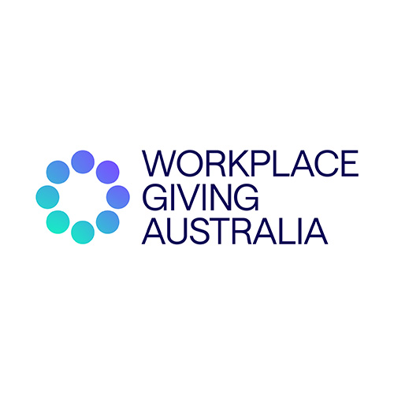](https://workplacegiving.org.au/enabling-giving/workplace-giving-platform)

[Workplace Giving Australia](https://workplacegiving.org.au/enabling-giving/workplace-giving-platform)

Employees can donate to FARE through [Workplace Giving Australia’s](https://workplacegiving.org.au/enabling-giving/workplace-giving-platform) Good2Give platform. They can easily create accounts, select FARE as their charity of choice, and manage contributions independently.

[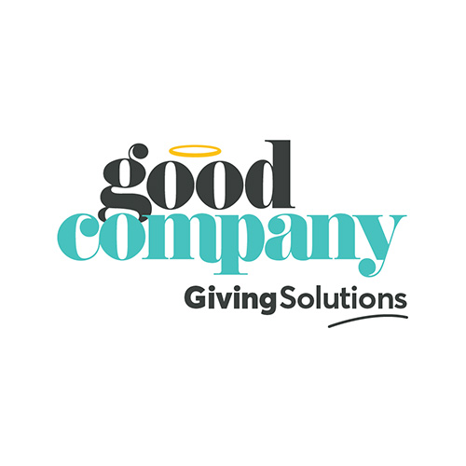](https://www.goodcompany.com.au/au/donating?query=Foundation%20for%20Alcohol%20Research%20and%20Education&filters%5B0%5D%5Bidentifier%5D=_index&filters%5B0%5D%5Bvalue%5D=charitygifts-v2&size=24)

[Good Company](https://www.goodcompany.com.au/au/donating?query=Foundation%20for%20Alcohol%20Research%20and%20Education&filters%5B0%5D%5Bidentifier%5D=_index&filters%5B0%5D%5Bvalue%5D=charitygifts-v2&size=24)

FARE is also a charity partner of [Good Company](https://www.goodcompany.com.au/au/donating?query=Foundation%20for%20Alcohol%20Research%20and%20Education&filters%5B0%5D%5Bidentifier%5D=_index&filters%5B0%5D%5Bvalue%5D=charitygifts-v2&size=24) which facilitates workplace giving, donations, fundraising and volunteering. The GoodCompany platform provides an easy 3 step simple workplace giving solution.



Bank Transfers

Employers can set up your Workplace Giving program internally through regular bank transfers that coincide with your pay cycle. In order to set up a bank transfer, please fill out this [enquiry form](#elementor-action%3Aaction%3Dpopup%3Aopen%26settings%3DeyJpZCI6IjEzOTg1NiIsInRvZ2dsZSI6ZmFsc2V9). Once you have completed the form you will receive the deposit details.

## FAQs for Employers

What is workplace giving?

Workplace giving is a program that enables employees to donate a portion of their pre-tax salary directly from their payroll to charitable organisations, like FARE.

Why should my organisation offer workplace giving to employees?

Workplace giving demonstrates corporate social responsibility, enhances employee engagement, and contributes to a positive workplace culture.

Why do companies match workplace giving donations?

Matching donations not only amplifies the impact of individual contributions but also showcases your commitment to social issues, fostering goodwill among employees and the broader community.

Workplace giving is a program that enables employees to donate a portion of their pre-tax salary directly from their payroll to charitable organisations, like FARE.

Workplace giving demonstrates corporate social responsibility, enhances employee engagement, and contributes to a positive workplace culture.

Matching donations not only amplifies the impact of individual contributions but also showcases your commitment to social issues, fostering goodwill among employees and the broader community.

We'll be documenting our team's progress in the months leading up to race day across all of our social media channels.

Stay tuned for updates as we inch closer to our fundraising goal, hear insights from our City2Surf community, and get immersed in the excitement around FARE's first fun run!

[Facebook-f](https://www.facebook.com/FAREAustralia/" \t "_blank) [X-twitter](https://twitter.com/fareaustralia) [Instagram](https://www.instagram.com/fare.australia/) [Linkedin](https://www.linkedin.com/company/2404161/)

Together, we can run towards a future where all Australians are free from alcohol harms.

Creating a City2Surf running crew full of family or friends is a terrific way to keep yourself motivated and accountable while training and on race day.

## FAQs for Employees

What are the benefits of workplace giving?

Workplace giving allows employees to easily support causes they are passionate about while also realising potential tax benefits. Often, employees have their contributions matched by their employer, doubling the impact of their donation.

What happens if I change jobs?

If you change jobs, you can usually continue your workplace giving contributions at your new workplace using their preferred workplace giving platform. Alternatively, you can support FARE through other means, such as individual donations.

What happens if I need to pause or cancel my workplace giving contributions?

If you need to pause or cancel your workplace giving contributions, you can do so through the workplace giving platform or by contacting your HR/payroll department. Remember that any changes may take effect at the beginning of the next pay cycle.

Workplace giving allows employees to easily support causes they are passionate about while also realising potential tax benefits. Often, employees have their contributions matched by their employer, doubling the impact of their donation.

If you change jobs, you can usually continue your workplace giving contributions at your new workplace using their preferred workplace giving platform. Alternatively, you can support FARE through other means, such as individual donations.

If you need to pause or cancel your workplace giving contributions, you can do so through the workplace giving platform or by contacting your HR/payroll department. Remember that any changes may take effect at the beginning of the next pay cycle.

We'll be documenting our team's progress in the months leading up to race day across all of our social media channels.

Stay tuned for updates as we inch closer to our fundraising goal, hear insights from our City2Surf community, and get immersed in the excitement around FARE's first fun run!

[Facebook-f](https://www.facebook.com/FAREAustralia/" \t "_blank) [X-twitter](https://twitter.com/fareaustralia) [Instagram](https://www.instagram.com/fare.australia/) [Linkedin](https://www.linkedin.com/company/2404161/)

Together, we can run towards a future where all Australians are free from alcohol harms.

Creating a City2Surf running crew full of family or friends is a terrific way to keep yourself motivated and accountable while training and on race day.

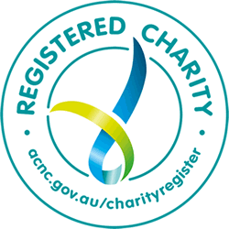

FARE is registered as a charity with the Australian Charities and Not-for-profits Commission (ACNC). Eligible tax-deductible donations have Deductible Gift Recipient (DGR) status with the Australian Tax Office (ATO).

## Join us in creating an Australia free from alcohol harms

Together, we can make a meaningful difference in preventing alcohol harms and building healthier, safer communities. Join us by participating in workplace giving today.

For further enquiries or assistance, please don't hesitate to contact us. Thank you for your support.

[Contact us](https://fare.org.au/contact/)