# What you may not know about breastfeeding and alcohol

There are a lot of mixed messages about alcohol and breastfeeding. We need clear messages on how to ensure breastmilk is alcohol-free.

According to the [National Alcohol Guidelines](https://www.nhmrc.gov.au/health-advice/alcohol), not drinking alcohol is safest for the baby when breastfeeding. It is important we ensure the breastmilk babies drink is always alcohol-free.

But [recent research](https://fare.org.au/wp-content/uploads/Alcohol-and-breastfeeding-Beliefs-attitudes-knowledge-and-behaviours.pdf) shows that almost two-thirds of Australian women who breastfeed did not feel they fully understood the risks of drinking alcohol while breastfeeding.

The research also found that while most people who drink alcohol while breastfeeding say they use some form of harm minimisation strategy, only 39 per cent had calculated how long they should wait after drinking to breastfeed based on the number of standard drinks they'd consumed.

That is why it is important that new parents and parents-to-be are aware of how to ensure that breastmilk is alcohol free.

##### Not drinking alcohol is safest for the baby when breastfeeding.

So, what happens when there is alcohol in the breastmilk?

In the short term, even small amounts of alcohol can disrupt your baby’s sleep and make feeding more difficult due to reductions in milk supply and the flow of milk.

In the long term, alcohol can damage developing infant brains because they are more vulnerable to alcohol than adults. Alcohol has been linked to reductions in their verbal IQ, lower cognitive ability and slowed growth in early childhood.

[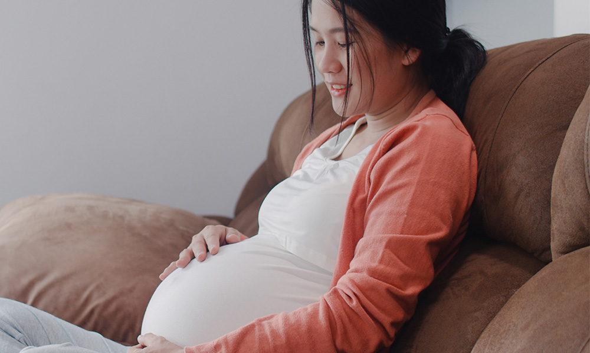](https://fare.org.au/reflections-from-nofasd-australias-fasd-forum/)

[Read more: Reflections from NOFASD Australia’s FASD Forum](https://fare.org.au/reflections-from-nofasd-australias-fasd-forum/)

How can you protect your baby from breastmilk containing alcohol?

As your baby grows, it is safest to avoid alcohol while you continue to breastfeed. But if you do drink alcohol, there are steps you can take to prevent your baby from drinking breastmilk containing alcohol:

* You should wait a minimum of two hours per standard drink before feeding your baby to ensure your milk is alcohol free.
* You can use the FeedSafe app to know when your breastmilk is alcohol free. FeedSafe uses your weight and height to calculate when alcohol will be cleared from your breastmilk.
* Expressing breastmilk before you drink alcohol means you or someone else can feed your baby by bottle while the alcohol remains in your body.

##### We want all Australians to be aware of the risks as well as useful strategies that can help ensure the milk their baby drinks remains alcohol-free.

If you think alcohol will be in your breastmilk, you can express milk for comfort and to maintain supply, but this milk should be discarded.

The health and well-being of our children is of utmost importance. That’s why we want all Australians to be aware of the risks as well as useful strategies that can help ensure the milk their baby drinks remains alcohol-free.

FARE is launching a new resource that outlines information you might not know about pregnancy, breastfeeding, and alcohol. [You can find the brochure here.](https://everymomentmatters.org.au/wp-content/uploads/2022/08/Pregnancy-and-breastfeeding-DL-SINGLE-PAGE.pdf)  
  
The resource is part of FARE’s national campaign supporting alcohol-free pregnancy and breastfeeding. The campaign, called Every Moment Matters, launched on 30 November 2021 and runs until June 2024.   
  
To learn more: visit [everymomentmatters.org.au](https://everymomentmatters.org.au/)

For more information and support on breastfeeding, visit the [Australian Breastfeeding Association](https://breastfeeding.asn.au).

[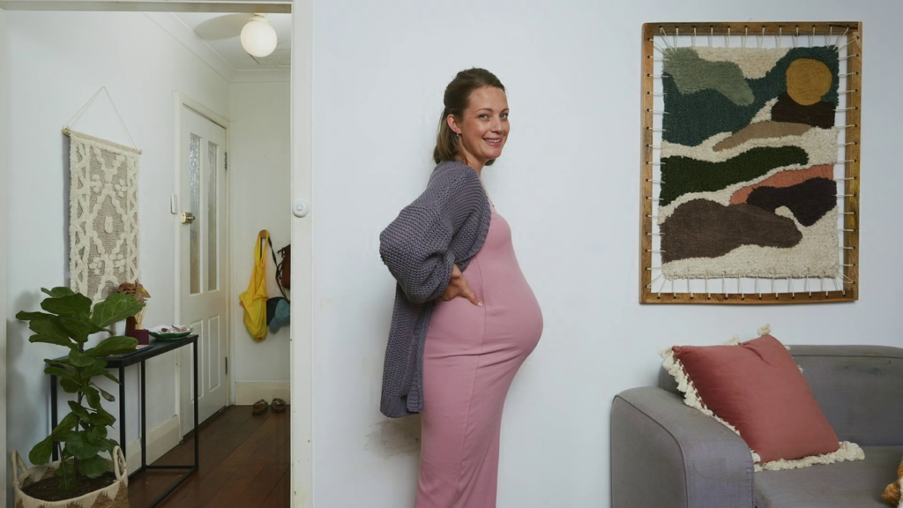](https://fare.org.au/every-moment-matters-the-campaign-to-raise-awareness-of-the-risks-of-drinking-alcohol-while-pregnant-planning-a-pregnancy-or-breastfeeding-and-fasd/)

[Read more: Every Moment Matters: The campaign to raise awareness of the risks of drinking alcohol while pregnant, planning a pregnancy, or breastfeeding and FASD](https://fare.org.au/every-moment-matters-the-campaign-to-raise-awareness-of-the-risks-of-drinking-alcohol-while-pregnant-planning-a-pregnancy-or-breastfeeding-and-fasd/)