# Voices of Change old

# Voices of Change

Alcohol affects individuals, families and communities every day through injury, violence, chronic diseases like cancer, mental ill-health, and disabilities like Fetal Alcohol Spectrum Disorder.

Sadly, people affected by alcohol are too often seen as numbers and statistics.

But at the heart are real people who have important stories and experiences. They are people we love and care about — our family members, our friends, and our community members.

When we are concerned about ourselves, or someone who is going through a difficult time because of alcohol, it can help to know we are not alone. Sharing stories is a valuable way to break down barriers and connect with each other.

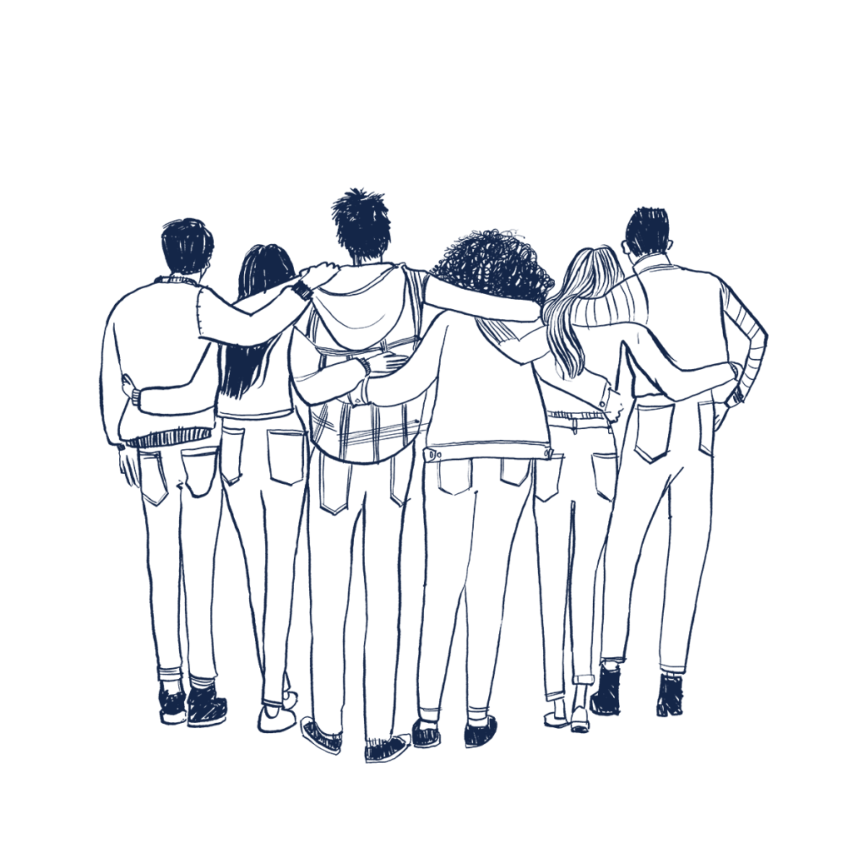

**FARE has created an online space for these real-life experiences, where you can share your story, learn from others’ experiences, and also find resources and support.**

Our aim is to use these stories, with your permission, to channel hope, urgency and solidarity, and build an environment that encourages people to reach out. By sharing your story, you may be able to assist us with a range of communications including (but not limited to):

* newsletters
* fundraising campaigns
* social media
* media interviews
* government submissions
* long-form feature article or feature video.

If you would like support related to your alcohol use or someone else's, please visit our [Support Services](https://fare.org.au/resources/support/) page.

*Please feel free to email us at* [*campaigns@fare.org.au*](mailto:campaigns@fare.org.au) *if you have any questions about this project. In submitting this form you agree that your story or parts of it can be shared by FARE in its communications.*

## What happens after I fill out the form?

Through sharing your experiences, you will have contributed to helping create change in Australia.

When using quotes from your submission in policy reports, on our website, or on social media, FARE will attribute the quote as First Name, State, Age.

If you indicate interest in sharing your story through a blog, feature article or video, one of our friendly team members may be in touch to discuss your story and explore opportunities to share your story in more detail.

If you or someone you love has a story to share with us, please get in touch. Your information will always be treated with care and respect, and always in accordance with our Privacy Policy.

* Have you seen a harmful ad online?*
  + Yes
  + No
* First name*
* Last name
* Email*
* State/Territory*
* Upload a photo/screenshot of the ad, if available:

Drop files here or Select files

Max. file size: 8 MB.

* Please provide details regarding the ad. You can share your experience in a sentence or a few paragraphs.*
* CAPTCHA

FARE has created an online space for these real-life experiences, where you can share your story, learn from others’ experiences, and also find resources and support.

Our aim is to use these stories, with your permission, to channel hope, urgency and solidarity, and build an environment that encourages people to reach out. By sharing your story, you may be able to assist us with a range of communications including (but not limited to):

* newsletters
* fundraising campaigns
* social media
* media interviews
* government submissions
* long-form feature article or feature video.

## What happens after I fill out the form?

Through sharing your experiences, you will have contributed to helping create change in Australia.

When using quotes from your submission in policy reports, on our website, or on social media, FARE will attribute the quote as First Name, State, Age.

If you indicate interest in sharing your story through a blog, feature article or video, one of our friendly team members may be in touch to discuss your story and explore opportunities to share your story in more detail.

If you or someone you love has a story to share with us, please get in touch. Your information will always be treated with care and respect, and always in accordance with our [Privacy Policy](https://fare.org.au/privacy-statement/).

## Join our community

Will you join the community taking action on alcohol?