# Voices of Change

# Voices of Change

## At the heart of discussions about alcohol are real people with important experiences waiting to be heard.

Discover the real-life stories of fellow Australians or share your experience to help inspire others and bring about change.

## Hear from our community

Uncover stories of people around the country who have an experience to share about the role of alcohol in their lives, whether for themselves, their family, or their friends.

When we are worried about alcohol for ourselves or someone we love, it can help to know others have been through this before – to hear their experiences and learn from their advice.

### [Read more stories](https://fare.org.au/stories)

"I grew up in a normalised binge drinking culture. Drinking in large amounts was revered and a badge of honour." *Kathryn, Victoria* 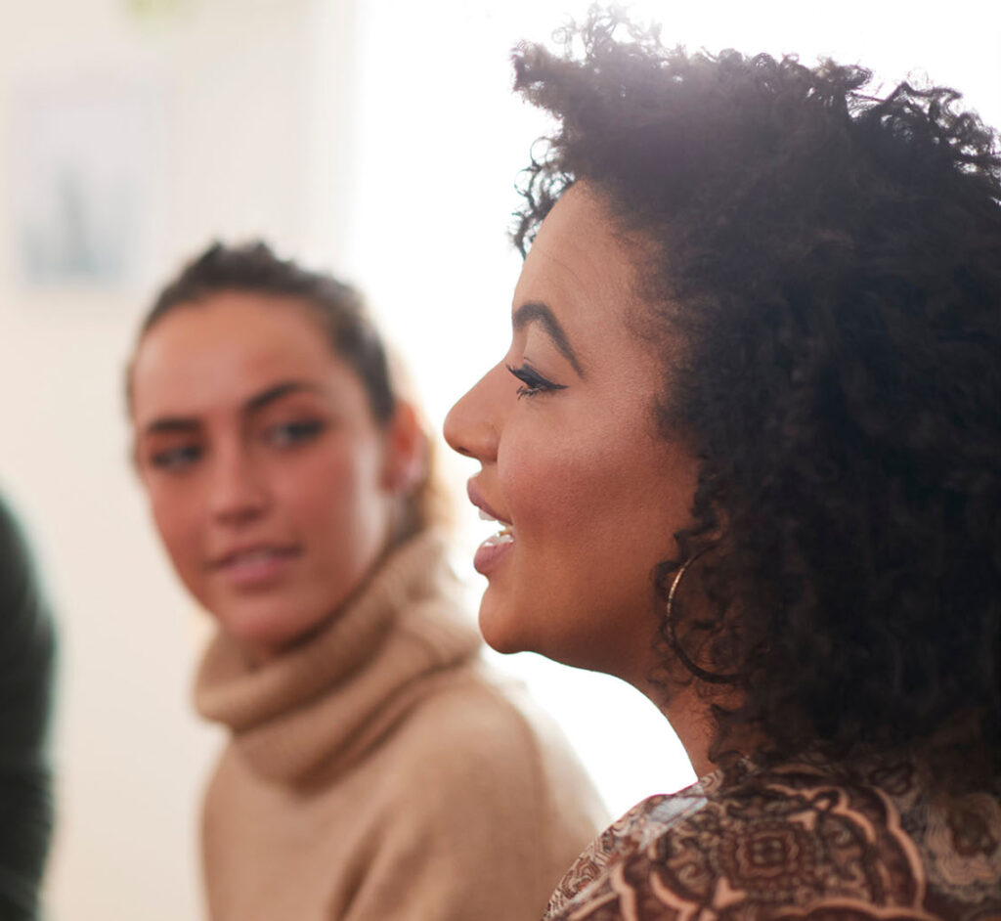

## Share your story

Every experience with alcohol is unique, and your voice has power.

Share your story to help create change – whether through encouraging others to reach out for support, or ensuring decision-makers consider the real experiences of everyday Australians when deciding on policies that affect our communities.

* Do you have a story to share?*
  + Yes
* First name*
* Last name
* State/Territory*
* Age
* Email*
* How has alcohol impacted your life?*
* Where would you be comfortable with this story being shared?*
  + Policy papers and submissions
  + Social media post
  + Blog or feature article
  + Video
* Do you want to remain anonymous?
  + Yes
  + No

## Discover more voices

Across Australia we’re beginning to have a more honest conversation about the culture surrounding alcohol and how it affects our health and our lives.

Check out some of the stories shared by people and organisations we admire.

[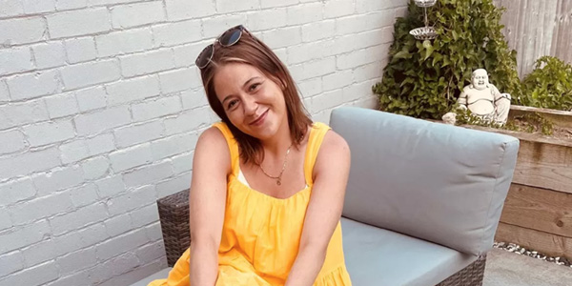](https://hellosundaymorning.org/2022/11/25/my-second-chance/)

### [My Second Chance](https://hellosundaymorning.org/2022/11/25/my-second-chance/)

For Emma it wasn't until she was faced with serious health challenges, was so forced to address her relationship with alcohol.

[Read more](https://hellosundaymorning.org/2022/11/25/my-second-chance/) [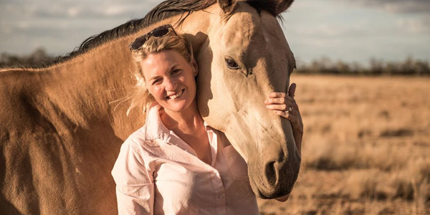](https://www.abc.net.au/news/2019-11-15/last-drinks/11705194)

### [Last Drinks](https://www.abc.net.au/news/2019-11-15/last-drinks/11705194)

How one woman created an online tribe and showed rural and remote Australia that it’s okay to say 'no' to a beer.

[Read more](https://www.abc.net.au/news/2019-11-15/last-drinks/11705194) [](https://fare.org.au/transparency-report/)

### Advertisements on digital platforms: How transparent and observable are they?

[Read more](https://fare.org.au/transparency-report/) [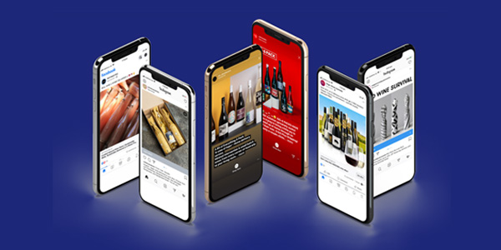](https://fare.org.au/wp-content/uploads/2020-05-08-CCWA-FARE-An-alcohol-ad-every-35-seconds-A-snapshot-final.pdf)

### An alcohol ad every 35 seconds

[Read more](https://fare.org.au/wp-content/uploads/2020-05-08-CCWA-FARE-An-alcohol-ad-every-35-seconds-A-snapshot-final.pdf) [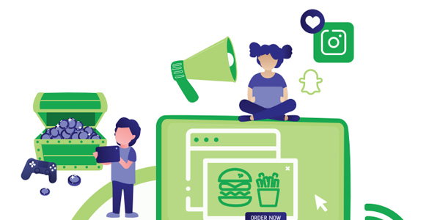](https://www.vichealth.vic.gov.au/-/media/ResearchandEvidence/Under-the-radar--Harmful-industries-digital-marketing-to-Australian-children.pdf?la=en&hash=960D0ED61D543DE331A5C8306EC87E95422FADC2)

### Under the radar: Harmful industries’ digital marketing to Australian children

[Read more](https://www.vichealth.vic.gov.au/-/media/ResearchandEvidence/Under-the-radar--Harmful-industries-digital-marketing-to-Australian-children.pdf?la=en&hash=960D0ED61D543DE331A5C8306EC87E95422FADC2)

## Donate

Australians deserve to have a say in the role that alcohol plays in their lives and communities.

At FARE, we want to amplify community voices about the impact of alcohol, to make sure people are put first when it comes to decisions that affect their health.

With your support, local advocates and grassroots organisations can create the change they want to see in their communities.

## Join our community

Will you join the community taking action on alcohol?