# Tips and tools for cutting back

# Tips and tools for cutting back

## Alcohol can be hard to quit — here are ways to set yourself up to succeed

Whether you’re aiming to drink less or to quit altogether, here are some tips and tools that can help you cut back on alcohol.

Know that you don’t have to make changes alone. There is a [range of help and support available.](https://fare.org.au/support/)

* What is a standard alcoholic drink?
* Tips for cutting down your alcohol
* Tools to help you cut back on alcohol

## What is a standard alcoholic drink?

https://fare.org.au/wp-content/uploads/FARE-Animation-1.mp4 How much is too much?

The less alcohol you drink, the lower your risk of harm.

The [Australian Alcohol Guidelines](https://www.nhmrc.gov.au/health-advice/alcohol) recommend you have:

* no more than four standard drinks a day, and
* no more than ten standard drinks a week

Children and young people under 18 years of age should not drink any alcohol. When pregnant, planning a pregnancy you should also not drink any alcohol. If you are breastfeeding, it is safest not to drink any alcohol.

What is a standard drink?

A standard drink may be less than you think.

The number of standard drinks in a serve of alcohol depends on the alcohol volume (strength) and the size of the serve. A standard drink contains 10 grams of pure alcohol.

One standard drink is contained in a small 100ml glass of red wine, a can or bottle (375ml) of mid-strength beer, or a shot or nip (30ml) of spirits.

Knowing what is meant by a standard drink is important so that, if you’re drinking alcohol, you can stay within the recommended [Australian Alcohol Guidelines.](https://www.nhmrc.gov.au/health-advice/alcohol)

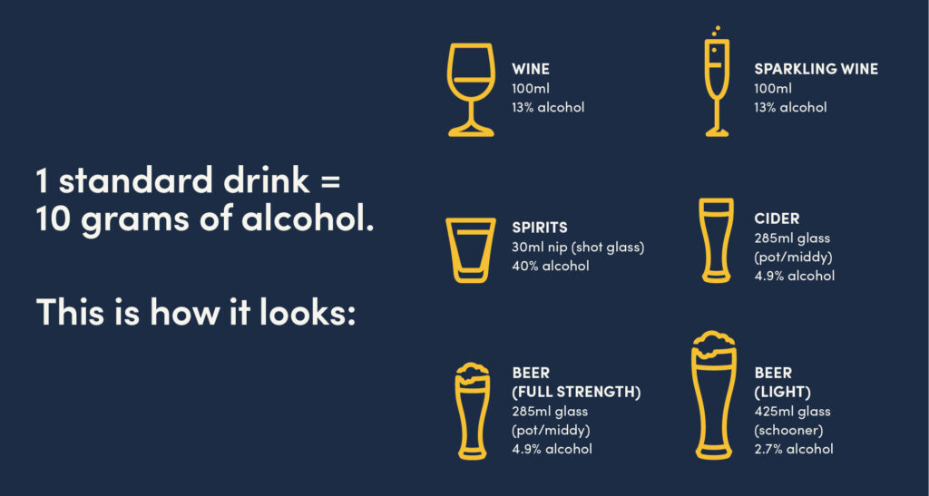

Keeping track of how many standard drinks you have will also help if you want to reduce or stop drinking.

Check out the Australian Department of Health [guide on standard drinks.](https://www.health.gov.au/health-topics/alcohol/about-alcohol/standard-drinks-guide) You can also download our [*Keeping track of standard drinks*](https://fare.org.au/wp-content/uploads/FARE-Fact-Sheet-Keeping-track-of-standard-drinks.pdf) information sheet.

How can I check a standard drink?

You can see how many standard drinks are in a packaged bottle or can of alcohol by checking the product label. Every alcohol product in Australia is required to be labelled with the number of standard drinks that it contains.

You can also use an online standard drink calculator to measure the number of standard drinks in different sized serves of alcohol.

Here are two handy standard drink calculators:

* Your Room [standard drink calculator](https://yourroom.health.nsw.gov.au/games-and-tools/pages/standard-drink-calculator.aspx)
* Alcohol Think Again [standard drink tool](https://alcoholthinkagain.com.au/alcohol-your-health/online-tools/standard-drink-tool/).

## Tips for cutting down your alcohol

https://fare.org.au/wp-content/uploads/FARE-Animation-2.mp4 Review your alcohol intake

If you drink alcohol, it can be helpful to review your intake to understand whether you could benefit from cutting back or giving up.

The Australian Alcohol Guidelines advise to have no more than ten standard drinks in a week, and no more than four standard drinks in a day. (See [*Australian Alcohol Guidelines*](https://fare.org.au/wp-content/uploads/FARE-Fact-Sheet-Alcohol-guidelines.pdf) for more information).

Cutting back or giving up on alcohol is especially important if drinking is impacting your daily activities, relationships, health, or wellbeing, or is putting you or others at risk.

Some signs you could benefit from reducing your drinking or giving up alcohol include:

* You feel like your drinking is impacting your physical or mental health or wellbeing
* You are looking to be healthier and want to reduce your risk of the health effects of alcohol
* You sometimes find it hard to stop drinking once you have started
* Your loved ones, friends or a health professional have been concerned about how much alcohol you drink
* Your drinking has interfered with daily activities or responsibilities, such as your job or your relationships
* Your alcohol use is impacting others around you

You can complete an online questionnaire for initial guidance on whether your alcohol intake is putting you at risk. Turning Point have a helpful [alcohol self-assessment tool](https://www.turningpoint.org.au/treatment/self-assessments).

Drinking less alcohol will benefit your health and wellbeing

In a [2019 study](https://www.sussex.ac.uk/news/article/47131-how-dry-january-is-the-secret-to-better-sleep-saving-money-and-losing-weight), people who stopped drinking alcohol for one month reported the following benefits:

* Better quality of sleep (71%)
* Better overall health (70%)
* More energy (67%)
* Weight loss (58%)
* Improved concentration (57%)
* Better skin health (54%)

By cutting back on alcohol you **can**:

* reduce your risk of serious diseases, such as cancer, heart disease, and stroke
* lessen your chances of accident and injury from risky single-occasion drinking, and
* **improve** your sleep, mood, and energy levels

Learn more about the effects of alcohol on your health [here](https://fare.org.au/resources/alcohol-effects/), and about what happens when you stop drinking alcohol [here.](https://hellosundaymorning.org/what-happens-when-you-stop-drinking-alcohol/)

Goal setting and tracking your progress

It can be helpful to set a goal and make a plan when you’re thinking about reducing the amount you drink. Having a plan will help you stay on track and measure the benefits of cutting back.

Your plan might be to have more alcohol-free days or to have less alcohol when you drink. To help with your plan, think about:

* Your goals — Why do you want to reduce or quit alcohol?
* Your triggers — Why and when do you drink alcohol?
* Strategies to overcome these — How will you reduce or quit alcohol?
* Support networks and services — Who will you turn to for help?

Sharing your goals with close family members and friends can help you achieve them — by increasing your commitment to achieving the goal and securing their support to help you keep it.

[Click here](https://www.health.gov.au/health-topics/alcohol/about-alcohol/how-can-you-reduce-or-quit-alcohol) to find out more tips and tools for cutting back or download our information sheet [*Cutting back on alcohol.*](https://fare.org.au/wp-content/uploads/FARE-Fact-Sheet-Cutting-back-on-alcohol.pdf)

Tips for limiting your alcohol intake

If you are in a situation where you or others are drinking, here are some strategies that can help you reduce the amount of alcohol you drink.

1. Set a limit on the number of drinks you plan to have, and be mindful of the number of standard drinks in each serve.
2. Drink slowly. For every alcoholic drink have a glass of water or soft drink.
3. Choose drinks without alcohol or with lower alcohol content.
4. Choose smaller serving sizes or don’t pour a full glass.
5. Avoid top-ups, and don’t say yes to another drink if you haven’t finished the one you are drinking.
6. If you are going out, offer to be the designated driver and make sure you stay under the legal blood alcohol level for driving.

Try alcohol free days

Committing to having alcohol-free days each week can be a great way to reduce the amount you drink.

Having alcohol-free days can be a useful circuit breaker if you need to reset habits and reduce how often you drink.

Alcohol-free days can also help support healthy daily habits that don’t involve alcohol, such as exercise or eating well.

## Tools to help you cut back

Apps that can help you

**Daybreak**

A free app from Hello Sunday Morning, Daybreak offers self-directed activities to help you change your drinking habits, whether you want to cut back or quit drinking completely. ‘Daybreakers’ receive support from like-minded community members who can help each other achieve their alcohol change goals. One-on-one coaching is also available. Daybreak is free for Australian residents and is confidential, anonymous and secure.

[Download the app](https://hellosundaymorning.org/daybreak/)

**Drinksmeter**

A free app containing tools like goal setting and a drinking diary to help you cut down your drinking, including an interactive drink pouring tool helping you make sense of standard drinks. Confidential, personalised feedback is provided about your alcohol use, based on risk factors in your family and medical history. The app can also record and monitor how much you spend on alcohol and how many kilojoules or calories the alcohol you drink contains. It compares your drinking with other users of the app, and with Australia’s national alcohol guidelines.

[Download the app](https://www.cancercouncil.com.au/wellness/drinks-meter/)

Reaching out

We all need help and support from time-to-time. If you need support in making a change around alcohol, [have a look at our](https://fare.org.au/support/) contact list for further advice and assistance.

If you have been drinking heavily for a long time, it could be dangerous to reduce or quit alcohol on your own without medical advice or additional support.

Your doctor can help by advising on withdrawal planning, prescribing medication, or referring you to withdrawal and counselling services.

## Join our community

Will you join the community taking action on alcohol?