# "My hands were tied"

***Content warning:*** *This article discusses alcohol use and other sensitive issues.*

“My hands were tied. No matter what I did, he would still have access to a delivery service that fed his addiction and because he could order late at night for delivery the next day while I was at work, I had no idea of what was happening in my own home.”

This is a direct quote from a woman who lost her ex-husband to alcohol. He was 47.

In the lead up to his death, he was being sold six boxes of cheap wine at a time delivered to his door.

This is one of the[personal submissions to the ACT Government’s consultation](https://hdp-au-prod-app-act-yoursay-files.s3.ap-southeast-2.amazonaws.com/2217/1989/3267/Submissions.pdf) on the same-day delivery of alcohol.

I have had two people in the ACT share their stories of losing a loved one in very similar circumstances.

Both of the lives lost were men, both were in their 40s and both died of diseases relating to alcohol.

**Both families also believed the delivery of alcohol and lack of controls in place made it worse.**

One of these people is [Alex Bagnara](http://fare.org.au/alexs-story). Her close friend died last year at the age of 46 from alcohol-related organ failure.

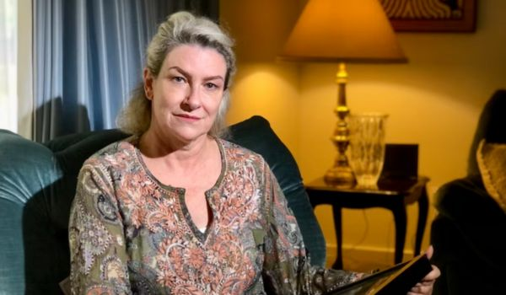

Alex Bagnara is calling for better controls on alcohol delivery and marketing to prevent harm.

Alex says targeted social media ads and the availability of alcohol to be rapidly delivered to his home contributed to his death.

""They would deliver him alcohol with little or no vetting. I am sure that there were times when he was sold alcohol online, while already intoxicated – and that if he had gone into a licensed premises, he may have been denied service," she said.

Friends and families face even greater challenges in supporting loved ones to cut back on drinking in a world where alcohol is readily available around the clock.

The ACT government committed to exploring further reforms in it’s [Listening Report](https://hdp-au-prod-app-act-yoursay-files.s3.ap-southeast-2.amazonaws.com/2217/1955/8368/Listening_Report_-_Same_Day_Delivery_.pdf), responding to the consultation, saying they have: “clearly heard feedback from stakeholders in relation to the need for any reform in this space to also address predatory marketing issues”.

**This is important. We know that the line between marketing and the delivery of alcohol is increasingly blurred, with alcohol ads now the point of sale.**

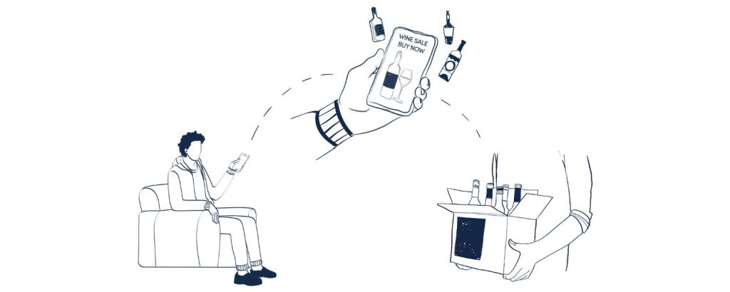

Online sale and delivery of alcohol has removed guardrails, or friction points, so there is no separation between advertising and the point of sale.

Most online ads have a button that links directly to sale – with alcohol now two clicks and 20 minutes away from being delivered.

An[analysis of almost 40,000 alcohol ads](https://fare.org.au/alcohol-companies-ply-community-with-40000-alcohol-advertisements-a-year-on-facebook-and-instagram/) that appeared on Facebook and Instagram over the course of a year found that most alcohol retailer advertisements (91%) used a call-to-action button directing people to find out how to buy, while 66.7% used a ‘Shop Now’ button to directly sell alcoholic products within the app.

Reforms to laws on the online delivery of alcohol cannot come soon enough, with [alcohol induced deaths in Australia at their highest rate in a decade](https://fare.org.au/alcohol-induced-deaths-in-australia/).

Governments can implement common sense measures to meaningfully address the marketing and online sale of alcohol.

This includes:

* A 2-hour safety pause between order and delivery, for alcohol-only orders, to prevent the rapid delivery of alcohol into homes
* Keeping deliveries to between 10am and 10pm, to reduce the risks of alcohol-related family violence and suicide, which increase later at night in the home
* Effective digital age verification for online sales of alcohol to ensure alcohol isn’t sold to children
* ID checks on delivery of alcohol delivery to ensure alcohol isn’t supplied to children or intoxicated people
* Addressing predatory, data-driven push marketing to protect people’s health and privacy and introduce friction points in the sale process
* Supporting delivery staff with delivery-specific training, not penalising them for non-delivery, and making delivery companies liable for non-compliance.

Progress in this space by [states and territories has been slow](https://fare.org.au/where-does-your-state-stand-in-preventing-harm-from-online-sale-and-delivery-of-alcohol/). But, do [state and territory governments have the power](https://fare.org.au/alcohol-and-gendered-violence/) to take steps that can save lives.

For every story shared as part of this review there are many, many more we don’t hear because this harm so often happens behind closed doors.

Now is the time for change.

*If you or someone you know needs support, there are* [*services available.*](https://fare.org.au/resources/support/)

*You can find out more about the ACT Government’s consultation on the online delivery of alcohol* [*here*](https://yoursayconversations.act.gov.au/same-day-delivery-alcohol-canberra)*.*

*You can find FARE’s full submission to the consultation process* [*here*](https://fare.org.au/wp-content/uploads/FARE-submission-ACT-online-sale-delivery-consultation.pdf)*.*