# The impact of COVID-19: More alcohol going into Australian homes than ever before

|  |  |
| --- | --- |
| **Author** | Luke Maxfield |
| **Date** | 2021-02-23 09:21:55 |
| **Categories** | Health |

### As the COVID-19 pandemic and lockdowns hit our shores triggering a public health crisis, the alcohol retail sector experienced unprecedented growth.

As the COVID-19 pandemic and lockdowns hit our shores triggering a public health crisis, the alcohol retail sector experienced unprecedented growth.

[The Foundation for Alcohol Research and Education](https://fare.org.au/) (FARE) analysed alcohol retailer turnover in its report [*Alcohol retail during COVID-19*](https://fare.org.au/wp-content/uploads/Alcohol-retail-industry-during-COVID-19.pdf). The report found that alcohol retail turnover in Australia reached a record $15.6 billion in 2020.

Alcohol retail experienced steady growth of between one and three per cent in recent years. However, the [Australian Bureau of Statistics (ABS) retail data](https://www.abs.gov.au/statistics/industry/retail-and-wholesale-trade/retail-trade-australia/latest-release) used in the analysis showed this trend rapidly accelerated during 2020. In the alcohol retail sector, of which Woolworths and Coles account for 65 per cent, turnover increased by 27 per cent in 2020, amounting to a $3.3 billion increase.

While the big alcohol retailers have been trumpeting their boosted profits, flooding homes with alcohol risks increasing alcohol-fuelled harms.

FARE’s analysis found that alcohol retail turnover, which is primarily made up of alcohol retail sales, was significantly elevated above recent annual trends throughout the pandemic-affected period of 2020. Spikes in turnover were observed in March and May 2020 at the start of the pandemic, and all pandemic-affected months had turnover increase by 15–46 per cent. May’s monthly turnover increased by almost half a billion dollars ($428.9 million) compared to May 2020, which, at 46 per cent, is the largest monthly increase from 2019 equivalent months. Monthly turnover in December 2020 reached a record $2 billion, exceeding the previous monthly peak by $427 million.

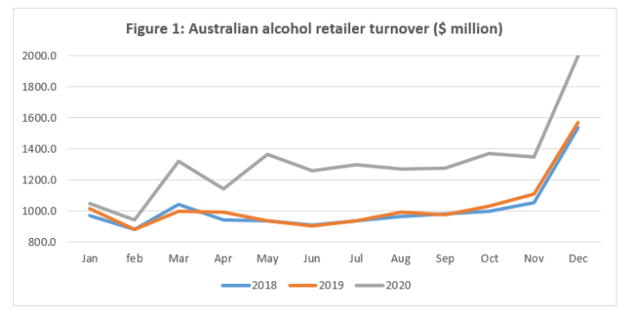

The impact of lockdowns caused by the pandemic was felt across all states and territories, especially in Victoria. There sales remained elevated over a nine-month period continuing from the first COVID-?19 wave to the second.

In January 2020, FARE’s [Annual Alcohol Poll](https://fare.org.au/annual-alcohol-poll-2020-we-drink-more-alcohol-and-most-often-at-home-even-before-covid-19-lockdowns/) found that 73% of Australians drink most frequently at home compared to other locations.

Given most of the alcohol sold in Australia was already takeaway and delivery before the pandemic — and with COVID-19 boosting levels to unprecedented levels — the risk is that these additional alcohol sales will lead to increased hidden harms in the home.

The increase in retail turnover during the pandemic is unsurprising when considering the COVID-19-related alcohol marketing drawing on community insecurities used during this time. Alcohol retailers and online delivery companies have engaged in prolific marketing that promotes using alcohol to cope during the pandemic.

The 2020 report by Cancer Council WA and FARE, [An alcohol ad every 35 seconds](https://fare.org.au/alcohol-ad-every-35-seconds-during-covid-19/), revealed that during just one hour on a Friday night during the COVID-19 pandemic, 107 sponsored alcohol advertisements were displayed on a person’s Facebook and Instagram accounts, which equates to approximately one alcohol advertisement every 35 seconds.

While big alcohol retailers are benefitting from increased turnover, individuals, families, and communities across Australia are experiencing alcohol harms including chronic disease, child neglect, poor mental health, self-harm, and domestic and family violence. Alcohol use increases both the severity and frequency of these harms. Since the pandemic there are indications that these harms at home are heightened; for example, 1800RESPECT, the national counselling service for family violence, recorded an [11% increase in calls](https://www.abc.net.au/news/2020-05-01/domestic-violence-brace-for-demand-coronavirus-restrictions/12203178).

Looking forward, the risk to the Australian community is that these elevated levels of alcohol retailer turnover remain at record highs in a post-pandemic world and permanently increase the risk of alcohol harms in the home.

Given the scope and danger of these risks, it is incumbent on state, territory, and national governments to deliver fit-for-purpose regulation that places limits on late night and rapid online alcohol product delivery and boosts funding for alcohol and other drug services.

Ensuring ID checks for alcohol delivery, providing a two-hour buffer for on-demand alcohol delivery and preventing late-night delivery past 10pm are simple measures that will reduce alcohol harms in the home.

With alcohol retail turnover increasing so much, public health advocates, governments and the Australian community must work together to reign in large alcohol retailers to help reduce alcohol-fuelled harm.

You can read FARE’s full report [here](https://fare.org.au/australia-records-highest-month-in-history-for-alcohol-retailer-turnover-in-december/). If you or someone you know needs support to cut back or give up alcohol, you can find information and relevant services at: [fare.org.au/support](https://fare.org.au/support/)

### Metadata