# ‘Strong Born’: Supporting Aboriginal communities to yarn about FASD

Sharing information about alcohol-free pregnancies and Fetal Alcohol Spectrum Disorder (FASD) can help every baby to be *strong born*.

*Strong Born is* the latest part of the broader *Every Moment Matters* initiative and shares new resources created with and for Aboriginal and Torres Strait Islander peoples in rural and remote communities.

It was developed by the National Aboriginal Community Controlled Health Organisation (NACCHO), in collaboration with a National FASD Expert Working Group, which includes multi-disciplinary staff from Aboriginal Community Controlled Health Organisations, and cultural and clinical FASD experts and researchers, and with support from FARE.

*Strong Born* includes culturally appropriate health information for women and families, educational materials for the Aboriginal workforce and guidance for healthcare providers that work with Aboriginal and Torres Strait Islander communities.

[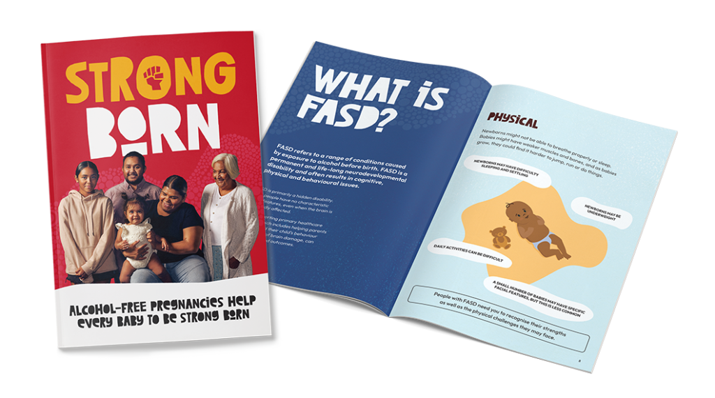](https://everymomentmatters.org.au/resources/?type=first-nations-peoples)

It does this by raising awareness of the risks of drinking alcohol during pregnancy by taking a culturally safe and stigma-free approach.

It is also about supporting people with FASD, and their families and carers, by increasing community understanding of FASD and the support services that may be available for individuals and families.

By making sure that communities are given accessible information and support, the hope is that every baby is *strong born*.

*To find out more about the Strong Born campaign and to access the campaign resources visit* [***www.naccho.org.au/FASD***](http://www.naccho.org.au/FASD)***.***

*You can also download and view the campaign resources on the Every Moment Matters* [***website***](https://everymomentmatters.org.au/)***.***

*Strong Born and Every Moment Matters are endorsed and funded by the Australian Government.*