# Strategic Plan 2024-27

# Strategic Plan 2024-27

### Working together to create an Australia free from alcohol harms

[I want a summary tailored to me](#summary) [I want to read the full strategy](https://fare.org.au/wp-content/uploads/FARE-Strategic-Plan-2024-27.pdf)

## Australians deserve to live a life where they are healthy and safe.

Every day, people across Australia are negatively impacted by alcohol, including through injury, violence, mental ill-health, chronic disease, family violence and disadvantage.

Far too many Australians die because of alcohol. Alcohol also causes Fetal Alcohol Spectrum Disorder (FASD), a lifelong disability.

The way alcohol companies choose to sell and market their products increases the risk of these harms. Their growing use of online marketing and sales, for example, poses new threats to children and other people who are vulnerable.

By working together, we can change this.

We work collaboratively to build the capacity of people wanting to create change, raise community awareness of the harms that alcohol causes, advocate for policy change that will lead to the prevention of alcohol harms and increase the accountability of companies that fuel harm.

Working with local communities, people with lived experience of alcohol harm, values-aligned organisations, health professionals, researchers and governments across the country, we are improving the health and wellbeing of everyone in Australia.

## What are our values?

 Collaborative

We work with and are informed by a diverse community of people and organisations who are passionate about creating change to improve the health and wellbeing of Australians.

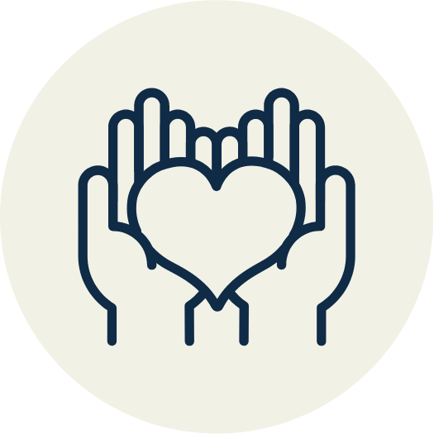 Empathetic

We listen and seek to understand the views of people directly impacted by alcohol harm, having their voices guide our work.

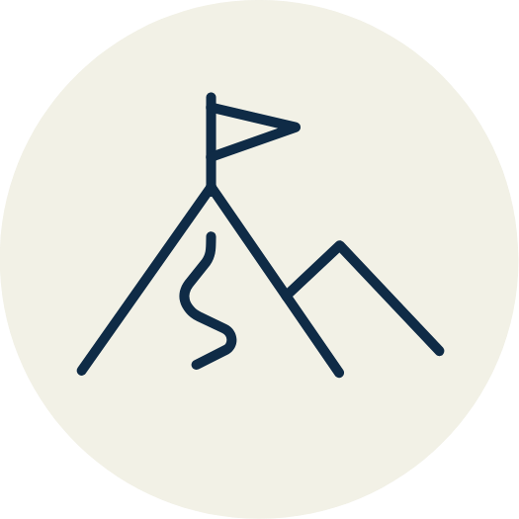 Courageous

We know lasting change can only happen if we elevate the voices of the community ahead of people with vested interests and we don’t shy away from this challenge.

 Impact-driven

We focus on achieving the best outcomes for communities and learn and grow by evaluating our work to extend our impact.

## Our pillars of change

FARE’s strategic plan focuses on four key areas to address alcohol harm in our communities:

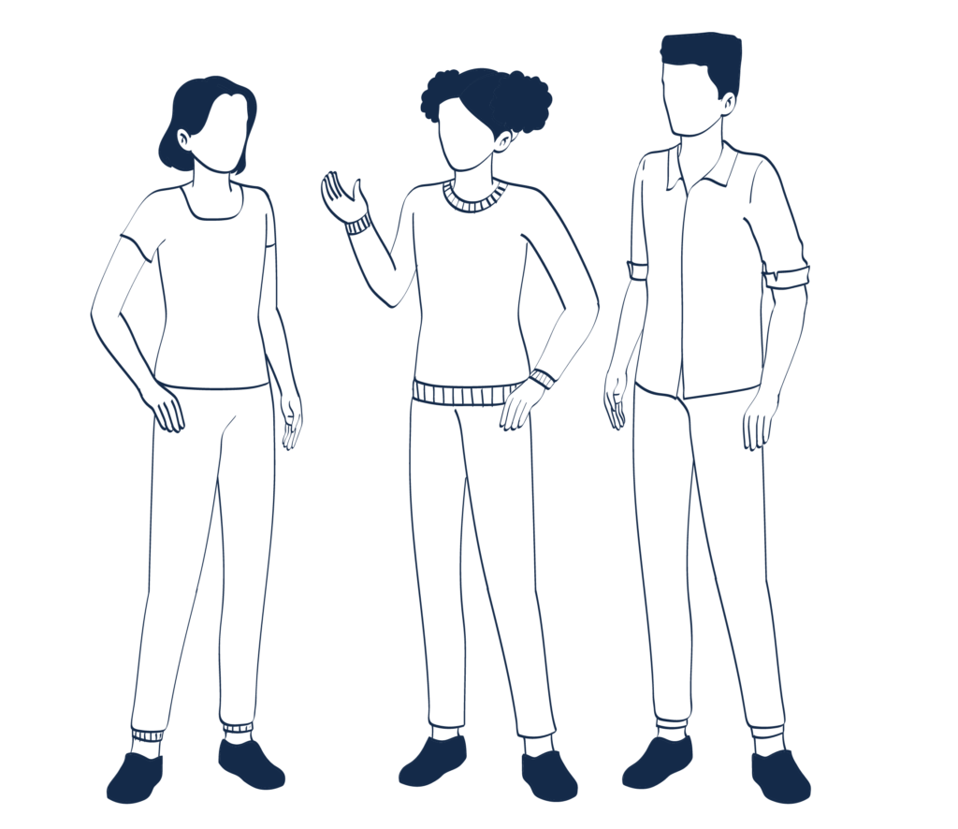

### Building individual capacity

Community voices should be elevated in discussions about laws, policies and programs that impact on their health and wellbeing.

This is why we work alongside people who have a lived experience of alcohol harm and communities disproportionately impacted by alcohol harm to create change.

#### How

We support the capacity building of people who have experienced alcohol harm to drive change.

#### Outcome

People are empowered to drive change that improves community health and wellbeing.

#### Examples

* Amplifying the voices of people with lived experience of alcohol harm through our Voices of Change project.
* Being an engine room for individuals and communities that are advocating for changes that will prevent the harms from alcohol.

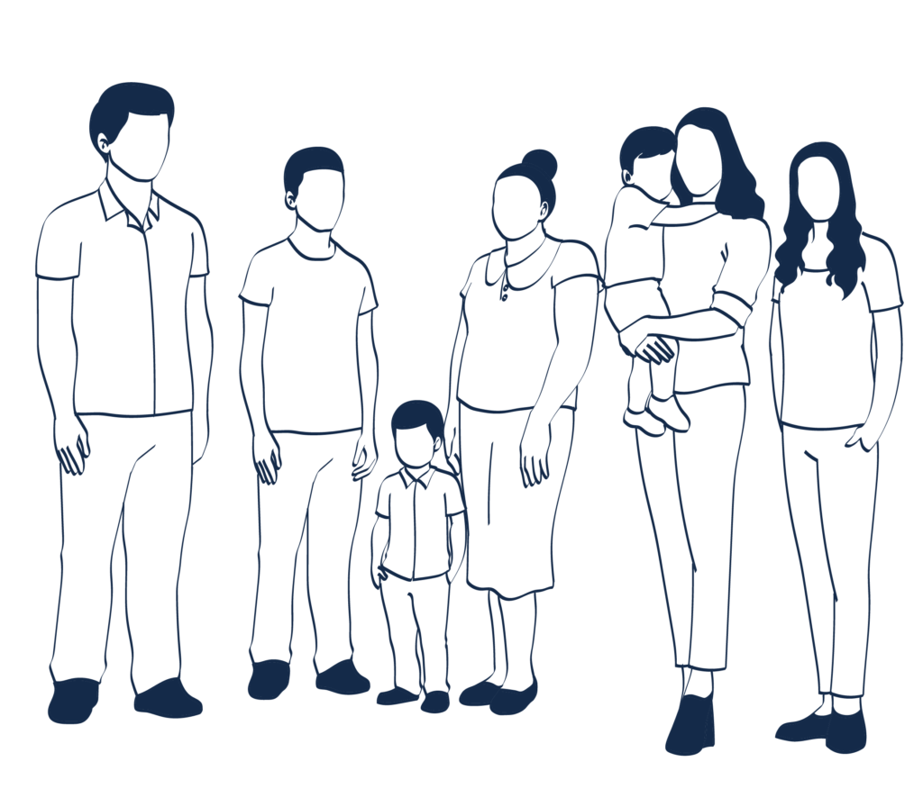

### Raising community awareness

Communities deserve to have access to honest and accurate information about the harms that alcohol causes from a trusted source.

This is why we develop and deliver health education, campaigns and resources that raise community awareness and prevent harm.

#### How

We develop and deliver evidence-informed health campaigns and resources about alcohol harms and the health and wellbeing benefits of reducing alcohol use.

#### Outcome

Communities have access to honest and accurate information, and resources to improve their health and wellbeing.

#### Examples

* Partnering with other organisations and governments to develop and deliver awareness campaigns about alcohol.
* Developing and communicating health information through our website and digital channels.
* Contributing to the evidence-base on effective health campaigns and resources through robust evaluations.



### Driving policy change

 Communities expect that laws, policies and programs prioritise our health and wellbeing.

This is why we undertake and translate research and develop and drive policy change that creates healthy and just environments and prevents alcohol harm.

#### How

We advocate for evidence-informed laws, policies and programs that prevent and reduce harm from alcohol in Australia.

#### Outcome

Decision-makers implement laws, policies and programs that prioritise community health, wellbeing and equity.

#### Examples

* Developing alternative models for alcohol laws in Australia that prioritise health, wellbeing, human rights and equity.
* Advocating for safer digital environments where checks and balances are in place to ensure that companies are not driving harm among people who are most at risk.
* Translating research into timely and meaningful policy recommendations so that decision makers have the most up to date information on the extent of alcohol harm and approaches to prevention.



### Increasing industry accountability

The health and wellbeing of our community should be prioitised ahead of corporate vested interests.

This is why we act in the public interest and shine a light on harmful practices by industry in driving harm.

#### How

We shine a light on the harmful industry practices that fuel harm.

#### Outcome

Community health, wellbeing and equity is prioritised ahead of the interests of companies that profit from and fuel alcohol harms.

#### Examples

* Undertaking research into the ways that people are tracked, traced and targeted by companies online and how this contributes to alcohol harm.
* Highlighting industry practice that undermines democracy and fuels harm.
* Developing tools that monitor industry influence of democratic processes.

System change

To reduce alcohol harm, communities need to be protected by good public policy.

FARE knows laws have struggled to maintain pace with new developments such as online sale and delivery, and the reckless digital marketing tactics used by alcohol companies.

Our community expects, and deserves, better. That’s where our research comes in.

Through advocating for Governments to implement evidence-based public health policy, we ensure decision makers have the information they need to pursue change that improves protections on digital platforms, betters health outcomes and minimises alcohol harm.

Community awareness

Alcohol companies have spent millions of dollars promoting misinformation about their products.

Historically, this spending has obscured the community’s access to accurate and current information about the potential harms of alcohol.

We respond to this by providing evidence-informed health campaigns and valuable resources through traditional and digital channels that is upfront, honest and follows modern health guidelines.

By equipping people and Governments with tools to improve community awareness, we can raise awareness of harms and the wellbeing benefits of cutting back on alcohol.

Capacity building

Our community should have a say in laws, policies and programs that affect them.

For too long, the power wielded by alcohol companies and lobbyists has created an imbalance that places their vested interests above the welfare of all Australians.

So, FARE has established itself as a platform for people with lived experience of alcohol harm to advocate on behalf of everyone.

We work closely with communities disproportionately impacted by alcohol harm, including Aboriginal and Torres Strait Islander peoples.

By amplifying and supporting their voices, we can drive meaningful change.

Corporate accountability

Big alcohol companies fuel alcohol harms every day.

For too long, the industry’s hidden impact on Australians’ lives has gone under the radar.

Just last year, we helped reveal gambling and alcohol industry lobbyists’ millions of dollars in donations to political parties.

Their lobbyists undermine our democracy by influencing key decision-makers, affecting policies that concern Australians’ health and wellbeing.

FARE is helping to shine a light on these insidious industry practices by:

* Highlighting when democracy is undermined
* Developing tools that track when democratic processes are subverted

Collaborative

We work closely with local communities, values-aligned organisations, people with lived experience of alcohol harm, health professionals, researchers and Governments to produce positive, research-backed programs and policies across Australia.

Empathetic

We place people first. Our work is guided by the lived experiences of people who have been directly impacted by alcohol harm. Only through listening to their stories can we advocate for change that addresses harmful practices at their core.

Courageous

We believe in the power of elevating everyone’s voices against the vested interests of big alcohol companies. We do this unapologetically, without fear or favour.

Impact-driven

We recognise that effective change never happens if we stand still. Our work constantly evolves through research, evaluation, and ongoing learning about the potential risks that our communities face – which is more important than ever with online platforms.

## What our plan means for you

### Australians with lived experience

FARE will continue building a platform for Australians who have felt the harms of alcohol first hand.

Our strategic plan places them at forefront of everything we do, from developing policy approaches and advocating for change, through to storytelling that elevates their stories and ensures others with similar experiences know they are not alone.

Through our Voices of Change initiative, lived experience advocates can feel empowered that their voice will make a difference to the lives of others.

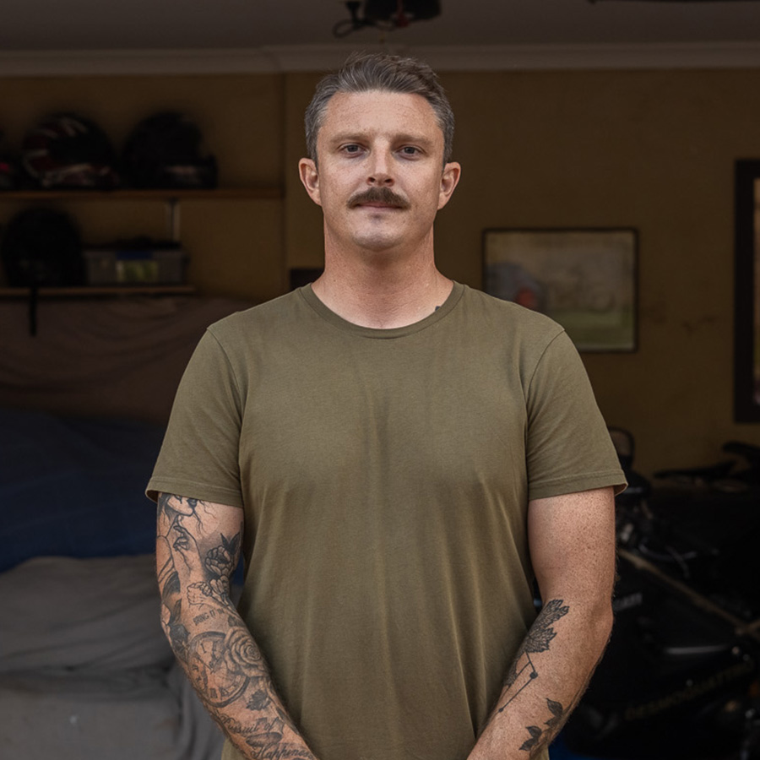 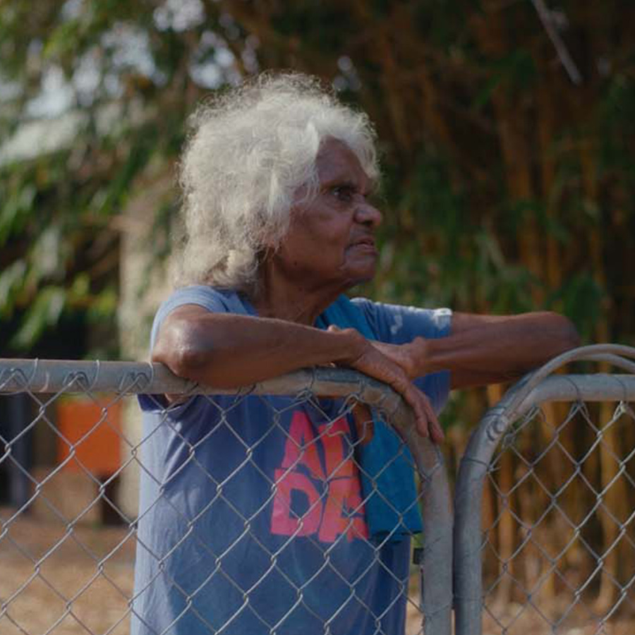

### Aboriginal and Torres Strait Islander peoples

We acknowledge Aboriginal and Torres Strait Islander peoples’ role in championing community-led responses to prevent alcohol harm in their communities.

We supported Darwin’s Bagot Community as it led a grassroots campaign that stopped Woolworths from building a Dan Murphy’s megastore on the doorstep of their dry community.

FARE will continue to work with Aboriginal and Torres Strait Islander peoples and organisations, collaborating in meaningful ways to place their health and wellbeing at the centre of programs and policy that’s tailored to their needs.

### The wider community

We will continue to be an engine room for current, reliable information around alcohol harm reduction, which will reach millions of Australians each year.

Our Every Moment Matters pregnancy campaign has made an astonishing impact on intentions and behaviours around pregnancy and breastfeeding.

More Australian mothers than ever know there is no safe number of drinks to be consumed during pregnancy, while the number of people abstaining from alcohol during a pregnancy has increased substantially.

FARE will also advocate on behalf of our communities on online sales and marketing of alcohol.

We will continue highlighting how children, young people and others at high risk are being targeted through relentless online advertising, while shining a light on how alcohol companies collect and misuse Australians’ social media data.

 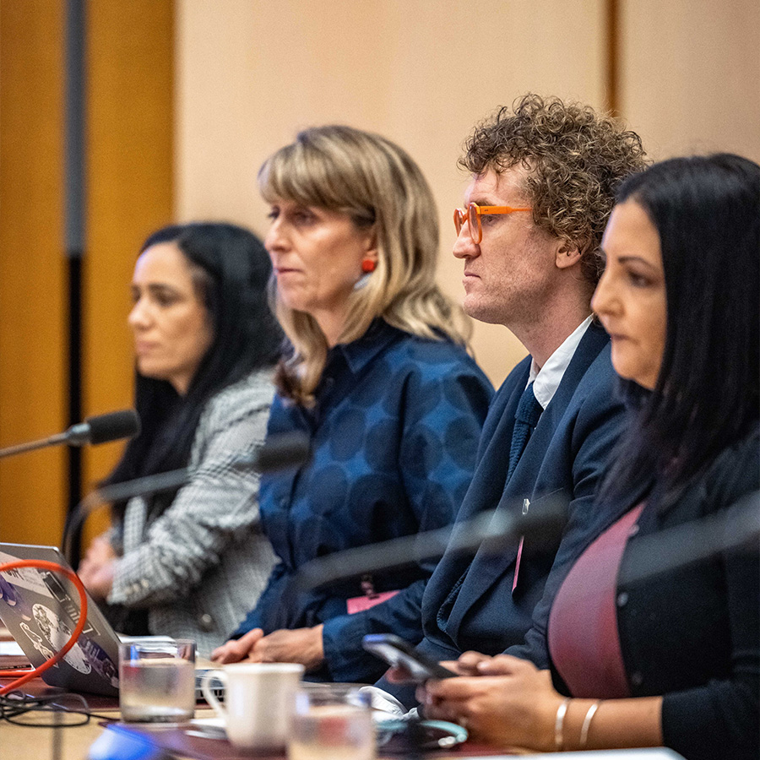

### Governments

FARE will continue to work alongside Governments to create effective change that reduces the risk of alcohol harm for our communities.

Some of that work will be geared toward the online space.

We are advocating for South Australia and the ACT that introduces some common-sense measures to drive down the harms caused by the rapid online sale and delivery of alcohol.

Meanwhile, we submit research-backed evidence to Governments during consultation processes for new policies and legislation reviews, that highlight the harms of how alcohol is marketed and sold to the community.

## A pathway to change

We can only produce meaningful change if we have conversations with people directly impacted by alcohol harm, and the values-aligned community organisations that support them.

From there, our approach to change follows this pathway:

We **engage** with people directly impacted by alcohol harm and values-aligned community organisations to understand the issues.

We **scan the environment** and analyse the evidence to inform our priorities.

We work collaboratively to **identify and prioritise** policies and programs that make the greatest impact to prevent and reduce harms and improve health and wellbeing.

We build, develop and support a **strong team and organisation** to achieve the change we are seeking.

We work collaboratively with people with lived experience of alcohol harm, communities and organisations to **develop, advocate for and implement** policies and programs.

We **evaluate** our impact and refine our approach based on what we learn.

## Our pillars of change

FARE’s strategic plan focuses on four key areas to address alcohol harm in our communities, and each impact different groups of Australians:

 System change

To reduce alcohol harm, communities need to be protected by good public policy.

FARE knows laws have struggled to maintain pace with new developments such as online sale and delivery, and the reckless digital marketing tactics used by alcohol companies.

Our community expects, and deserves, better. That’s where our research comes in.

Through advocating for Governments to implement evidence-based public health policy, we ensure decision makers have the information they need to pursue change that improves protections on digital platforms, betters health outcomes and minimises alcohol harm.

Close  Community awareness

Alcohol companies have spent millions of dollars promoting misinformation about their products.

Historically, this spending has obscured the community’s access to accurate and current information about the potential harms of alcohol.

We respond to this by providing evidence-informed health campaigns and valuable resources through traditional and digital channels that is upfront, honest and follows modern health guidelines.

By equipping people and Governments with tools to improve community awareness, we can raise awareness of harms and the wellbeing benefits of cutting back on alcohol.

Close  Capacity building

Our community should be have a say in laws, policies and programs that affect them.

For too long, the power wielded by alcohol companies and lobbyists has created an imbalance that places their vested interests above the welfare of all Australians.

So, FARE has established itself as a platform for people with lived experience of alcohol harm to advocate on behalf of everyone.

We work closely with communities disproportionately impacted by alcohol harm, including Aboriginal and Torres Strait Islander peoples.

By amplifying and supporting their voices, we can drive meaningful change.

Close  Corporate accountability

Big alcohol companies fuel alcohol harms every day.

For too long, the industry’s hidden impact on Australians’ lives has gone under the radar.

Just last year, we helped reveal gambling and alcohol industry lobbyists’ millions of dollars in donations to political parties.

Their lobbyists undermine our democracy by influencing key decision-makers, affecting policies that concern Australians’ health and wellbeing.

FARE is helping to shine a light on these insidious industry practices by:

* Highlighting when democracy is undermined
* Developing tools that track when democratic processes are subverted

Close

## Our Impact 2020-23

### Advocating for pregnancy warnings

Visible and effective pregnancy health warning labels were made mandatory on all alcoholic products in August 2023.

This was the direct result of years of advocacy by FARE, values-aligned community organisations, researchers and lived experience advocates who raise awareness of Fetal Alcohol Spectrum Disorder (FASD).

FARE researched attitudes to warning labels, audited the alcohol industry’s poor uptake of a voluntary labelling system, spread messaging on traditional and digital channels and encouraged thousands of Australians to sign an open letter to ensure the Government put the health and wellbeing of their community first.

[Learn more](https://fare.org.au/labelling-campaign/)

### Stopping Woolworths' Darwin alcohol megastore

FARE stood alongside Aunty Helen and Darwin’s Bagot Community for five years as they rallied against Woolworths’ plans for a Dan Murphy’s megastore.

We worked with health, community and Aboriginal organisations to platform the community’s stories of alcohol harm, took out full-page ads in national newspapers, and publicised petitions that received more than 155,000 signatures.

In 2021, Woolworths announced it would back down from its plans, showcasing how grassroots people power can drive tangible change.

[Learn more](https://fare.org.au/darwin/)

### Elevating community voices through Voices of Change

People with lived experience of alcohol harm have shared their stories through the Voices of Change project.

This initiative has helped foster meaningful conversations about alcohol and its impacts, while breaking down the stigma around alcohol and encouraging people to seek support.

We also act as an ‘engine room’, providing a platform for people to connect with media and key decision-makers, while amplifying their voice in the wider community.

[Learn more](https://fare.org.au/voicesofchange/)

### Raising Community Awareness through Every Moment Matters

The Every Moment Matters campaign takes a whole of community approach to raise awareness and change behavioural intentions about alcohol use during pregnancy and breastfeeding.

The campaign has been developed in collaboration with NOFASD Australia and the National Aboriginal Community Controlled Health Organisation (NACCHO).

In just two years, it’s had a seismic impact on raising awareness of the risks of alcohol use during pregnancy and safe breastfeeding practices and shaping intentions around alcohol.

The campaign video has been viewed more than 52 million times and more than half a million people have visited the campaign website.

Between October 2021 (a month prior to the campaign launch) and October 2023¹, there are significant changes in the proportion of Australians who:

* know there is no safe number of standard alcoholic drinks a pregnant woman can consume on any one day to avoid harm to the developing baby 73.3 per cent to 79.6 per cent
* know there is no safe type of alcohol that can be consumed during pregnancy 69.2 per cent to 73.2 per cent
* know there is no safe time to consume alcohol during pregnancy 67.5 per cent to 73.5 per cent

Between January 2022 (Wave 1 survey) and November 2023 (Wave 5 survey)² there has been:

* an increase in the proportion of women who would abstain from alcohol during pregnancy if they were to become pregnant from 82.6 per cent to 90.9 per cent.
* a decrease in the proportion of women who would consume at least some alcohol from 15 per cent to 9.7 per cent.

[Learn more](https://everymomentmatters.org.au/" \t "_blank)

1. The national pre- and post-campaign surveys were conducted via the Life in Australia™ panel to survey a nationally representative sample of the Australian adult population. The total post-campaign survey sample was N=5,075. This included n=1,959 respondents who completed the pre-campaign survey and n=3,116 ‘new’ respondents (i.e. those who did not complete the pre-campaign survey).
2. Data describes unpublished results of an external evaluation led by the University of Adelaide. The online surveys were conducted by Pure Profile in January 2022 (six weeks after campaign launch) and November 2023. Each survey included at least 800 Australians with equal representation from women who are pregnant/breastfeeding, trying/planning a pregnancy, women aged 18-44, and partners of women who are pregnant/breastfeeding/trying/planning. All changes are statistically significant (p<.01).

## Join our community

Will you join the community taking action on alcohol?