# State and territory governments are taking on alcohol marketing

|  |  |
| --- | --- |
| **Author** | Hannah Pierce |
| **Date** | 2020-01-23 09:30:00 |
| **Categories** | Policy |

### States and territories are beginning to address the negative impacts alcohol advertising has on young people

*“Kids shouldn’t be encouraged to drink on the way to class every day – that’s why we’re banning alcohol advertising near schools.”* These were [the words](https://www.premier.vic.gov.au/new-laws-to-protect-minors-from-alcohol-harm/) of Victorian Gaming and Liquor Regulation Minister Marlene Kairouz in March 2018 when she announced alcohol ads would be banned within 150m of all Victorian schools.

We heard [similar sentiments](https://www.mediastatements.wa.gov.au/Pages/McGowan/2018/06/End-in-sight-for-alcohol-advertising-on-public-transport.aspx) from Western Australian Health Minister Roger Cook in June 2018 when he announced alcohol ads would be removed from buses, trains, and train stations in WA: *“I am delighted this important ban has come into effect… Many young people use public transport and we need to reinforce the message that excessive alcohol consumption is dangerous.”*

Over the last few years, we’ve seen a number of state and territory governments announce restrictions on alcohol marketing. It appears the dominos are slowly falling – so much so that it has become difficult to keep track of which jurisdiction has announced what restrictions, and whether they were successful in implementing them.

Given all this activity, the Alcohol Programs Team at the Public Health Advocacy Institute of WA and the Foundation for Alcohol Research and Education decided to find out exactly what the situation is when it comes to restrictions on outdoor alcohol advertising in Australia.

We inquired with relevant ministerial offices, government departments, and non-government organisations in every jurisdiction to better understand what action has been taken. Our latest report, [*Outdoor alcohol advertising in Australia: Snapshot of the current state of play*](https://alcohol.phaiwa.org.au/assets/publications/reports/Outdoor-alcohol-advertising-in-Australia_Snapshot-report-FINAL.pdf), highlights that a number of state and territory governments have been busy addressing alcohol marketing.

[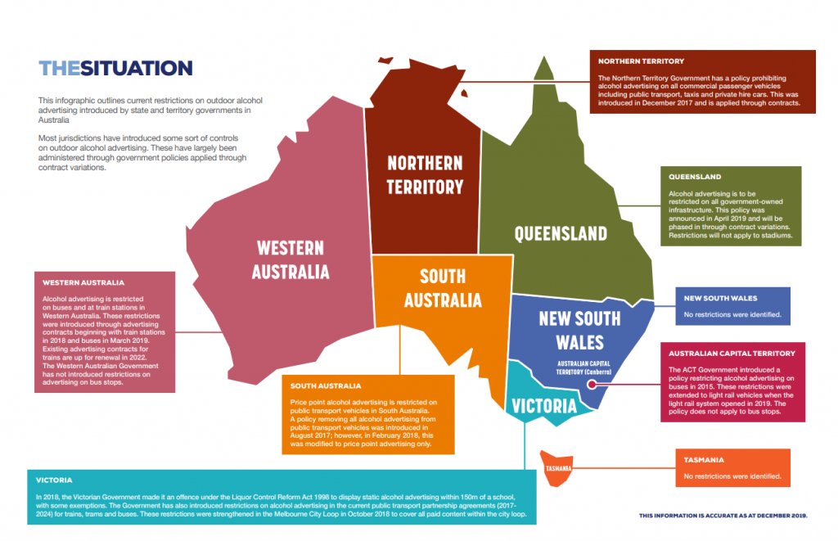](https://drinktank.org.au/wp-content/uploads/the-situation.png)

The ACT, Northern Territory, South Australian, Victorian, and Western Australian Governments have all introduced some sort of controls on outdoor alcohol advertising. These mostly restrict alcohol ads on public transport vehicles, and have largely been administered through government policies applied through contract variations.

The Queensland Government has announced plans to restrict alcohol advertising on all government-owned infrastructure. If introduced, it will be the state with the most comprehensive restrictions on outdoor alcohol advertising in Australia.

New South Wales and Tasmania were the only jurisdictions where no restrictions on outdoor advertising were identified.

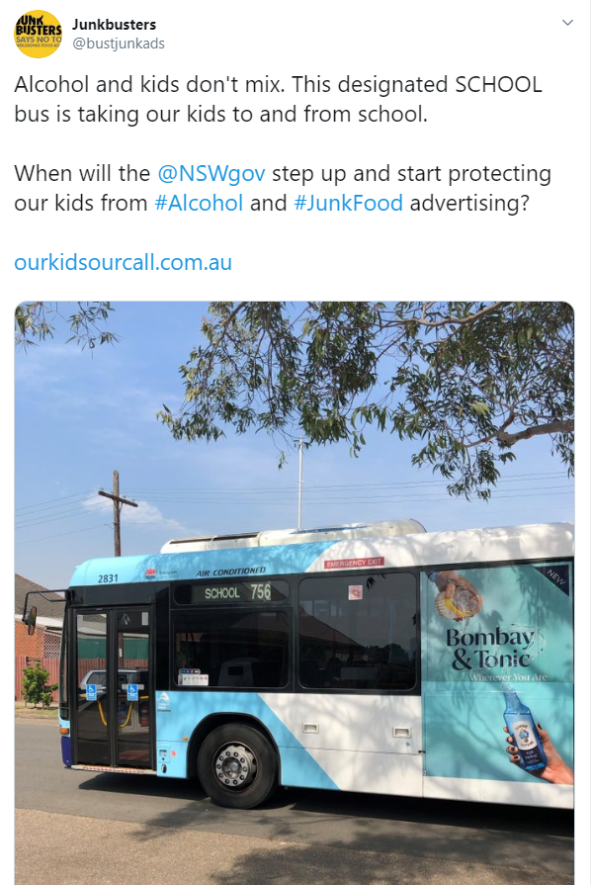

Image: Advertisement for Bombay Sapphire on a designated school bus in Willoughby, NSW. A complaint made to ABAC did not make it to panel review because it was deemed outside the scope of the ABAC Code, as placement rules only apply to fixed signs. Tweet by @bustjunkads 18 November 2019.

Our review is timely given the Federal Government has recently released the [National Alcohol Strategy 2019-2028](https://www.health.gov.au/resources/publications/national-alcohol-strategy-2019-2028). It was great to see the Strategy recognise the significant body of evidence demonstrating that alcohol advertising impacts on young people. What we are less enthusiastic about is the lack of direction the Strategy provides governments. While “Implement measures to reduce alcohol advertising exposure to young people (including online and sporting events)” is listed as a policy option with ‘Shared Responsibility’ between all levels of government, it is not clear in the Strategy what the next steps should be for those governments wanting to take action.

One area where strong leadership is needed is alcohol sponsorship of sport. Our review highlighted that no jurisdictions in Australia have introduced restrictions on alcohol marketing in sports stadiums. There has been a complete lack of movement from the Australian Government, despite sponsorship being a regulatory black hole. The industry’s self-regulatory system [specifically states it doesn’t cover sponsorship](https://www.abac.org.au/wp-content/uploads/2019/06/ABAC-Responsible-Alcohol-Marketing-Code-21-June-2019.pdf), and has been dismissing community concerns about alcohol sponsorship of sport [for years](https://www.abac.org.au/wp-content/uploads/2013/04/64-12-Final-Determination-Bundaberg-Rum-BWS-20-August-2012.pdf). This is hardly surprising, given the substantial conflicts of interest at play when the alcohol industry is permitted to regulate the marketing that helps reap eye-watering profits. The time has now come for all governments to prioritise the removal of alcohol sponsors in sport.

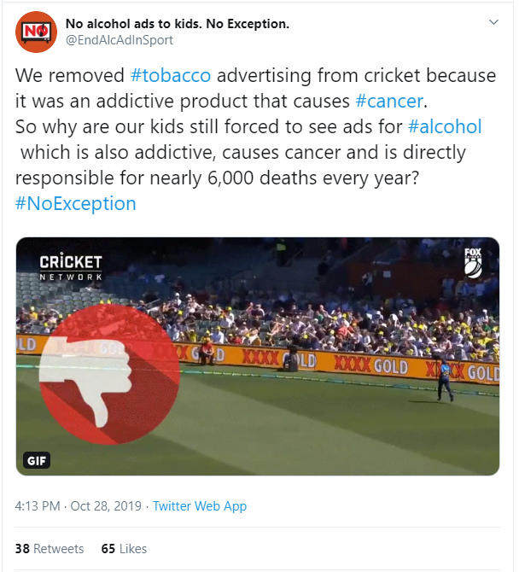

Image: Advertisement for XXXX Gold on banner signage at Adelaide Oval, 27 October 2018. A similar complaint regarding XXXX signage in the cricket grounds was dismissed in April 2018 as the ABAC Code does not apply to sponsorship. Tweet by @EndAlcAdInSport on 28 October 2019.

It is evident from our review of outdoor alcohol advertising that despite fierce opposition from the alcohol and advertising industries, state and territory governments are pulling their weight when it comes to regulating alcohol marketing. Given our new national strategy lists alcohol marketing regulation as a ‘shared responsibility’, it is time for the Australian Government to support our states and territories. It is time for the Australian Government to stop the current system of industry self-regulation, and work with the states and territories to introduce legislation removing alcohol advertising from all places where children and young people are exposed.

### Metadata