# Research shows how alcohol companies swamp social media feeds pushing sales, rapid delivery

When Alex Bagnara lost her friend Greg* last year to alcohol-related organ failure, she knew relentless online ads and the availability of rapid delivery had contributed to his death.

"Alcohol companies would often send my friend push notifications with special deals and reminders when he was in a really vulnerable state," Ms Bagnara said.

"[They would deliver him alcohol with little or no vetting](https://fare.org.au/alexs-story/). I am sure that there were times when he was sold alcohol online, while already intoxicated,"

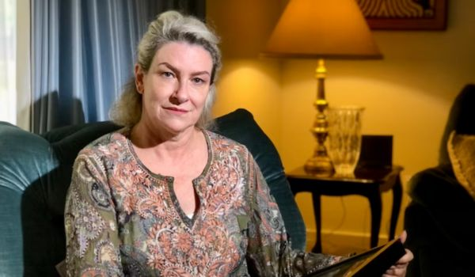

"More needs to be done to hold alcohol companies to a higher standard when it comes to marketing and selling alcohol online."

[New research conducted by the University of Queensland](http://fare.org.au/buy-now-button-report/), alongside Curtin, Monash and Queensland University of Technology, has found online alcohol ads have been inextricably linked to the sale and rapid delivery of these harmful products.

The study looked at almost 60,000 advertisements on Instagram and Facebook between October 2021 and June 2023.

The research revealed:

* More than 83% of the ads included a button encouraging people to engage with the ad.
* Almost 40% had a button directing people to an online platform where alcohol is sold.
* Of ads which had a ‘shop now’ button, almost 90% directly linked people to alcohol sale.
* Of ads which had a ‘learn more’ button, almost a quarter directly linked people to alcohol sale.
* Vinomofo, Vintage Cellars, and BWS published the highest number of alcohol ads with a button directly linking to sale.
* Nine alcohol retailers that sell alcohol through rapid delivery were responsible for 36% of all ads with a button linking to sale.

The rise of targeted online advertising has allowed alcohol companies to take advantage of these platforms as a virtual storefront, removing any gap between ads and the point of sale.

Urgent action is needed to address the unchecked expansion of alcohol delivery.

This includes limiting deliveries to before 10pm, introducing a two-hour safety pause between when an order is made and when alcohol is delivered, and ending predatory marketing tactics by removing buttons linking to sale and push notifications prompting purchases.

This report is a clear message to policymakers that legislation urgently needs to catch up with the invasive nature of digital alcohol ads.

We need modest, common-sense laws to address the increased access to alcohol that we know is causing increased harm in our communities.

[Read the full report](http://fare.org.au/buy-now-button-report/)