# 'You're not alone': How a decision to cut out alcohol supported Jo's mental health

***Content warning: this story contains references to death, mental ill health, and alcohol use.***

***If you need support, there is help available 24/7. You can contact*** [***Lifeline***](https://www.lifeline.org.au/) ***at 13 11 14 or*** [***13YARN***](https://www.13yarn.org.au/) ***at 13 92 76.***

My name is Jo, and I’m part of the amazing FARE team.

In the spirit of [Mental Health Month](https://www.un.org/en/healthy-workforce/files/WMHMCalendar.pdf), I wanted to share a bit about my personal experience with alcohol and mental health.

About two years ago I stopped drinking alcohol.

I’m very fortunate to have never been severely impacted by alcohol harm.

I’ve never been alcohol dependent, or needed alcohol to get by in social situations.

I stopped drinking because my mental and physical health was not great, and alcohol wasn’t helping.

There were many people who were doing it tough at this time, and I was fortunate to have a secure home and job and the support of my friends and family, which many people do not have.

Like many Australians, my husband and I juggled work and parenting responsibilities during the COVID-19 lockdowns.

We poured our energy into establishing a new routine inside the four walls of our small Canberra apartment with our bubbly then-six-year-old.

My husband couldn’t work much during this time, so he took charge of helping our son with his online schooling and homework, and looking after meals and household chores.

I set up my new “office space” in our bedroom, and learned very quickly how to best work with my team and colleagues in a remote environment.

My husband, son and I tried to stay focused on all the positive aspects of being together 24/7 and did all we could to prevent one of us from contracting or spreading COVID-19.

Another aspect of my daily life at this time was the responsibility of being the primary carer for my dad, who was terminally ill with cancer, and was rapidly deteriorating.

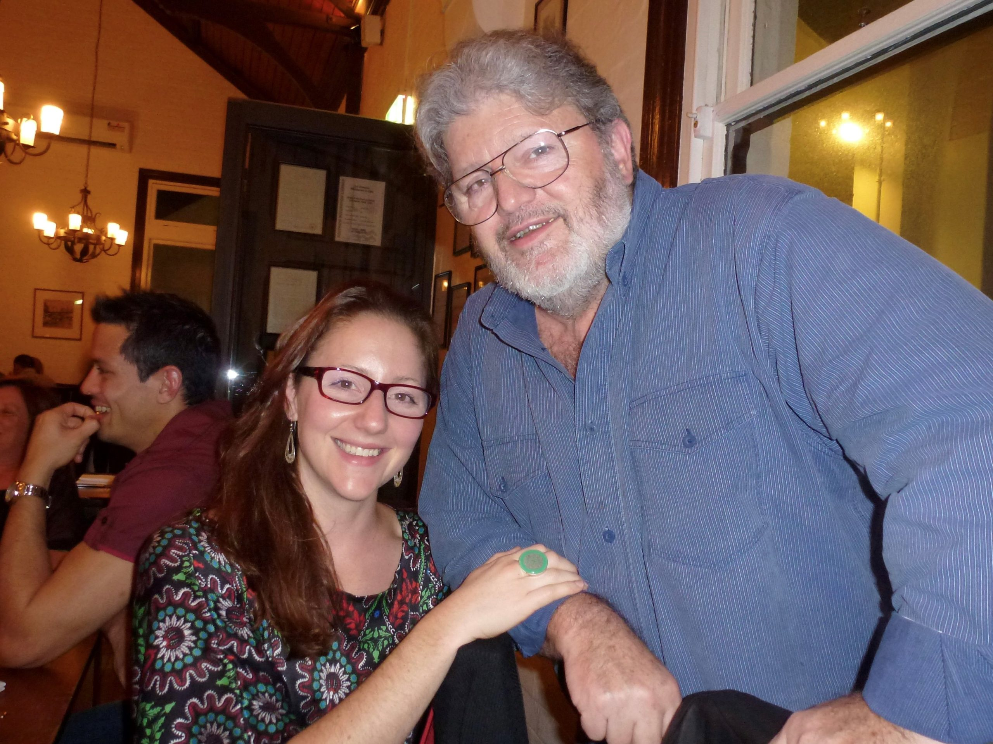

Jo and her father.

Caring for him was made more difficult by the travel restrictions which meant my family members who lived interstate often weren't able to be with us.

He was given an estimated life expectancy of 5-8 years, but sadly passed away within 12 months of his diagnosis.

After dad died, I continued to process my grief and the physical and emotional strain of caring for him while cancer took over his body and mind. I had been in fight or flight mode for about 18 months, and this took its toll.

I pride myself on being fairly resilient, capable and confident in most scenarios – but this situation was one I hadn’t experienced before, and I was struggling.

I had to do everything I could to help my healing and support my mental and physical health – and alcohol wasn’t helping.

Through my work with FARE over nearly 10 years, I learned the ins and outs of how alcohol has a negative impact on our physical and mental health.

So, I decided to cut it from my life.

For me, it was a relatively small change, but it felt good knowing I could do something to help myself.

I also sought support from a GP and psychologist, as well as shared how I was going with close friends and family.

I established a more regular, gentle exercise routine and mindfulness practice, and limited my social media use.

For some people, cutting back or cutting out alcohol is a straightforward process, and for others it’s incredibly tough.

If you’re worried about your alcohol use or someone else’s, it’s important to know you’re not alone.

FARE is one of many organisations that is here to help – we have accurate and [evidence-based information and resources](https://fare.org.au/resources/) about alcohol, and links to help you get support if you need it.

[FARE'S HEALTH RESOURCES](https://fare.org.au/resources/)