# Red Shoes Rock: Welcome to FASD Awareness Month

After last year’s massively successful campaign, the[Red Shoes Rock](https://redshoesrock.org.au/) team is back and ready to rock!

We’ve been working hard behind the scenes and are so excited to be launching FASD Awareness Month 2024. Together we are spreading the word and raising awareness about FASD (Fetal Alcohol Spectrum Disorder), the leading cause of non-genetic disability in Australia.

Did you know that for more than 20 years, the 9th hour on the 9th day of the 9th month – symbolising the 9 month period of gestation – has held special significance for millions (yep, millions) of individuals worldwide living with the consequences of prenatal alcohol exposure?

You may be surprised to learn that despite common misconceptions, not drinking any alcohol during pregnancy is best for the health of the mum and developing baby and yes, that includes from conception! Even low levels of exposure can be harmful to your baby’s developing brain and body.

FASD is deeply misunderstood and often misdiagnosed – FASD serves as a blanket term for a whole range of cognitive and physical challenges, as a result of the fetus being exposed to alcohol: Autism, ADHD, conduct disorder, developmental delay, learning disability, mental illness, auto-immune diseases, metabolic disorder, gastrointestinal issues, Dysautonomia, congenital heart defects, thyroid dysfunction, joint and skeletal abnormalities, hearing and vision impairments, chronic pain, sleep disorder. The list goes on and on.

Awareness along with the right diagnosis is critical to positive outcomes.

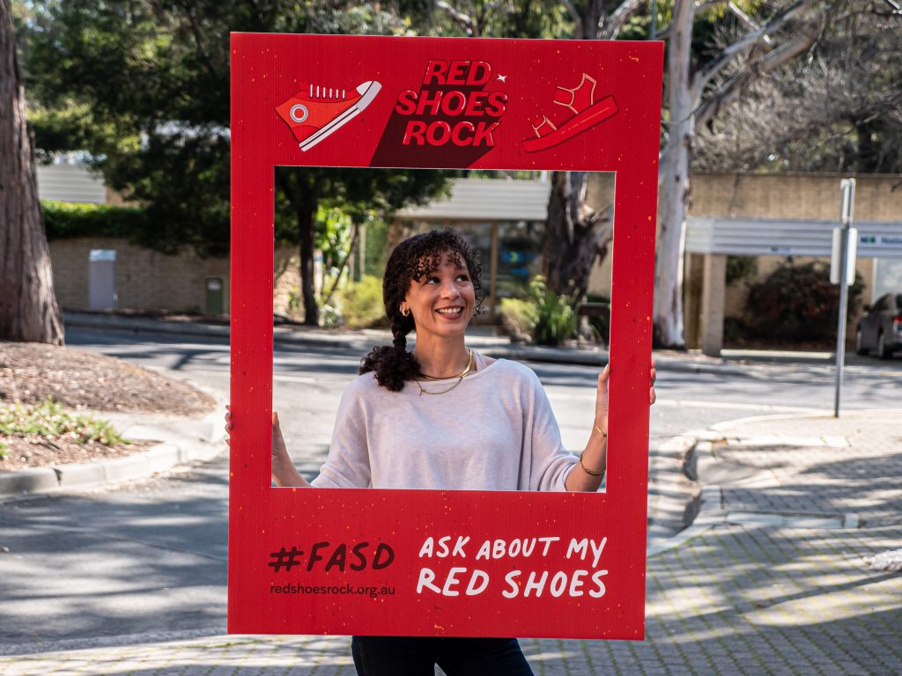

FASD does not discriminate between socio-economic classes or race. Around 60% of Australian women consume alcohol regularly, and around 60% of pregnancies are unplanned.

These numbers boggle the mind, but stigma deafens the ears of Australians, who often hang onto the belief that FASD “only happens to other people”. We know this is not the case.

Life is really tough for people with FASD, and it impacts every sector of Australian life. Without awareness and support, outcomes are poor, and the prognosis is often grim. The cost is severe, but it doesn’t have to be that way. We can do better, and we need to do better for all Australians

Throughout September organisations, healthcare workers, educators, parents/carers and individuals alike [put their red shoes on and come together to share vital information](https://redshoesrock.org.au/) to support families, empower women, promote alcohol-free pregnancies and drive prevention while advocating for much needed education, training, diagnostic clinics and support services.

Help us amplify the conversation and raise awareness of this hidden, permanent and lifelong disability. By wearing your red shoes (or socks) you can help us make what has long been an “invisible” disability, visible.

Check out the resource page on our website and be a part of this very important message: together we can support our communities to have healthy pregnancies and change outcomes for Australians living with FASD.

Let’s Rock!

[get involved in RED SHOES ROCK](https://redshoesrock.org.au/)