# Proposed changes to the Commercial TV Industry Code of Practice

# Help stop 800+ hours of alcohol ads from flooding our TV screens

Community, health and children’s organisations are warning of the disastrous impact of proposed changes to the Commercial TV Industry Code that could allow 800 hours of additional alcohol ads on television each year.

The Commercial Television Industry Code of Practice is overseen by the commercial television stations under the banner of “Free TV” and the Australian Communications and Media Authority (ACMA).

Free TV is proposing to change the Code to extend alcohol advertising on weekends, public holidays and during school holidays – plus continue to advertise alcohol during sports, when children are more likely to be watching.

Community organisations and advocates have submitted objections to the proposed changes citing concerns about the increased risk of harm to women and children.

https://www.youtube.com/watch?v=CySx6ZuUZ9o “I’ve worked in television for more than 40 years and understand deeply how television creates and reflects our culture. The TV industry which I've been part of for so long has a responsibility to our communities.” 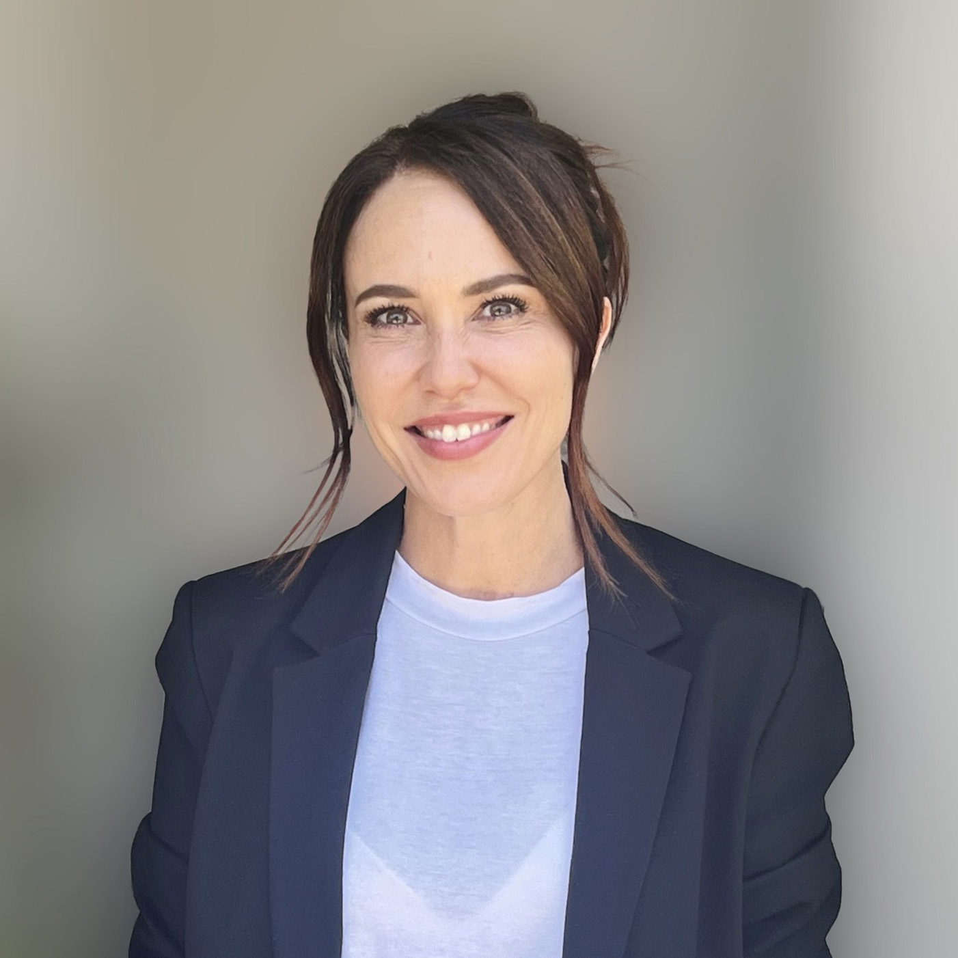 *Kym ValentineTelevision actor and Survivor Advocate* “Extending alcohol advertising hours prioritises short-term profit over the long-term health of Australian children.” 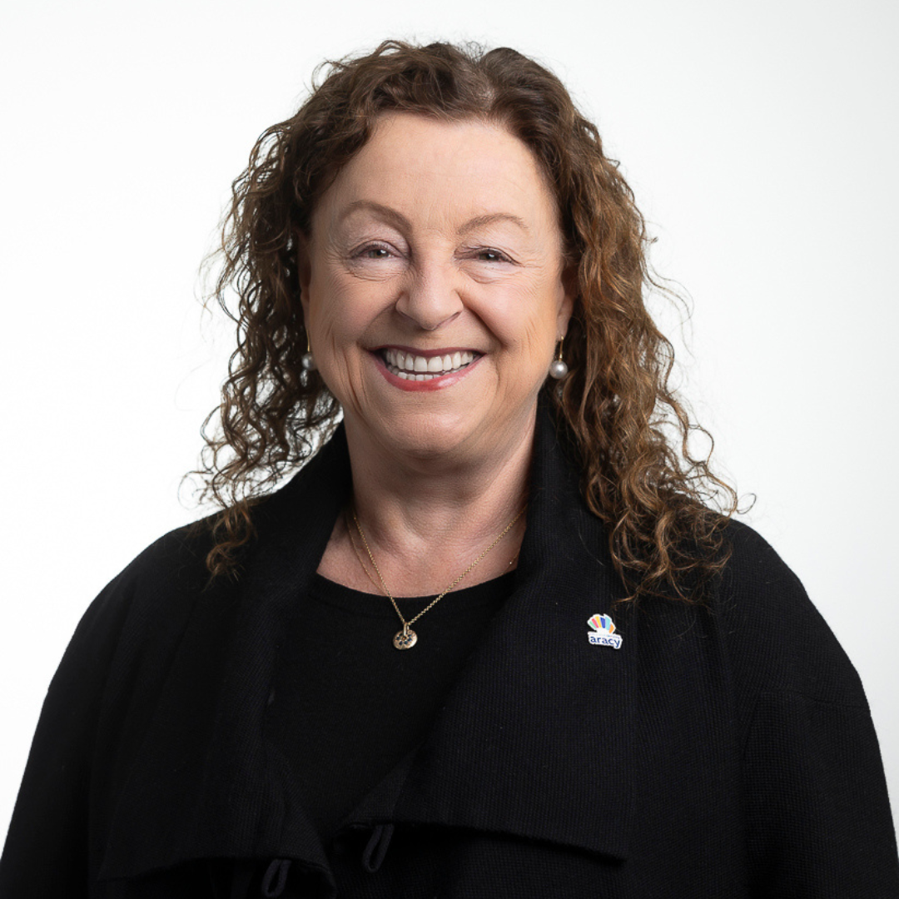 *Prue WarrilowChief Executive Officer, ARACY - Australian Research Alliance for Children and Youth* “We know that these changes will continue a trend towards commercial TV becoming a riskier place for children. Australian families deserve better.” 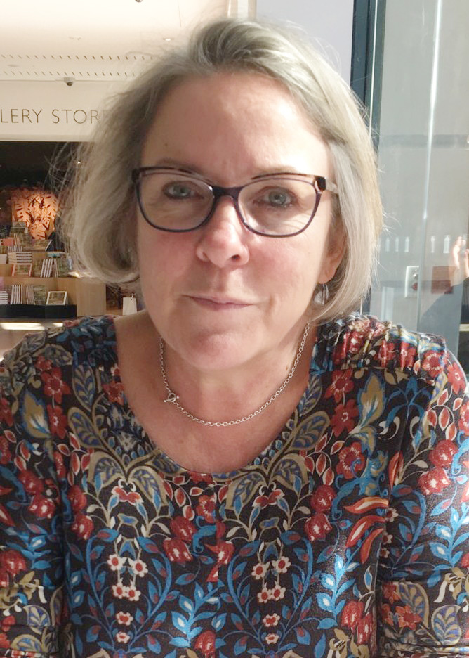 *Professor Elizabeth HandsleyPresident of Children & Media Australia*

## What is the government doing about it?

The Australian Communications and Media Authority – the independent Commonwealth statutory authority that regulates media – can intervene under the Broadcasting Services Act, if industry standards are not meeting community expectations.

In 2022 they developed a [policy paper](https://www.acma.gov.au/sites/default/files/2022-06/What%20audiences%20want%20-%20Audience%20expectations%20for%20content%20safeguards.pdf) on what audiences expect around content safeguards, and found “ongoing concerns that existing alcohol, gambling and junk food advertising restrictions do not go far enough, noting the nature of harms associated with gambling, alcohol and junk food consumption involve complex health and social issues.”

The Act states that broadcasting services should, “place a high priority on the protection of children from exposure to program material which may be harmful to them” and that industry codes “provide appropriate community safeguards”.

Under a self-policing system, this is clearly not happening. The rules around how alcohol is advertised should not be left to corporations that have their profits, and not community safety as their guiding star.

## What is the community saying?

According to our [latest polling](https://fare.org.au/poll-snapshot-australians-views-on-alcohol-advertising/), 90% of the community is concerned about the potential for more alcohol ads on television.

These concerns have been formally raised to Free TV by numerous organisations and individuals through their consultation process, however there is currently no public record of these submissions.

In the interests of transparency, we are sharing below the submissions we are aware have been lodged with Free TV. Want yours listed? Email us at [campaigns@fare.org.au](mailto:campaigns@fare.org.au).

### Submissions by organisations (click logo to open)

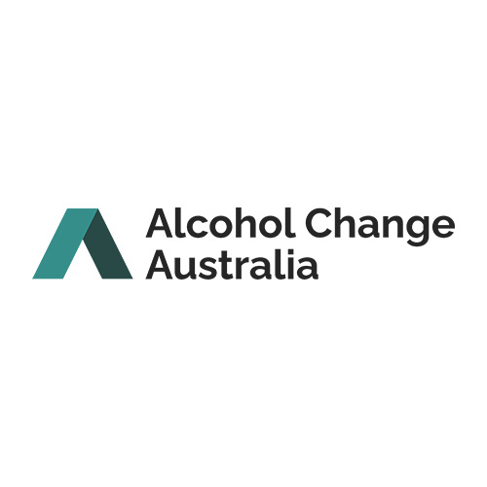 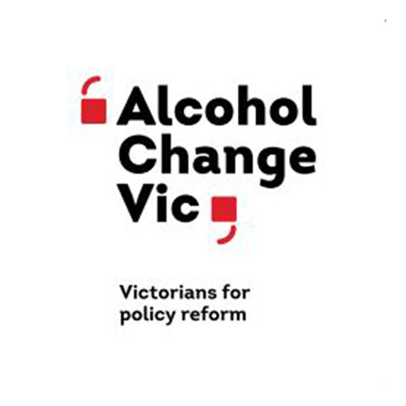 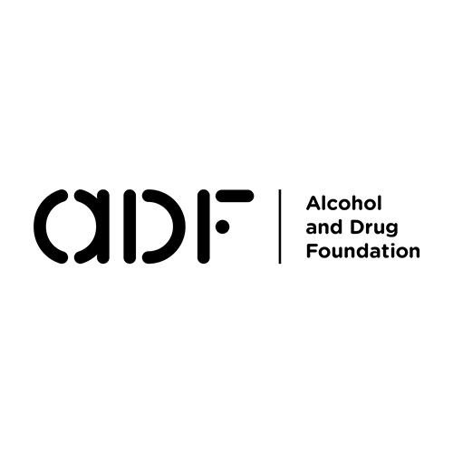 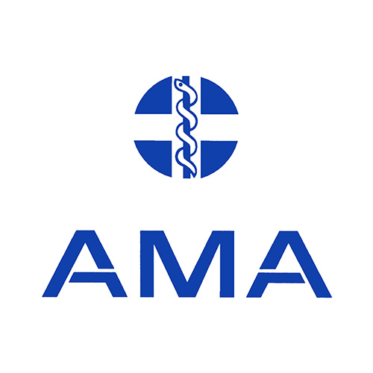 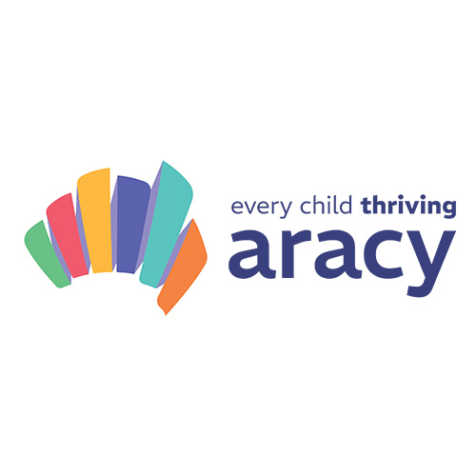 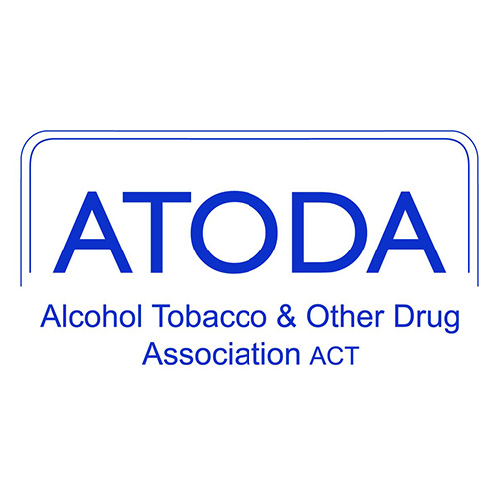 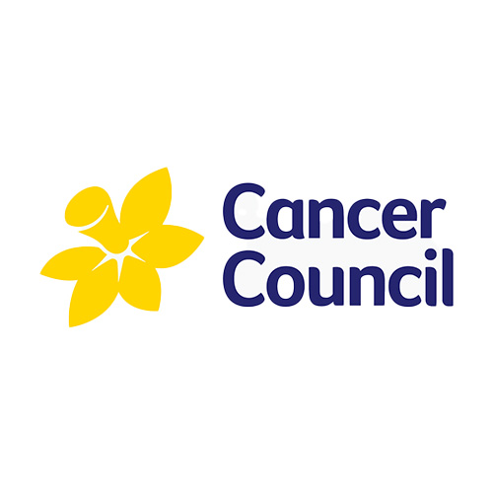 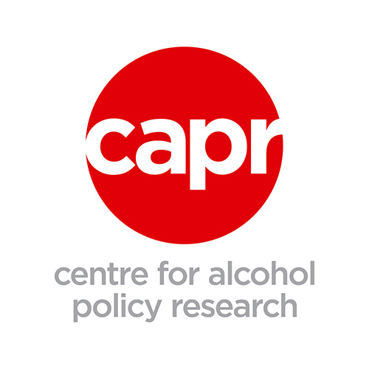 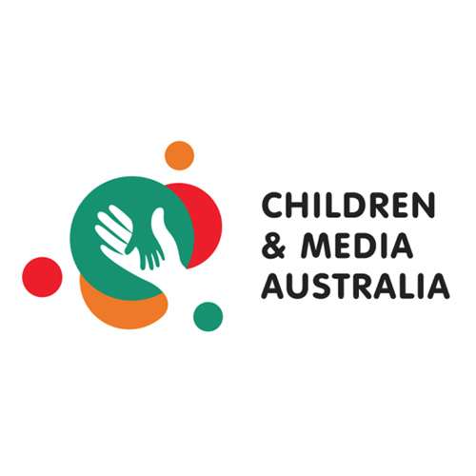 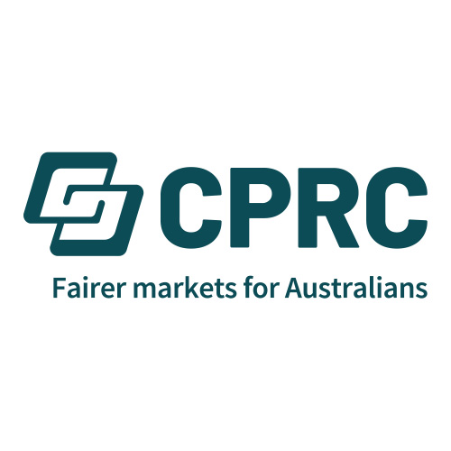 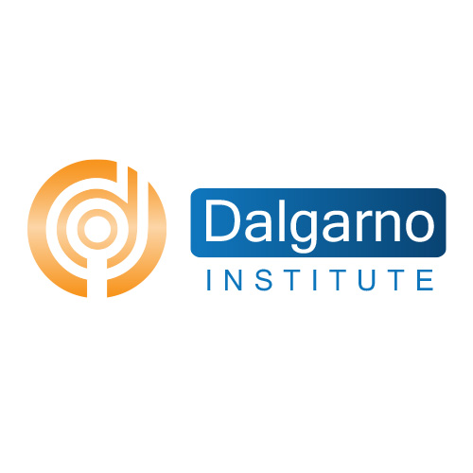 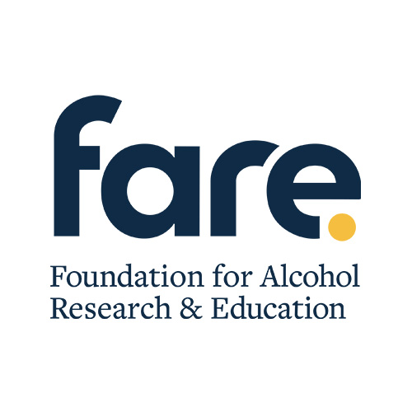 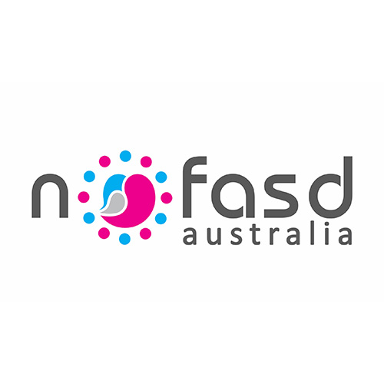 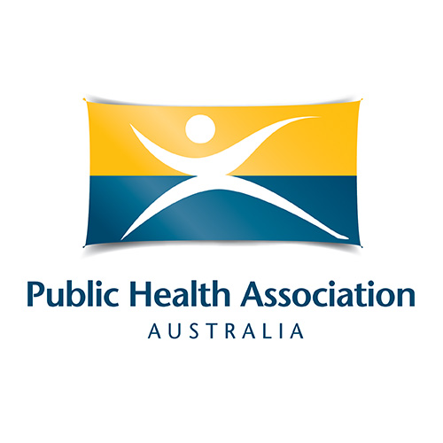 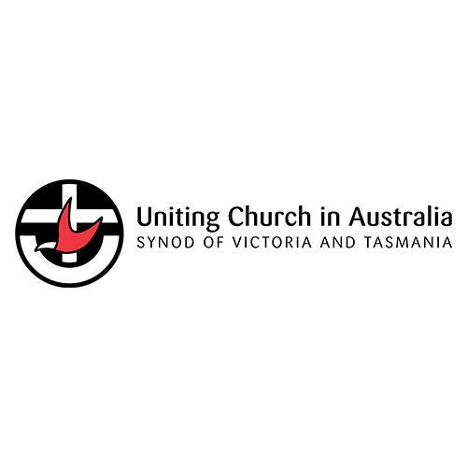 

### Submissions by individuals

[View Kym Valentine's submission](https://fare.org.au/wp-content/uploads/Submission-on-the-Free-TV-code-Kym-Valentine-1.pdf" \t "_blank) [View William Spaul's submission](https://fare.org.au/wp-content/uploads/W.Spaul-submission-4-1.pdf)

## Why does this matter?

The proposal by Free TV to extend alcohol advertising comes after the Australian Government’s [Rapid Review on accelerating action to end domestic, family and sexual violence](https://www.pmc.gov.au/sites/default/files/resource/download/unlocking-prevention-potential.pdf), recommended that “given the statistical increase in DFSV incidents during football grand finals, as well as the high number of children who watch sport on television and mobile apps, the Review recommends that alcohol advertising be restricted during sporting events”.

Research shows that [women and children are at higher risk of violence](https://fare.org.au/domestic-violence-surge-state-of-origin-game-leaves-women-and-children-battered-and-bruised/) during sports broadcasts and on public holidays, yet these broadcasters are proposing to increase alcohol advertising during these times.

We also know that significantly increasing children’s exposure to alcohol marketing is linked to [young people drinking at earlier ages and at riskier levels](https://pubmed.ncbi.nlm.nih.gov/27565582/).

The proposal by Free TV demonstrates they are out of step with community expectations and completely disregard the advice provided by the expert panel, which strongly urged the government to further restrict advertising.

## Campaign timeline

13 January 2025

A new survey finds 90 per cent of Australians are concerned by the industry proposal that could allow 800 hours of additional alcohol ads on TV each year.

#### [**New survey shows majority of Australians are concerned about industry proposal for more alcohol ads on TV**](https://fare.org.au/new-survey-shows-majority-of-australians-are-concerned-about-industry-proposal-for-more-alcohol-ads-on-tv/)

[Read the media release](https://fare.org.au/new-survey-shows-majority-of-australians-are-concerned-about-industry-proposal-for-more-alcohol-ads-on-tv/) 21 November 2024

Community, health and children’s organisations warn of the disastrous impact of proposed changes to the Commercial TV Industry Code, citing concerns about the increased risk of harm to women and children.

#### [**Community opposes industry plan to flood TV screens with more alcohol ads**](https://fare.org.au/community-opposes-code-changes/)

[Read the media release](https://fare.org.au/community-opposes-code-changes/) 5 November 2024

Senator David Pocock questions ACMA during Senate Estimates on alcohol ads during sporting events, when there is a documented increase in domestic and family violence incidents.

#### [**Commercial TV exploits loopholes to bombard children with alcohol ads**](https://www.instagram.com/p/DCP7abaI6Pw/)

[Watch the video](https://www.instagram.com/p/DCP7abaI6Pw/" \t "_blank) October 2024

ACMA states the proposed changes to the Code would likely cause concern among the community, given the changes would extend the times when alcohol advertising is allowed on TV.

[Read ACMA's statement](https://www.acma.gov.au/sites/default/files/2024-10/ACMA-views-on-Free-TV-code-review.pdf" \t "_blank) 30 September 2024

Free TV commences public consultation of proposed changes to the Code that could allow an extra 800 hours of alcohol ads on TV each year. Community organisations submit objections to the proposal.

#### [**Commercial Television Industry Code of Practice public consultation**](https://fare.org.au/commercial-television-industry-code-of-practice-public-consultation/)

[Read FARE's submission](https://fare.org.au/commercial-television-industry-code-of-practice-public-consultation/) March 2018

The Code is updated to incorporate new gambling advertising rules including restricting gambling ads in live sport during children’s viewing hours.

[See the current code](https://www.freetv.com.au/wp-content/uploads/2019/07/Free_TV_Commercial_Television_Industry_Code_of_Practice_2018.pdf" \t "_blank) April 2015

The Australian Communications and Media Authority (ACMA) review the Commercial Television Industry Code of Practice. Free TV and alcohol companies seek to allow more alcohol marketing on TV.

#### [**High price to pay: Free TV code will expose children to more alcohol advertising**](https://fare.org.au/submission-to-the-review-of-the-commercial-television-industry-code-of-practice/)

[Read FARE's submission](https://fare.org.au/submission-to-the-review-of-the-commercial-television-industry-code-of-practice/)