# Preventing harms from alcohol marketed and sold online

Everyone deserves to be safe when they go online to connect, stay informed and be entertained.

But as the ways we use digital technology have changed, alcohol companies have developed new approaches to marketing their harmful and addictive products online.

**These companies collect hundreds of data points on community members and use them to send highly targeted ads for their harmful and addictive products.**

We know that people who are trying to cut back or stop drinking alcohol often feel like they can’t escape this relentless alcohol marketing as they go about their daily lives. This can make it harder to prioritise their health and wellbeing.

Alcohol causes far too much harm to far too many Australians, including accidents, injuries, self-harm and family violence. It is also linked to health problems including cancers and cardiovascular disease.

By making alcohol more accessible at home – the most common place for people to use alcohol – online sale and delivery can increase the risk of alcohol harms.

A [FARE survey](https://fare.org.au/wp-content/uploads/ALCPOLL-2020.pdf) showed rapid delivery within two hours is associated with risky drinking – with 38 per cent of people drinking more than 11 standard drinks on the day of delivery.

[Australian Bureau of Statistics data](https://fare.org.au/alcohol-induced-deaths-in-australia/) shows alcohol-induced deaths in this country are at their highest rate in a decade.

The [latest data from the Australian Institue of Health and Welfare](https://fare.org.au/alcohol-is-harming-millions-of-australians-new-data-highlights-the-need-for-change/) shows more people are accessing treatment for alcohol and more people are being hospitalised because of alcohol. Alcohol-related hospitalisations, which peaked during the COVID-19 pandemic lockdowns, remain concerningly high when compared with pre-pandemic years.

## How has the digital environment changed the way alcohol is promoted?

Alcohol companies are rapidly adapting how they market their harmful and addictive products, but laws across Australia haven’t kept pace with how these companies do business.

**More Australians are harmed by alcohol because of the digital environment** and the absence of measures to hold alcohol companies accountable and prevent harm.

These companies are generating more than $2 billion a year from sales of alcohol products online, a figure which has doubled in five years.

The biggest alcohol retailer in Australia, Endeavour Group, recently invested $74 million into its online digital capability, EndeavourX, in a bid to adopt the same approach to marketing its harmful products as platforms like Netflix and Spotify.

That means collecting extensive, personal information to target people with hyper-focused marketing to determine what they want next.



[When most of these targeted ads contain a button](https://fare.org.au/alcohol-companies-ply-community-with-40000-alcohol-advertisements-a-year-on-facebook-and-instagram/) directing people to buy or find out how to buy, such as a ‘shop now’ button, we are in a **digital environment where every phone has become a bottle shop.**

Alcohol companies sell more than half of all alcohol products to 10% of people, and 36% of alcohol products to 5% of people.

With this intensive data collection and the pandemic which pushed everyone online, alcohol companies have been able to target the 5%, which we believe is one reason alcohol harms are increasing.

When companies use this data to micro-target people, it can cost people their lives. Alex Bagnara’s friend died last year at the age of 46 from alcohol-related organ failure, after alcohol companies sold and delivered him alcohol online. Alex is calling for better controls to protect people who are most at risk.

“I know there would have been many occasions when my friend may not have been sold alcohol if he had had to go to a bar or a bottle shop, but companies could keep delivering endless amounts of alcohol to his home,” Alex said.

## Strong community support for common-sense measures to reduce harm

There are several measures state and territory governments can implement to reduce alcohol harms.

**Guardrails are a vital part of reducing harms from alcohol.** When it comes to [online sale and rapid delivery](https://fare.org.au/policy/online-sale-and-delivery/), there is no separation between advertising and the point of sale.

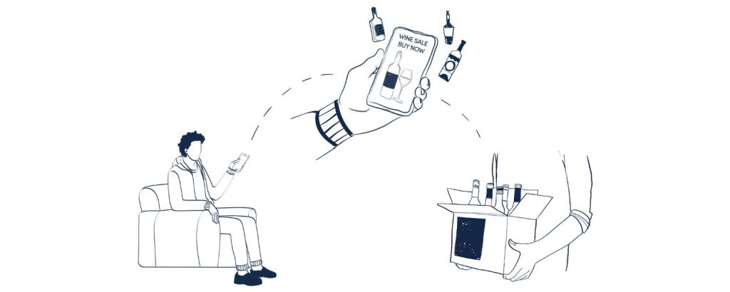

We can introduce highly effective guardrails including:

* A 2-hour safety pause between order and delivery, for alcohol-only orders, to prevent the rapid delivery of alcohol into homes;
* Keep deliveries to between 10am and 10pm, to reduce the risks of alcohol-related family violence and suicide, which increase later at night in the home;
* Effective digital age verification for online sales of alcohol to ensure alcohol isn’t sold to children;
* ID checks on delivery of alcohol delivery to ensure alcohol isn’t supplied to children or intoxicated people;
* Address predatory, data-driven push marketing to protect people’s health and privacy;
* Support delivery staff with delivery-specific training, not penalising them for non-delivery, and making delivery companies liable for non-compliance.

[Polling across the ACT](https://fare.org.au/online-sale-and-delivery-of-alcohol-in-the-act/), [South Australia](https://fare.org.au/poll-snapshot-online-sale-and-delivery-of-alcohol-in-south-australia/) and [Queensland](https://fare.org.au/poll-snapshot-online-sale-and-delivery-of-alcohol-in-queensland/) found strong support for these common-sense measures to reduce harm, and these states and territories are considering reforms. These changes can go a long way to ensuring our community can spend time online while keeping healthy and well.

It is important decision makers listen to community members when making decisions that affect their health and wellbeing. By making these changes, alcohol harms can be reduced.