# Pregnant Pause

# Community of heroes supporting mums-to-be to go alcohol-free

## What was the issue?

**“I feel those mixed messages, and it all comes from a beautiful place, but every single woman and support person has a different experience when it comes to pregnancy. And they want to share because they love you, but those messages aren’t always in line with the drinking guidelines.”**

Pregnant Pause ambassador and Canberra radio personality Kristen Davidson knows that when it comes to pregnancy, there are a lot of mixed messages coming from the community.

While some of these pieces of advice are harmless, misinformation can lead to confusion and a lack of support for alcohol-free pregnancies.

With the help of the ACT Government’s Health Promotion Grants Program, the Foundation for Alcohol Research and Education (FARE) has delivered the Pregnant Pause project to the Canberra community for seven years, with the ultimate goal of supporting women who are pregnant to go alcohol-free.

In its most recent iteration, Pregnant Pause: Community Heroes, FARE focused its efforts on broadening community awareness of messaging around alcohol and pregnancy to ensure women are properly supported in their decision to go alcohol-free.

## Why did it matter?

Alcohol consumption during pregnancy can lead to miscarriage, stillbirth, premature birth and low birth weight. It is also the cause of Fetal Alcohol Spectrum Disorder (FASD), lifelong disability that can result in significant cognitive, behavioural, health and learning difficulties.

Despite this, mixed messages being shared within the community means the official [advice](https://www.health.gov.au/health-topics/alcohol/about-alcohol/how-much-alcohol-is-safe-to-drink) – that women who are pregnant or planning pregnancy should not drink alcohol – is not properly understood.

A baseline survey undertaken by FARE showed there was low awareness of the conditions associated with alcohol use during pregnancy (stillbirth, miscarriage and low birth weight) among adults in the ACT.

Experiencing her first pregnancy throughout the duration of the rollout of the Community Heroes project, Kristen said she understood the need to cut through community confusion around alcohol and pregnancy.

***“I’ve been an ambassador for Pregnant Pause for a while now and I have always understood it, but now being a mum for the very first time this year, I get it, I feel it.”***

https://vimeo.com/588706463

## What did we aim to do?

Through Pregnant Pause: Community Heroes, the project turned its attention beyond the program’s well-established community of expecting parents and their families and friends. Instead, it focused on spreading awareness throughout the community that there is no safe amount, no safe type, and no safe time during pregnancy to drink alcohol.

By reaching out to Canberra-based businesses and organisations, the project aimed to create a community of support for women who are pregnant by sharing correct health messages and meeting expecting parents where they are – in their community.

Community Hero and small business owner Rita Chanis agrees a supportive community can make all the difference to someone’s pregnancy experience.

**“All mums-to-be need the biggest support network they can get, and that’s what Pregnant Pause can give. We joined because [we’re] about supporting parents to take the next steps into a whole new world, hand-in-hand,”** she said.

The project recruited for Community Hero participants through targeted social media posts, as well as by reaching out to existing FARE contacts and stakeholders, third-party endorsements through community groups, and through targeted local publications.

Official Community Heroes featured in a range of content that promoted their involvement in the Program, which was then re-shared on Pregnant Pause social media channels.

Upon taking the Pregnant Pause Community Hero pledge, businesses and organisations were provided with a suite of digital and hard copy materials to amplify the project’s key messages, display Pregnant Pause merchandise, and help establish the Pregnant Pause “village”.

Reflecting on the importance of the motherhood “village”, local business owner and Canberra mum Robyn-Leigh Gordon joined a line-up of panellists for the *Pregnant Pause Community Heroes: Meet the Village* event which saw over 50 Community Heroes, expectant parents and new mothers come together to celebrate the project.

**“New motherhood can feel like you’re throwing yourself from a plane at 30,000 feet – without a parachute! Terrifying, but also an adrenaline rush… Know what I mean?**

[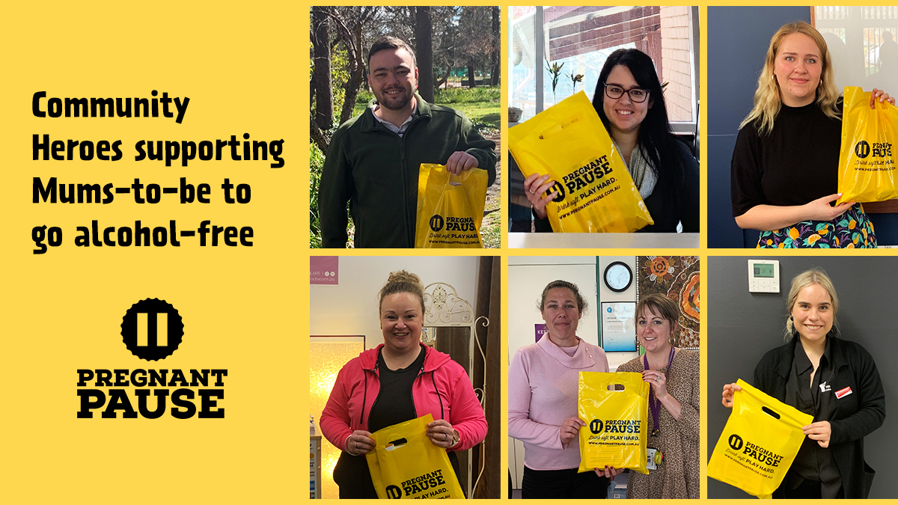](https://fare.org.au/wp-content/uploads/PP-2021-community-heroes-old.jpg) [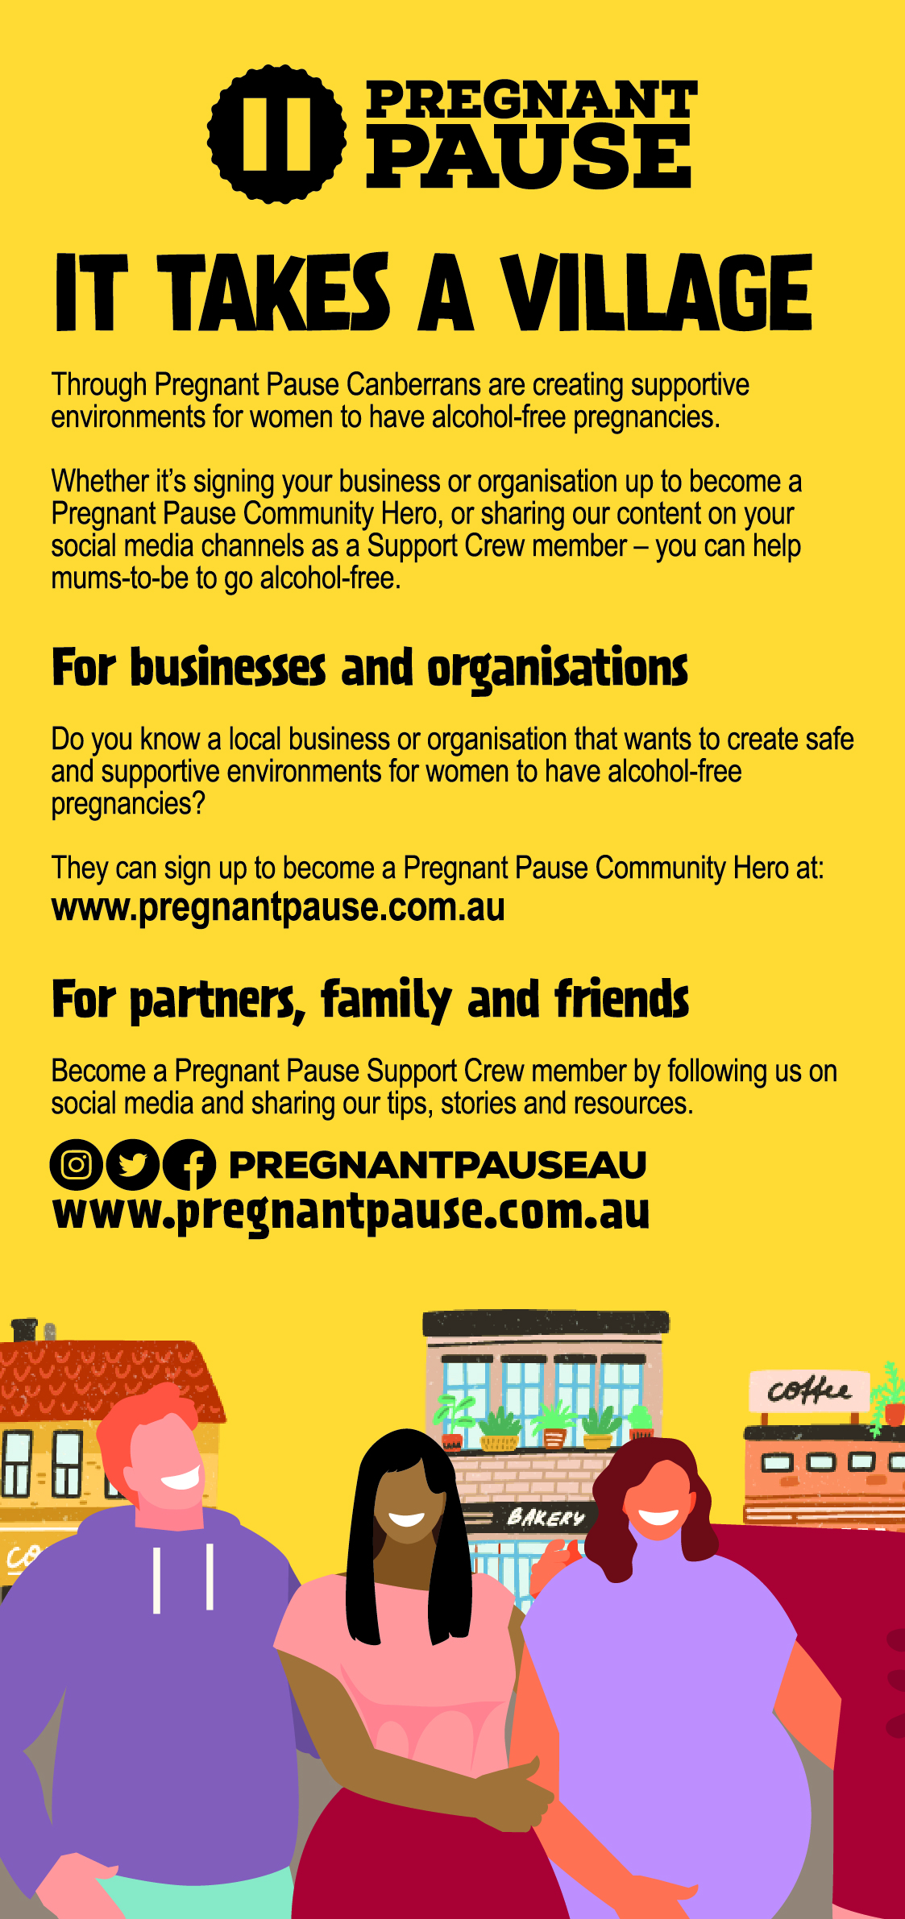](https://fare.org.au/wp-content/uploads/DL-FRONT.jpg)

## What did we achieve?

Throughout the duration of the project (June 2020-June 2021), Pregnant Pause recruited 26 Canberra businesses and organisations as official Community Heroes. These included service providers, gyms, cafes, community organisations, not-for-profits and bespoke businesses. With the help of these organisations, the Program reached more than 720,000 social media users on Pregnant Pause social media platforms.

The project also engaged two local publications: *Her Canberra*, which has a high following of professional women; and *Canberra Mums*, known locally as a trusted source of conversations and discussion around pregnancy and motherhood. These partnerships enhanced the promotion the project and its messages to a wider audience. More than 55,000 local women saw content relating to the program on the *Canberra Mums* Facebook page, meanwhile content created for *Her Canberra’s* electronic direct mail (EDM) achieved nearly 10,000 unique opens.

Pregnant Pause’s own Instagram followers grew by 23 per cent and website performance showed that pageviews were stable throughout the project (over 1,000 per month). These combined figures show that the project’s messages resonated with the target audiences and that information distribution and recruitment via digital media is effective in reaching the relevant audience.

Key learnings from the Pregnant Pause Community Heroes program will help inform community engagement opportunities on larger-scale alcohol and pregnancy projects, such as for FARE’s National FASD awareness program set to in November 2021.

https://vimeo.com/512381146