# Poll snapshot: Pregnancy health warning on alcoholic products

We all want our families to have access to clear information about the health and safety of the products they buy – especially products that may harm our children. However, in Australia, alcoholic products have never been legally required to carry a health warning about the risks alcohol can cause during pregnancy including miscarriage, stillbirth, low birth weight, pre-term birth and Fetal Alcohol Spectrum Disorder (FASD). This is changing.

From 31 July 2023, alcoholic products sold in Australia will be required by law to display a visible pregnancy health warning. The evidence-based label was carefully designed to have high visibility and impact, in order to increase Australians’ awareness of the risks of drinking alcohol while pregnant.

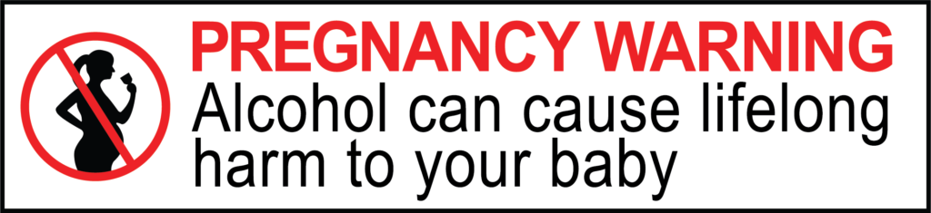

Image: Visible pregnancy health warning required to be displayed on alcoholic products from 31st July 2023.

Since the decision in July 2020 for these warnings to be mandated, they have been appearing on alcoholic products. In June 2023, FARE commissioned a poll of 1,004 Australians asking whether they recalled whether they have seen the pregnancy health warning on alcoholic products. We found:

* Just over half of Australians (56.4%) reported that they have seen the pregnancy health warning on alcoholic products.
* People were more likely to recall seeing the warning if they had an alcoholic drink in the last 12 months (59.2%), than if they had not (38.2%).
* Recall of the pregnancy health warning was highest among people aged 18-25 years (79.1%) and 26-41 years (72.9%).

[read the report](https://fare.org.au/wp-content/uploads/Pregnancy-health-warning-poll-snapshot.pdf)