# One year on: Celebrating a monumental community victory in the Northern Territory

|  |  |
| --- | --- |
| **Author** | Editorial |
| **Date** | 2022-04-29 08:00:00 |
| **Categories** | Community stories |

### Today we celebrate the first anniversary of the community victory against Woolworths and their plan to build an alcohol store outside dry Aboriginal communities in Darwin.

**Today we celebrate the first anniversary of the community victory against Woolworths and their plan to build an alcohol store outside dry Aboriginal communities in Darwin.**

Isn’t it inspiring to watch local communities stand up for themselves and fight for what is right?

But what is more inspiring is witnessing these communities take on multi-million-dollar corporations and emerge victors.

Let us relive the powerful victory as communities and health groups in the Northern Territory (NT) successfully stopped Woolworths from building an alcohol megastore in Darwin.

After a five-year-long battle, in April 2021, communities in the NT won a massive victory when they pushed aside Woolworths and their plans to build an alcohol megastore in Darwin at the doorstep of dry Aboriginal communities.

FARE was honoured to stand shoulder-to-shoulder and work with health and community advocates, such as Aunty Helen Fejo-Frith from the Bagot community, Danila Dilba Health Service, Aboriginal Medical Services Alliance NT (AMSANT), and the Northern Territory Council of Social Service (NTCOSS).

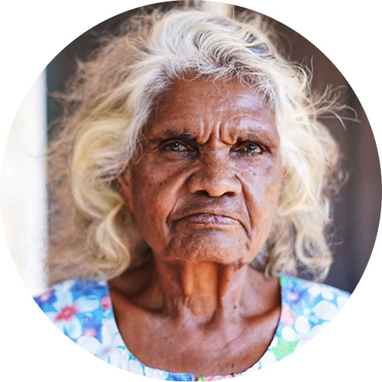

“My father used to say, 'If you know something's not right, go and do something about it'... we need to keep going back until we get results. And that's what we did.”

*Helen Fejo-Frith, Bagot Community*

The decision not to proceed with the alcohol megastore came after years of indifference and a lack of empathy for community concerns from one of the nation’s biggest corporations.

The NT has the highest rates of alcohol harm in the country. Over many years, health and community organisations have banded together to address this issue. The positive changes led by the local community in reducing alcohol harms were working. But Woolworths ignored all that good change.

They proceeded with plans to build an alcohol megastore despite strong community opposition and despite the NT’s independent liquor licencing agency rejecting their applications. They did not take ‘No’ for an answer and continued pushing for this store in the face of community opposition and concern.

But this did not stop the communities from fighting back.

During this long campaigning period, FARE helped the community fight back by writing to Woolworths, publishing open letters in newspapers and asking tough questions at their annual general meeting.

People from all over the country helped amplify the campaign to stop the megastore. More than 155,000 people signed petitions and shared content on social media. Together we made sure that Woolworths and Dan Murphy’s felt the public pressure and listened to what the communities had to say.

In April 2021, a review by Danny Gilbert and his panel found that the development of the alcohol megastore should not proceed because local communities, including Aboriginal and Torres Strait Islander groups, had not been adequately consulted.

Woolworths conceded.

If this campaign showed us anything, it was that even when the odds are against us and victory seems distant, community power can create change.

By working together, drawing on our strengths and persevering in the face of corporate power and influence, we successfully challenged big business as a community. ([To read the complete history of this campaign, click her](https://fare.org.au/darwin)e.)

https://www.youtube.com/watch?v=Fi9GoWRCGEc&ab_channel=FAREAustralia

Hear the Bagot community express why the now-abandoned Woolworths alcohol megastore in Darwin would have been harmful to their families and communities.

So, where do we go from here?

It is clear that corporations across Australia must do better to consider and respect community views.

This involves having meaningful conversations with communities every step of the way, listening to what they have to say and taking it on board – not just hearing it and noting it down.



“We don’t want any other community to go through this. And it did not need to happen the way it did, with the financial cost to Aboriginal organisations and the emotional burden borne by the Aboriginal leaders in Darwin.”

*John Paterson, CEO AMSANT, at Inquiry into how the corporate sector establishes models of best practice to foster better engagement with Aboriginal and Torres Strait Islander consumers.*

While there may still be a long way to go, moments like successfully taking on Woolworths never fail to inspire us.

This powerful story is for the ages.

Therefore, on this first anniversary, let us acknowledge the true might of people power and that real-world change is possible when people come together as one.

### Metadata