# Why Oliver is fed up with "intrusive" alcohol advertising

***Content warning:****This story contains references to alcohol use and other sensitive issues.*

I choose not to drink because me and alcohol, we aren’t good.

It was 2019 when I stopped drinking. I actually met this one guy who didn’t drink and realised that I’d never thought of not drinking. There were just so many heavy drinkers around me growing up.

I’m 36 now but when I was younger and I'd go out, the idea was to get disgustingly smashed. I’d never seen anything different. The message is, ‘this is just what you do’.

Alcohol ads might say, “drink responsibly”, but no-one actually takes that seriously.

Alcohol is part of any occasion: it’s after work, it’s Friday, it’s the weekend, or someone is coming to visit, or we’re celebrating something – anything that is good, there's always alcohol.

I find alcohol advertising very intrusive. It’s everywhere, and it’s not just billboards, [it follows me into my home through my phone](https://fare.org.au/facebook-alcohol-and-gambling-companies-target-ads-at-australians-most-at-risk-of-harm/?utm_content=linkstream_stream&utm_source=storystream). When I’m just trying to look at things – like I’m on Facebook Marketplace a lot – it even follows me there.

With sports it’s on the players, on the field, on the barriers, on the ads and it’s so normalised. I saw an ad for Melbourne Cup recently and it was just a photo of a whole bunch of people drinking in a bar.

I’m not saying people shouldn’t drink, I couldn’t care if people do or not, and I do see people can drink in moderation - but I'm not one of those people.

So the fact I’m being force-fed alcohol ads everywhere is really frustrating, and there’s no opt out.

As I’ve observed more people drinking less or even quitting, I’ve noticed a substantial increase in alcohol advertising. I believe there should be stricter [regulation of alcohol advertising](https://fare.org.au/alcohol-marketing-online/), bringing it in line with other Group 1 carcinogens, such as cigarettes.

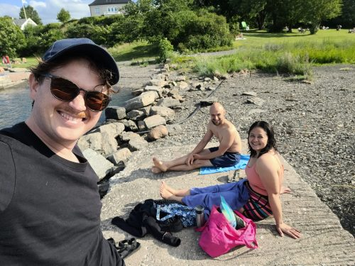

*Oliver spending time with friends on holiday*

When I stopped drinking it wasn’t because I was an alcoholic, by Australian standards I probably didn’t drink a lot.

For me, I thought I needed it to socialise. But alcohol had a negative impact on my behaviour, and I just did a lot of stupid things, which often resulted in me injuring myself.

The negative effects weren’t worth it - the hangovers were terrible, I didn’t sleep well and of course there’s other health reasons too, like alcohol’s link to cancer.

I have since discovered that I don’t actually have to drink to spend time with people and have a good time.

I’ve made my decision and some people find it very strange, but these days I’d rather go to bed earlier and get up and enjoy the next day, rather than feel like rubbish on the days I don’t have to work.

I wanted to share my story as there may be others who, like me, haven’t ever really considered their relationship with alcohol and whether the costs are truly worth it.

My point is that the world won’t end if you don’t drink; you don’t need to be an alcoholic to quit. In my experience, people eventually accept it, and you spend less money, feel better, sleep better, and have a clearer mind.

*If you have experiences to share that can help people know they’re not alone, please share your story through our*[***Voices of Change project.***](https://fare.org.au/voicesofchange/)