# NT on track keeping Territorians safe and well

|  |  |
| --- | --- |
| **Author** | Michael Thorn |
| **Date** | 2019-10-22 15:12:25 |
| **Categories** | Health |

### The NT community’s action to reduce alcohol-fuelled harm is saving individual lives and improving people’s health and wellbeing.

As the Northern Territory (NT) marks the one-year anniversary of the floor price on alcohol, it is also important to acknowledge - and never forget - that the community’s action to reduce alcohol-fuelled harm is saving individual lives and improving people’s health and wellbeing.

Alcohol harm has long been considered the biggest problem facing the Territory, which for many years has had the highest consumption rate in the country – 173 per cent of the national average. And in response, the NT Government introduced a comprehensive program of alcohol reform from 2018, including the Minimum Unit Price (MUP) which puts a floor on how cheaply alcohol can be sold.

The Government is now in the final stages of concluding the NT’s alcohol strategy, which includes many of the 200-plus recommendations of the *Review of alcohol policies and legislation* (the Riley Review) headed by former Chief Justice Trevor Riley. The introduction of the *Liquor Act 2019* (the Act) on 1 October this year, just 20 months later, saw more than 75 per cent of the Riley Review recommendations implemented.

As well as the review of the Act and the floor price of $1.30 per standard drink, the NT Government has established the NT Liquor Commission, a risk-based licensing framework, a Community Impact Assessment as part of the licence application process, and annual licence fees for liquor outlets. These complement existing measures, including the Banned Drinker Register (BDR), and the presence of Police Auxiliary Liquor Inspectors (PALIs) in some towns.

To help the NT community understand and appreciate the benefits of the alcohol harm-reduction reforms, the Foundation for Alcohol Research and Education (FARE) and the People’s Alcohol Action Coalition (PAAC) released a time series analysis of the measures introduced progressively in Alice Springs, Tennant Creek, Katherine and Darwin.

The report looked at data on assaults and domestic violence between 1 October 2018 and 31 July 2019, to highlight the impact of the reforms on the major centres. There are regional differences in drinking patterns across the Territory, and measures have been selected and tailored to address and prevent alcohol-related issues specific to each location.

Alice Springs was the first NT destination to introduce effective alcohol measures, both prior to and in line with the Riley Review reforms, including the BDR, PALIs and a de facto MUP.

Alice Springs, which has also had measures in place for the longest period, recorded the biggest improvement with a 43 per cent reduction in alcohol-related assaults and a 38 per cent decrease in family violence over the period.

Today the town’s harm-reduction policy has become a showcase of how the right combination and strength of measures can make communities safer. As the first Australian jurisdiction to introduce the MUP, the NT’s reform process is being monitored closely around the world.

In a similar move, Scotland introduced a modest-level MUP in May 2018 and early results show a reduction in the amount of alcohol purchased by households. An evaluation of the Scottish reforms also found that the MUP was a targeted policy, because it predominantly reduced purchases by households that bought the most alcohol.

It is encouraging that the NT Government has also accepted the importance of having robust research, data and evaluation initiatives. Evaluations of BDR and the MUP are now underway. A first report on the MUP evaluation is scheduled for December 2019, while the BDR evaluation is being conducted over the next four years.

This comprehensive evaluation process will build on the FARE/PAAC report that looks at publicly-available data. However, at this stage it appears that the NT’s alcohol reform measures are having the predicted positive impact of reducing alcohol-related assaults and domestic violence.

The data does not discriminate, and it is critical that the truth of the NT’s alcohol-reform journey is told without fear or favour. And while it is necessary to talk about the success of policy reform in terms of measures, performance markers and data, it is important to never lose sight of why this action is underway. These reforms are about saving lives, and improving the safety, health and wellbeing of community members, families and children. It is also about the cost to all taxpayers and reducing the pressure on the NT’s community, health and justice systems.

[**View the report**](https://fare.org.au/wp-content/uploads/NT-Alcohol-Harm-reduction-Report.pdf)

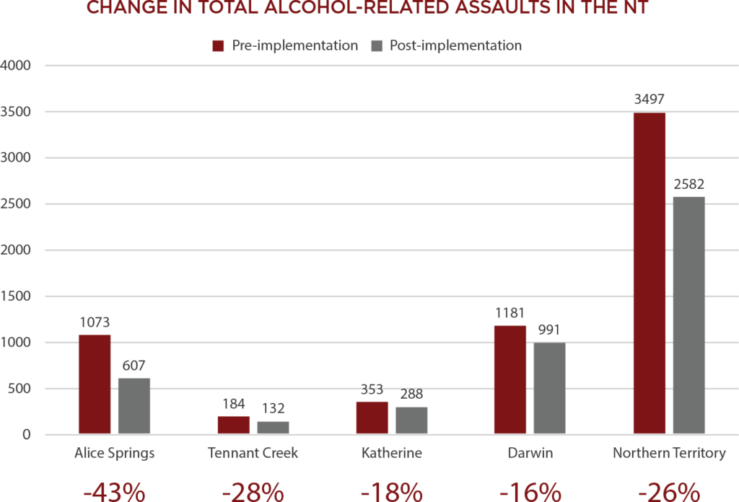

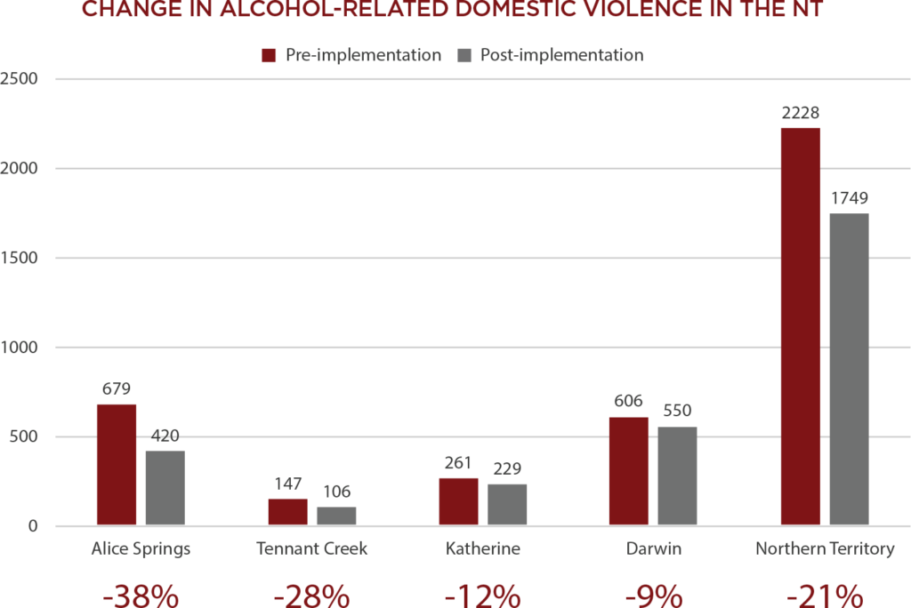

Pre-implementation = 1 October 2017 to 31 July 2018, post-implementation = 1 October 2018 to 31 July 2019

Note: Date period is not 12 months due to unpublished data beyond 31 July 2019. The same 10-month period has been used pre-implementation to draw accurate comparisons. Darwin includes Palmerston.

Source: [NT Police Crime Statistics](https://www.pfes.nt.gov.au/Police/Community-safety/Northern-Territory-crime-statistics/Statistical-publications.aspx)

### Metadata

|  |  |
| --- | --- |
| **Views** | 119 |