# Every Moment Matters

# National FASD Program

## Every Moment Matters in pregnancy

[Every Moment Matters](https://everymomentmatters.org.au/) is a groundbreaking national health campaign about alcohol, pregnancy and breastfeeding.

The campaign has been developed by the Foundation for Alcohol Research and Education (FARE) and is funded by the Australian Government from July 2020 to 2026.  https://www.youtube.com/watch?v=N2WUwlDPcPo

## About the campaign

The campaign aims to:

* Increase Australians’ awareness of the risks associated with alcohol consumption during pregnancy and while breastfeeding, including [Fetal Alcohol Spectrum Disorder (FASD)](https://www.nofasd.org.au/alcohol-and-pregnancy/what-is-fasd/)
* Increase the proportion of Australians who are aware alcohol should not be consumed during pregnancy and that it is safest not to drink alcohol when breastfeeding
* Increase the proportion of Australian women who intend to not drink any alcohol during pregnancy and when breastfeeding.

The Campaign has four streams, targeting the general public, women who are at an increased risk of alcohol use during pregnancy, health professionals and Aboriginal and Torres Strait Islander peoples.

The Campaign is being delivered in partnership with the [National Organisation for Fetal Alcohol Spectrum Disorder (NOFASD Australia)](https://www.nofasd.org.au/), the [National Aboriginal Community Controlled Health Organisation (NACCHO)](https://www.naccho.org.au/) and a number of health professional bodies who have endorsed, informed and promoted the campaign.

The Campaign is independently evaluated by the team at the University of Adelaide South Australian Health and Medical Research Institute (SAHMRI).

## Campaign impact

Since launching in November 2021, the Every Moment Matters campaign has effectively increased awareness, changed intentions and influenced behaviours when it comes to alcohol, pregnancy and breastfeeding across Australia.

In 2025, the [National FASD Program Social Return on Investment report](https://fare.org.au/wp-content/uploads/SROI-report.pdf) found that every $1 invested in the Campaign generated a $9 social return.

This has reduced the cost of alcohol harms in Australia by $236 million.

The report’s Author, Dr Angela Jackson, Lead Economist at Impact Economics and Policy, said that an estimated 16,554 fewer women consumed alcohol while pregnant in 2023 due to the campaign.

“Our analysis shows that the Campaign has contributed to more than 2,000 fewer cases of Fetal Alcohol Spectrum Disorder (FASD), 369 fewer babies being born with low birth weight, 958 fewer premature births, and 414 fewer miscarriages across the country,” she said.

Before the campaign, 66 per cent of women who were recently or currently pregnant said they would stop drinking alcohol after pregnancy confirmation. After viewing the campaign, 80.2 per cent said they would not drink alcohol.

[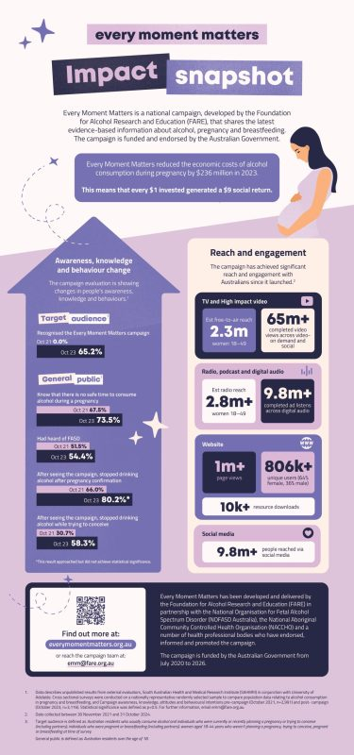](https://fare.org.au/wp-content/uploads/FARE-EMM-Impact_2025-1-scaled.jpg)

Click the image for an overview of Every Moment Matters' extraordinary impact

## Community resources and stories

The Campaign includes a central web resource that [houses health information](https://everymomentmatters.org.au/alcohol-and-pregnancy/), links to [support and resources](https://everymomentmatters.org.au/support/), and [community stories](https://everymomentmatters.org.au/community-stories/).

In addition, a combination of media engagement, events, connecting with health professionals and spreading the message via partner organisations has driven national awareness of the Campaign.

An important part of the campaign has been connecting to people’s lived experiences of Fetal Alcohol Spectrum Disorder (FASD) and [sharing community stories](https://everymomentmatters.org.au/community-stories/) to raise awareness and provide support and solidarity for women who are pregnant or breastfeeding.

https://www.youtube.com/watch?v=KPPLZJcuu2Ehttps://www.youtube.com/watch?v=a2fYCSUdJXA&t=1shttps://www.youtube.com/watch?v=kvwXDsR8SGo

## Training for health professionals

https://www.youtube.com/watch?v=aaRac_x1MD8

We have worked closely with health professionals to connect them to [e-learning to further their skills and knowledge](https://everymomentmatters.org.au/for-health-professionals/) to better support their patients.

Our evaluation shows that we have made a significant impact with health professionals, including GPs, obstetricians and gynecologists, nurses and midwives.

More than 15,000 health professionals have been reached through our participation in events, and more than 500 health professionals have registered to undertake the EMM accredited eLearning course.

The evaluation of the course indicates that those who have completed the core eLearning module have significantly increase their:

* Confidence in providing advice about alcohol and pregnancy ****(61.4 per cent to 87.4 per cent)****
* Confidence in providing advice about alcohol and breastfeeding ****(53.9 per cent to 89.5 per cent)****
* Comfort in initiating conversations about alcohol and pregnancy ****(78.9 per cent to 88.3 per cent)****
* Belief that providing advice to women about alcohol consumption in pregnancy will prompt behaviour change ****(61.4 per cent to 83.6 per cent)****
* Intentions to ask about alcohol use at every antenatal visit ****(22 per cent to 81.7 per cent)****
* Intention to assess alcohol consumption using Audit-C for Pregnancy ****(10.9 per cent to 74.6 per cent)****

## Steering Committee

The role of the Steering Committee is to provide oversight and expertise during the National Campaign’s development and implementation.

The members of the Steering Committee are:

|  |  |
| --- | --- |
| ****Organisation**** | ****Representing**** |
| National Organisation for Fetal Alcohol Spectrum Disorders (NOFASD) | Ms Louise Gray |
| National Aboriginal Community Controlled Organisation (NACCHO) | Ms Dawn Casey PSM |
| Central Coast Local Health District | Mr Steve Ella |
| University of Sydney | Professor Elizabeth Elliott AM |
| Australian College of Midwives (ACM) | Ms Alison Weatherstone |
| Royal Australian College of General Practitioners (RACGP) | Dr Hester Wilson |
| Royal Australian and New Zealand College of Obstetricians, and Gynaecologists (RANZCOG) Immediate Past President | Dr Vijay Roach |
| George Institute for Global Health | Professor Simone Pettigrew |
| Foundation for Alcohol Research and Education (FARE) | Ms Caterina Giorgi, Chief Executive Officer |

## National Organisation for Fetal Alcohol Spectrum Disorder (NOFASD)

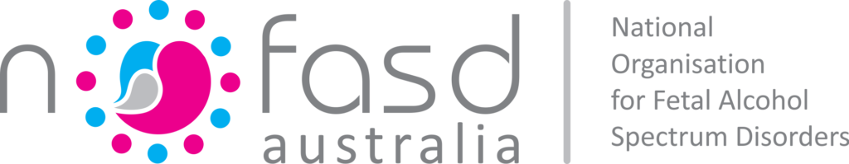

[The National Organisation for Fetal Alcohol Spectrum Disorders Australia](https://www.nofasd.org.au/) (NOFASD) collaborated with people with lived experience of FASD and alcohol use during pregnancy to develop a suite of [targeted resources](https://everymomentmatters.org.au/resources/) for:

* People working in the Out of Home Care Sector,
* People working in the Alcohol and Other Drug Sector, and;
* Women most at risk of having an alcohol-exposed pregnancy.

The resources are focused on raising awareness of the importance of early recognition of FASD and access to appropriate support services.

NOFASD has also developed a webinar series providing an entry point for people wanting to learn more.

## National Aboriginal Community Controlled Health Organisation (NACCHO)

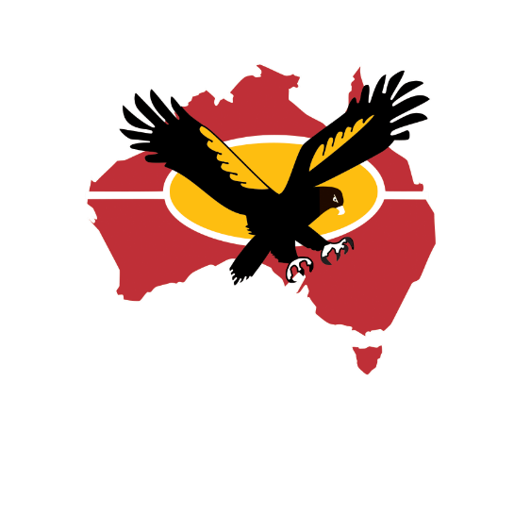

Led by the [**National Aboriginal Community Controlled Health Organisation**](https://www.naccho.org.au/) (NACCHO), the [Strong Born](https://www.naccho.org.au/fasd/) campaign raises awareness Fetal Alcohol Spectrum Disorder (FASD) and the risks of drinking alcohol while pregnant and breastfeeding, among Aboriginal and Torres Strait Islander peoples in rural and remote communities.

Strong Born is also about supporting people with FASD and their families and carers, by understanding what FASD is, and the services that may be available for individuals and families.

https://www.youtube.com/watch?v=8AsY7fbKQdU

## Meet the Team

FARE has appointed a passionate and experienced team to coordinate the development and implementation of the National Campaign. We look forward to working collaboratively with colleagues across the country to deliver this incredibly important piece of work.

* Caterina Giorgi, Chief Executive Officer
* Kristie Cocotis, Health Program Director
* Rosemary White, Health Programs Manager - National Campaign
* Pearl Prabal, Senior Health Promotion Advisor
* Meredith Anderson, Senior Health Promotion Advisor
* Claire Margan, Senior Health Promotion Advisor
* Carly Keene, Senior Health Promotion Advisor
* Susan Hickson, Senior Health Promotion Advisor
* Cameron Banks, Health Programs Manager - State Projects
* Jessica Birch, Lived Experience Advisor
* Angelene Bruce, Lived Experience Advisor

## Stay in touch

You can contact the National Program team at:

* Phone: 02 5104 9311
* Email: [emm@fare.org.au](mailto:emm@fare.org.au)