# Maz Compton shares her tips for cutting back on alcohol on her 10-year ‘soberversary’

When Maz Compton[woke up on New Year’s Day 2015](https://www.smh.com.au/lifestyle/health-and-wellness/nearly-half-of-australians-want-to-drink-less-so-why-don-t-they-20250113-p5l3v8.html) and decided to take a break from alcohol, she didn’t intend to still be sober 10 years later.

In Maz’s words: “The idea of even having a weekend without alcohol in December of 2014 was outrageous to me. It seemed impossible.”

But after “unlocking a Pandora’s box full of benefits” by cutting out alcohol, the morning breakfast radio host has just marked 10 years of sobriety.

https://www.youtube.com/watch?v=0sfLMcwWvSg

“It’s the biggest version of self-care I have ever done,” Maz said.

“Alcohol is no longer a part of my life in any way, shape or form – it's like it doesn’t exist.”

To celebrate the launch of a [brand-new resources hub on our website](https://fare.org.au/resources/) to support Australians to cut back on alcohol, Maz Compton shared with us the strategies that helped her make a change.

## ****Start with small, achievable goals****

You don’t have to start by setting a goal of never drinking again.

The idea of not drinking every again can feel so overwhelming it might scare some people into staying stuck.

Instead, break it down to a daily thing where you tell yourself: ‘Today, no matter what happens, whether it’s great, whether it’s terrible, I’m not going to drink.’

By starting small, you can get your head on the pillow that night, not have had a drink and build a habit you can stay accountable to.

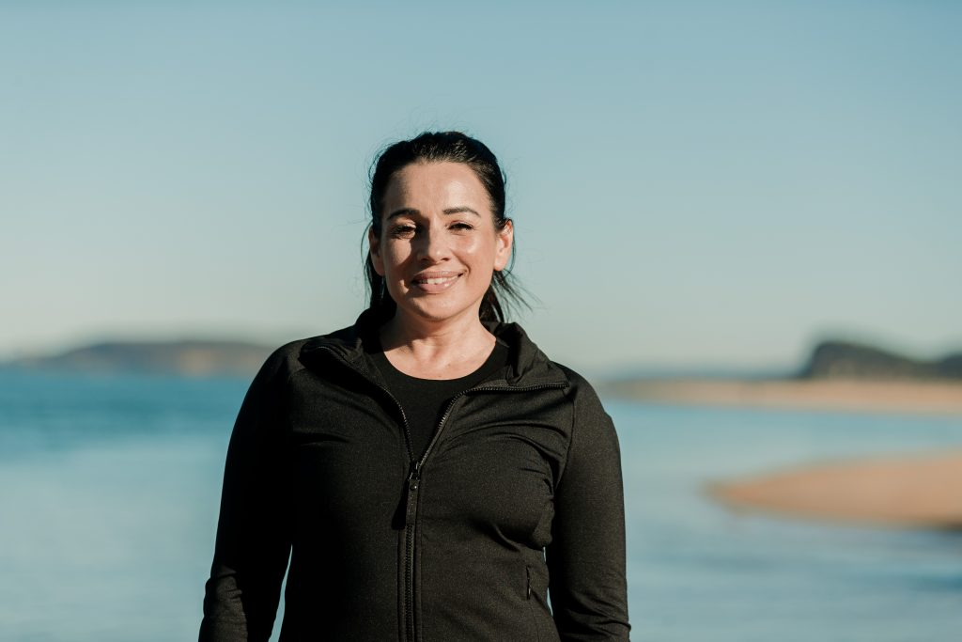

*Maz Compton says starting out with small, achievable goals can help you stay accountable and help make long-term habits stick.*

## ****Plan your "sober response"****

Over time, I refined my response to one succinct sentence and a full stop.

It’s like building a muscle. But it took me a couple of years to get there.

I experimented with responses. Some weren’t great because I’m human – I had moments where I overexplained my decision and at times became defensive.

But I eventually found one succinct response that explained what I was doing when I didn’t owe anyone an explanation.

I would then stop talking. I got good at sitting in that awkward silence where they just don’t know what to do.

I knew I was happy with my choice so it didn’t matter if the other person was bothered.

## ****Start journalling****

I journalled every day of the first 31 days after my decision to go sober.

It was just a verbal vomit into a book of anything and everything that I felt.

The journal was a key thing because I didn’t have lots of people I was talking to at the time.

In 2015, I was the only sober person I knew.



*Maz says she was the only person she knew who was sober when she made the decision to stop drinking on New Year's Day 2015.*

Some days I remember distinctly not wanting to write anything in my journal, so then I would write about how I didn’t want to journal.

It just became this way of processing the feelings that were coming up because I wasn’t drinking alcohol and suppressing all these big emotions anymore.

## ****Personify your relationship with alcohol****

I know this strategy is not for everyone.

But I changed how I thought about alcohol – how often I would drink, and how I felt during and after drinking – by giving alcohol a name.

So, I started referring to alcohol as ‘Jenny.’

I didn’t want to hang out with Jenny a lot of the time, even though she was around most afternoons in 2014.

When I was with Jenny, I usually went out way too late, I felt like rubbish, I usually did things I didn’t want to do, I spent too much money, and I wrote off weekends.

That made me think: ‘This Jenny character is not a great fit.’

If I was talking about a real person who had a detrimental impact on me as a person, any friend would say: ‘Hey, take a break from her.’

That’s how I was able to draw a line in the sand.

*Find out information about alcohol’s impact on our health, and further tips to cut back on alcohol, at* [*FARE’s new resources hub.*](https://fare.org.au/resources/)

*If you, or someone you know, is struggling with alcohol use, there is always support available.* [*Search our list of support services today.*](https://fare.org.au/resources/alcohol-support-services/)

*If you want to learn more about Maz Compton,* [*visit her website.*](https://mazcompton.com/)