# Effective health warning labels

# Together we won a long-fought campaign to see mandatory, visible pregnancy health warnings on all alcohol products in Australia and New Zealand

This is a victory for Australians with Fetal Alcohol Spectrum Disorder (FASD) and advocates who want to make sure the next generation of Australians have a healthier future.

## How did we get here?

For more than 20 years, people with FASD, their families, health groups, and community organisations such as [NOFASD](https://www.nofasd.org.au/) have been advocating for visible pregnancy warning labels on alcoholic products. After many years of research and advocacy, in 2020, there was an opportunity where these health warnings could become a reality.

[Independent regulator Food Standards Australia New Zealand (FSANZ)](https://www.foodstandards.gov.au/Pages/default.aspx) developed and proposed an effective and evidence-based alcohol health warning label. This label was mandatory on all products and included the key features required to make the label effective, such as ensuring it had contrasting, identifiable colours (red, white and black).

In March 2020, this label was considered at the [Forum on Food Regulation](https://foodregulation.gov.au/internet/fr/publishing.nsf/Content/Forum). At this meeting, Food Forum Ministers did not support the effective warning and instead requested FSANZ consider changes to the colour and warning text.

Removing colour and changing the warning text was the core request of alcohol corporations and their lobby groups, who launched a campaign against the evidence-based label called ‘Not This Label.’

These elements were critical to ensuring the label was effective, visible and easily understood. Watering down the label through changes to its colour, size or wording, would be risking the health and wellbeing of thousands of Australians for years to come.

#### This is what we fought for

[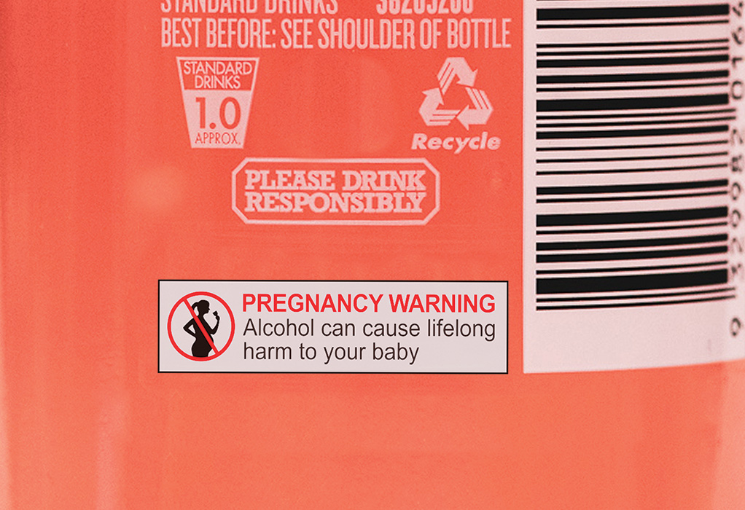](https://fare.org.au/wp-content/uploads/cruiser-good-label-1.jpg) [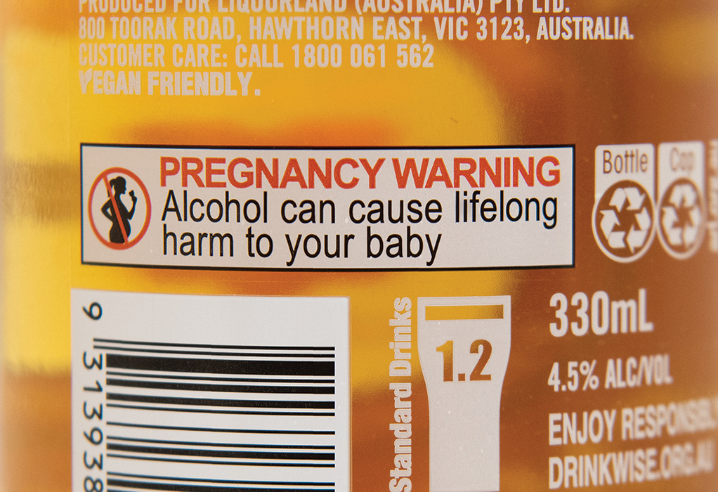](https://fare.org.au/wp-content/uploads/final-label.jpg)

Ministers were to meet once again in July 2020 to hear the outcome of FSANZ deliberations and make a final decision whether to support the evidence-based health warning label in full — or concede to alcohol corporation requests.   
   
Health advocates knew this was the final chance for the long-fought for label. They also knew alcohol corporations would be lobbying hard to do whatever they could to stop the warning from going ahead. In response, thousands of Australians around the country put incredible heart and energy into making sure alcohol corporations wouldn’t drown out community voices by sharing why this label was important to them in letters, calls, and meetings with Food Forum Ministers.

The FARE team worked closely with communities and advocates so that they could share their stories with the right people, at the right moment. We shared insights into the policy-making process, helped community members navigate conversations with decision-makers, created video content to reach a wider audience via social media and supported advocates to share their stories in the national media.

At the same time, we gathered support from people across Australia by asking them to sign an open letter which called for clear, visible health warnings. [You can read the open letter here](https://fare.org.au/labelling-open-letter/).

More than 4,000 community leaders and advocates, and more than 180 organisations, signed this open letter. Many who signed the open letter also wrote to, called and met with the Food Forum Ministers in the lead up to the vote. A range of stakeholders were also media spokespeople who ensured the message was heard from a diverse cross-section of the community.

When the ministers met in July 2020 to vote, they listened to the community and placed the health and safety of families first by voting to have mandatory, visible and effective health warning on alcohol products.  
   
And just like that, the community won!

## Why is this important?

We all want our families to have access to clear information about the health and safety of the products they buy – especially products that may harm our children.

However, in Australia, alcohol products have never been legally required to carry a health warning about the risks alcohol can cause during pregnancy including miscarriage, stillbirth, low birth weight, pre-term birth and FASD.

The [Australian guidelines to reduce health risks from drinking alcohol](https://www.nhmrc.gov.au/health-advice/alcohol) make it clear that no amount of alcohol is safe to consume during pregnancy.

Yet almost a quarter (23%) of Australians aren’t aware that drinking alcohol when pregnant is harmful to an unborn baby. Moreover, less than a third (31%) of Australians recall seeing warning labels on alcohol products about the risk of drinking alcohol when pregnant.

This lack of awareness in the community means that [one in four](https://www.aihw.gov.au/reports/illicit-use-of-drugs/ndshs-2016-detailed/contents/table-of-contents) Australian women continue to drink alcohol after finding out they are pregnant. This amounts to alcohol exposed pregnancies in Australia every year.

An effective health warning label on alcohol products was a small thing that can make a significant difference in the lives of many.

A well-designed, effective warning label can change behaviour. This was demonstrated recently in a [real-world trial](https://www.jsad.com/doi/10.15288/jsad.2020.81.225) which compared alcohol consumption in neighbouring regions in Canada – one with alcohol health warning labels and one without. It found a statistically significant decrease in alcohol consumption in the region with the warning labels.

An effective health warning label that clearly informs the community about the need to avoid alcohol during pregnancy would result in fewer miscarriages and stillbirths, and would help put a stop to the thousands of Australian children being born with FASD — a lifelong disability that can result in significant cognitive, behavioural, health and learning difficulties.

## Community stories

## News and media

[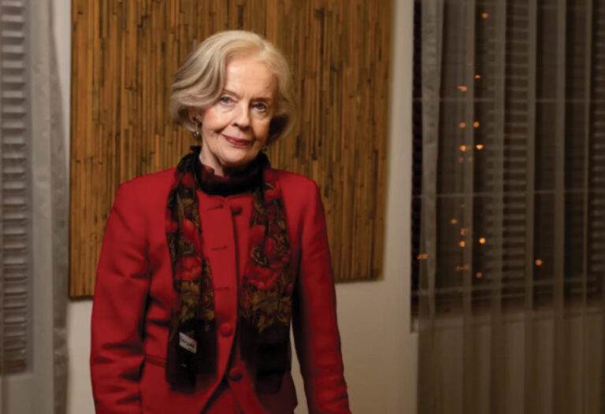](https://www.smh.com.au/politics/federal/grave-implications-dame-quentin-s-message-to-ministers-on-alcohol-pregnancy-warnings-20200625-p5560l.html)

##### ['Grave implications': Dame Quentin's message to ministers on alcohol pregnancy warnings](https://www.smh.com.au/politics/federal/grave-implications-dame-quentin-s-message-to-ministers-on-alcohol-pregnancy-warnings-20200625-p5560l.html)

Australia's former governor-general Dame Quentin Bryce is calling on governments to resist alcohol industry pressure and roll out clear, mandatory pregnancy warning labels.

[Read More »](https://www.smh.com.au/politics/federal/grave-implications-dame-quentin-s-message-to-ministers-on-alcohol-pregnancy-warnings-20200625-p5560l.html)

[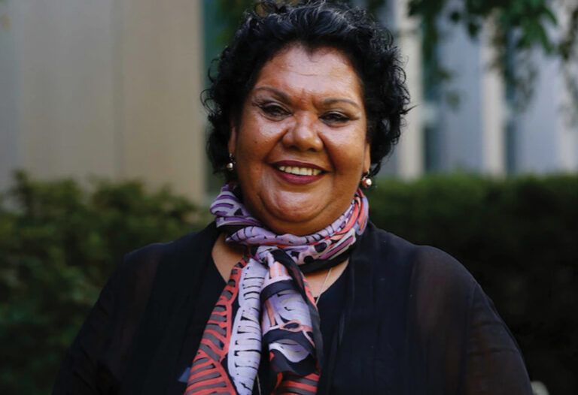](https://www.abc.net.au/news/2020-07-16/calls-for-alcohol-warnings-to-be-clearer-and-more-prominent/12458440)

##### [Australia's social justice commissioner links alcohol label reform to closing the gap](https://www.abc.net.au/news/2020-07-16/calls-for-alcohol-warnings-to-be-clearer-and-more-prominent/12458440)

Australia's Aboriginal and Torres Strait Islander social justice commissioner has written to the Ministerial Forum of Food Regulation urging the body to implement stronger pregnancy warnings.

[Read More »](https://www.abc.net.au/news/2020-07-16/calls-for-alcohol-warnings-to-be-clearer-and-more-prominent/12458440) [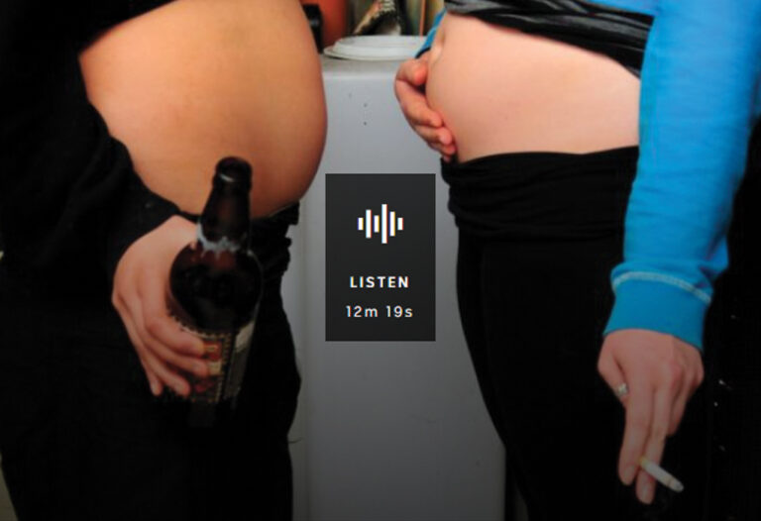](https://www.abc.net.au/radionational/programs/drive/calls-for-stronger-pregnancy-warnings-on-alcohol-labels/12431940)

##### [Woman living with FASD joins nationals calls for stronger pregnancy warnings on alcohol labels](https://www.abc.net.au/radionational/programs/drive/calls-for-stronger-pregnancy-warnings-on-alcohol-labels/12431940)

Calls are intensifying for the Federal Government to adopt stronger pregnancy warnings on alcohol labels. Now a person with FASD has decided to share her story in the hope of shedding light on the condition.

[Read More »](https://www.abc.net.au/radionational/programs/drive/calls-for-stronger-pregnancy-warnings-on-alcohol-labels/12431940)