# International Women's Day: Five female perspectives on alcohol harms

When our community comes together and speaks openly about alcohol harms and how we can take steps to reduce our alcohol intake, the impacts can be life-changing.

Over the past couple of years, our team has collaborated with women from diverse backgrounds through our Voices of Change and Every Moment Matters initiatives.

On this International Women’s Day, we are looking back on some of the candid conversations we’ve had with these amazing women – and the change they are creating.

## ‘The stories that we tell … we got to get it out there for people to listen’

https://vimeo.com/780195835

Aunty Helen Fejo-Frith is one of the staunch community leaders and advocates who stopped [Woolworths' plans for a Dan Murphy’s megastore](https://fare.org.au/darwin/) on the doorstep of Darwin’s dry Bagot community.

In recognition of her work during the grassroots campaign and her ongoing advocacy, Aunty Helen was [appointed as a Member of the Order of Australia.](https://twitter.com/FAREAustralia/status/1668040187144818688)

Aunty Helen shared her reflections on how alcohol continues to harm mob, and how elders in Bagot community are encouraging people young and old to reach out for support.

“There’s a reason behind what we’re saying, but we need you to get up and show us that you can do it,” Aunty Helen said.

## ‘That's where I've done most of my healing – in finding I wasn’t alone’

Angelene is the biological mum of a child with Fetal Alcohol Spectrum Disorder (FASD).

She developed a physical alcohol dependence before she was pregnant – and felt like a “failed empty vessel” after an OB-GYN urged her to immediately stop drinking, without discussing what support she might need to do so.

https://www.youtube.com/watch?v=kvwXDsR8SGo

After her son was [diagnosed with FASD at the age of 3](https://fare.org.au/angelenes-story/), Angelene saw the need to empower women to share their own experiences and connect with others, letting them know they are not alone.

“The shame is there. The guilt is there. It’s okay to feel it, but please don’t let it define you,” Angelene said.

## ‘I plan to shout about the link between alcohol and breast cancer’

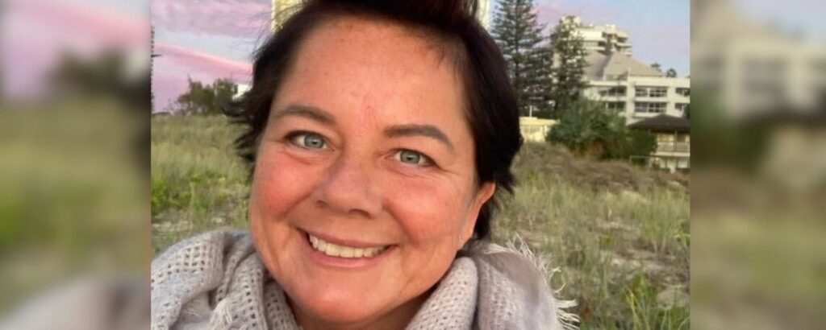

Corrine was diagnosed with breast cancer in early 2022. After her diagnosis, she discovered that alcohol is one of the biggest risk factors for breast cancer.

She dived into the research on alcohol and its classification by the World Health Organisation as a [Group 1 carcinogen](https://www.who.int/europe/news/item/04-01-2023-no-level-of-alcohol-consumption-is-safe-for-our-health#:~:text=Alcohol%20is%20a%20toxic%2C%20psychoactive,includes%20asbestos%2C%20radiation%20and%20tobacco.) while undergoing chemotherapy.

Now, Corrine is empowered to make sure everyone is aware of alcohol’s links to seven types of cancer.

“One day, I hope alcohol – much like tobacco – will be understood as the dangerous, toxic substance it is,” Corrine said.

[Read Corrine’s full Voices of Change story here.](https://fare.org.au/corrines-story/)

## ‘Having clear guidelines during pregnancy is incredibly helpful’

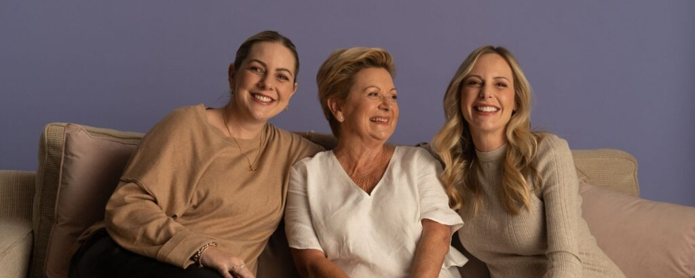

Taryn and Christy learned how much attitudes have shifted around alcohol and pregnancy by speaking to their mother, Robin.

Reflecting on her own experience three decades ago, Robin says her generation was not supported with accurate information on how alcohol can harm developing babies.

Now, the [Australian Alcohol Guidelines](https://everymomentmatters.org.au/resources/) advise women who are pregnant to not drink alcohol. Taryn and Christy say this clear advice supported them in difficult conversations - and reinforced their alcohol-free pregnancy journeys.

“Everyone’s got an opinion on how you should do pregnancy, how you should raise kids, what should be happening at different stages … it’s good to know the evidence and the facts, so you can make informed decisions about what you want to do,” Taryn said.

[Read Taryn, Christy and Robin’s full Voices of Change story here.](https://fare.org.au/taryn-christy-robins-story/)

## ‘We were all trying to figure out what’s the best way we can finish work’

When Melbourne was thrown into COVID-19 lockdowns, Pauline – who was never a big drinker - started relying on a glass of wine or two every night to cope with stress.

She quickly discovered that it would be more difficult to manage her mental health, because alcohol is addictive and can be a substance of dependence.

https://vimeo.com/761672295

Pauline acknowledged she needed to change her habits. So, she substituted alcohol for healthier calming activities, such as a soothing bath, walking and listening to podcasts.

“If I’m not taking care of me, I can’t think of others. So we need to constantly take care of ourselves,” Pauline said.