# How to ensure your breastmilk is alcohol free

Parents want clear and up to date information when it comes to the health of their babies.

When breastfeeding, parents can seek out information on alcohol, wanting to know about alcohol and breastmilk.

When it comes to alcohol, the National Health and Medical Research Councils (NHMRC) A*ustralian Guidelines to Reduce Health Risks from Drinking Alcohol* that advise ‘when breastfeeding, not drinking alcohol is safest for the health of your baby.’

If alcohol is consumed, it’s important to ensure that the breastmilk the baby drinks is alcohol-free.

Any alcohol consumed passes freely into your breastmilk, and while there is alcohol in your bloodstream it’s also in your breastmilk.

The only way to eliminate alcohol from breastmilk is to wait for your body to process the alcohol, which takes approximately two hours per standard drink.

https://www.youtube.com/watch?v=5NRae6it4ys&t=56s

## Why is this important?

If a baby ingests alcohol via breastmilk, even small amounts can disrupt their sleep or alter the flow of milk. A change in milk flow may make feeding more difficult and reduce supply.

It is also important to know that the brain of the developing infant is much more vulnerable to the effects of alcohol than an adult brain. Exposure to alcohol has been linked to developmental issues in early childhood.

The safest thing you can do for your baby is to not drink alcohol when you are breastfeeding.

## Tips and strategies

If you do drink alcohol, there are things you can do to make sure your breastmilk is alcohol-free before feeding.

You can:

* Wait two hours per standard drink before breastfeeding
* Express breastmilk before drinking in case your baby needs to feed sooner than planned
* Download and use the Feed Safe app on your phone

The Feed Safe app uses your height, weight, and information about the alcohol you have consumed to alert you when your breastmilk is alcohol-free and safe to feed your baby.

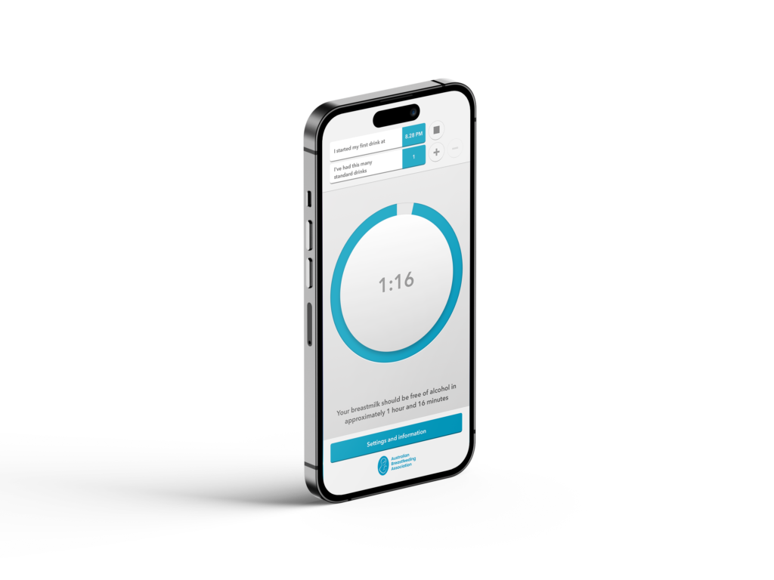

The app, first developed over 10 years ago has been used more than 3 million times!

## Every Moment Matters

This year, as part of the ‘*Every Moment Matters’* Campaign the Foundation for Alcohol Research and Education (FARE), the Australian Breastfeeding Association (ABA) and Dr Roslyn Giglia have worked in partnership to update the app.

Feed Safe has clear and current advice, a standard drinks guide, contact information for the National Breastfeeding Helpline and contact numbers for alcohol and drug services around Australia.

You can find the Feed Safe app and [download](https://www.feedsafe.net/) for free via the Apple or Android stores. You can also find it online.

To download the app or for further information, helpful facts and resources about alcohol, pregnancy and breastfeeding please visit [Every Moment Matters.](https://everymomentmatters.org.au/alcohol-and-pregnancy/breastfeeding/#feedsafe)