# Home REDESIGN

# FARE develops evidence-based policies and programs to reduce alcohol harm in Australia.

[About us](https://fare.org.au/about/)

# Learn more about how alcohol affects your health

[Learn more](https://fare.org.au/resources/)

# FARE Annual Report 2023-24 is now online

[Learn more](https://fare.org.au/wp-content/uploads/FARE-Annual-Report-2023-24.pdf" \t "_blank)

# Cutting back on alcohol can help you Be Nice To Brain

[Learn more](https://fare.org.au/be-nice-to-brain/)

# Join our campaign for action to prevent gender-based violence

[Learn more](https://fare.org.au/alcohol-and-gendered-violence/)

# Learn more about how alcohol affects your health

[Learn more](https://fare.org.au/resources/)

# FARE Annual Report 2023-24 is now online

[Learn more](https://fare.org.au/wp-content/uploads/FARE-Annual-Report-2023-24.pdf" \t "_blank)

# Cutting back on alcohol can help you Be Nice To Brain

[Learn more](https://fare.org.au/be-nice-to-brain/)

# Join our campaign for action to prevent gender-based violence

[Learn more](https://fare.org.au/alcohol-and-gendered-violence/)

## Learn more about alcohol

[Resource library](https://fare.org.au/resources/alcohol-resource-library/)

### [**Alcohol and your health**](https://fare.org.au/resources/alcohol-health-impacts/)

[Learn more](https://fare.org.au/resources/alcohol-health-impacts/)

### [**Reducing your risk**](https://fare.org.au/resources/reducing-your-risk/)

[Learn more](https://fare.org.au/resources/reducing-your-risk/)

### [**Cutting back**](https://fare.org.au/resources/cutting-back-alcohol/)

[Learn more](https://fare.org.au/resources/cutting-back-alcohol/)

### [**Talking about alcohol**](https://fare.org.au/resources/supporting-someone-alcohol-use/)

[Learn more](https://fare.org.au/resources/supporting-someone-alcohol-use/)

### [**Getting help**](https://fare.org.au/resources/alcohol-support-services/)

[Learn more](https://fare.org.au/resources/alcohol-support-services/)

* [Alcohol and your health](https://staging.wph.org.au/resources/alcohol-health-impacts/)
* [Reducing your risk](https://staging.wph.org.au/resources/reducing-your-risk/)
* [Cutting back](https://staging.wph.org.au/resources/cutting-back-alcohol/)
* [Supporting someone](https://staging.wph.org.au/resources/supporting-someone-alcohol-use/)
* [Support services](https://staging.wph.org.au/resources/support/)

## What we're working on right now

[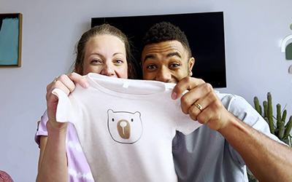](https://everymomentmatters.org.au)

[Every Moment Matters](https://everymomentmatters.org.au)

[Alcohol, Pregnancy & Breastfeeding](https://everymomentmatters.org.au)

[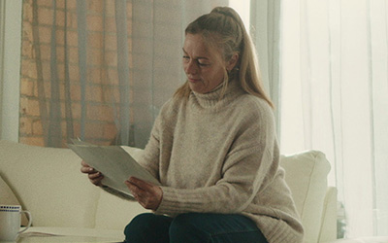](https://fare.org.au/voicesofchange/)

[Voices of Change](https://fare.org.au/voicesofchange/)

[An online space to share experiences](https://fare.org.au/voicesofchange/)

[](https://fare.org.au/harmful-alcohol-marketing-online/)

[Alcohol marketing online](https://fare.org.au/harmful-alcohol-marketing-online/)

[Protecting communities and children online](https://fare.org.au/harmful-alcohol-marketing-online/)

[](https://fare.org.au/alcohol-and-gendered-violence/)

[Action on gendered violence](https://fare.org.au/alcohol-and-gendered-violence/)

[Preventing harm to women and children](https://fare.org.au/alcohol-and-gendered-violence/)

## Help us amplify community voices

# We collaborate with people who have a lived experience of alcohol harm to share their story, advocate for change, and inform policies to prevent and reduce alcohol harm.

### [**Voices of Change**](https://fare.org.au/voicesofchange/)

Hear from our community about how alcohol has impacted their life, and the change they want to create.

[Explore](https://fare.org.au/voicesofchange/) [Share your story](https://fare.org.au/voicesofchange/#form) 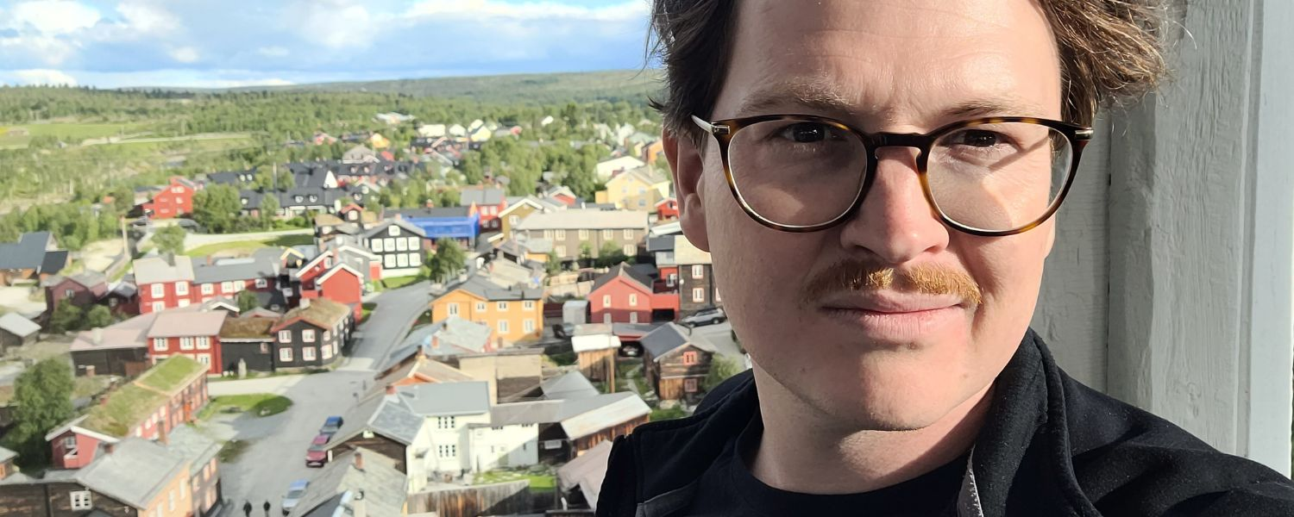 [Why Oliver is fed up with “intrusive” alcohol advertising](https://fare.org.au/olivers-story/)

## [**Why Oliver is fed up with “intrusive” alcohol advertising**](https://fare.org.au/olivers-story/)

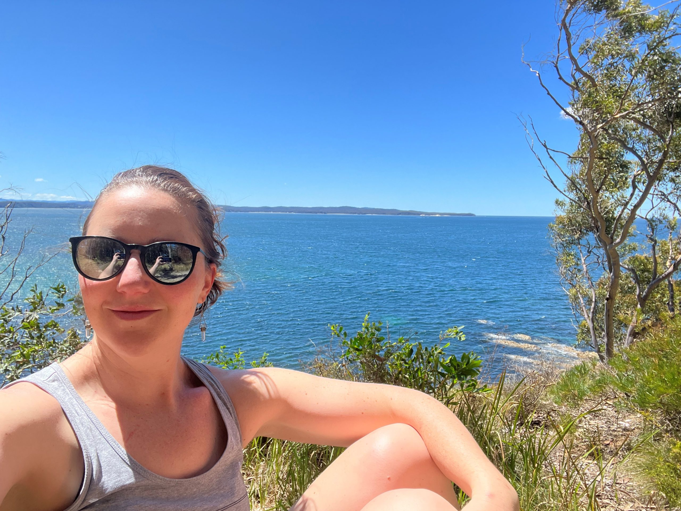 [‘You’re not alone’: How a decision to cut out alcohol supported Jo’s mental health](https://fare.org.au/reflections-alcohol-mental-health-awareness-month/)

## [**‘You’re not alone’: How a decision to cut out alcohol supported Jo’s mental health**](https://fare.org.au/reflections-alcohol-mental-health-awareness-month/)

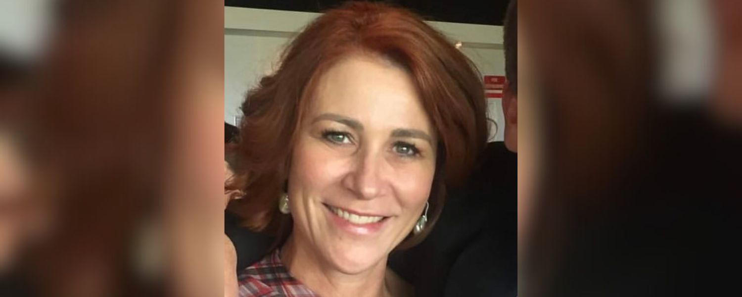 [“I knew there was going to be a serious tipping point and I was racing towards it”](https://fare.org.au/rebekahs-story/)

## [**“I knew there was going to be a serious tipping point and I was racing towards it”**](https://fare.org.au/rebekahs-story/)

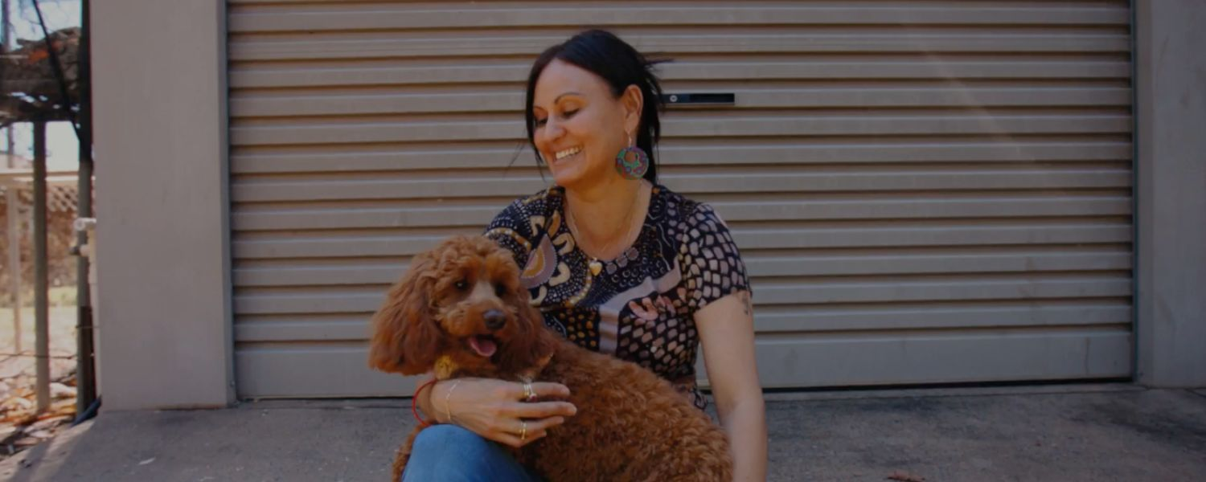 [Karyn created a safe space for young people in her community. Here’s why](https://fare.org.au/karyns-story/)

## [**Karyn created a safe space for young people in her community. Here’s why**](https://fare.org.au/karyns-story/)

 [Maz Compton’s story: What helped her ‘run towards’ a sober life without alcohol](https://fare.org.au/maz-compton-sobriety-alcohol-mtv-last-drinks/)

## [**Maz Compton’s story: What helped her ‘run towards’ a sober life without alcohol**](https://fare.org.au/maz-compton-sobriety-alcohol-mtv-last-drinks/)

 [“This wasn’t the first time her husband had been drinking and it wouldn’t have been the last”](https://fare.org.au/joans-story/)

## [**“This wasn’t the first time her husband had been drinking and it wouldn’t have been the last”**](https://fare.org.au/joans-story/)

### Donate to FARE

[Donate](https://fare.org.au/donate)

### Follow us

[Facebook-f](https://www.facebook.com/FAREAustralia/" \t "_blank) [X-twitter](https://twitter.com/fareaustralia) [Instagram](https://www.instagram.com/fare.australia/) [Linkedin](https://www.linkedin.com/company/2404161/)

### Find more ways to

[Take action](https://fare.org.au/action)

## Latest news and updates

[Media releases](https://fare.org.au/news/media-releases/) [Blog](https://fare.org.au/news/blog/)

### Submissions

[View all](https://fare.org.au/policy/submissions/) 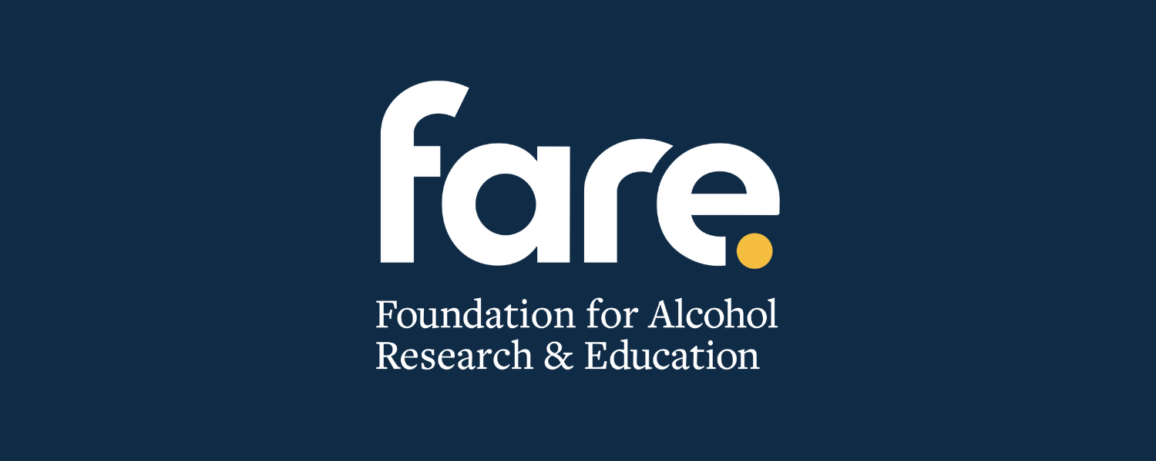 [FARE CEO update](https://fare.org.au/fare-ceo-update/)

## [**FARE CEO update**](https://fare.org.au/fare-ceo-update/)

 [Community and health leaders welcome draft alcohol laws in South Australia to prevent gendered violence](https://fare.org.au/community-and-health-leaders-welcome-draft-alcohol-laws-in-south-australia-to-prevent-gendered-violence/)

## [**Community and health leaders welcome draft alcohol laws in South Australia to prevent gendered violence**](https://fare.org.au/community-and-health-leaders-welcome-draft-alcohol-laws-in-south-australia-to-prevent-gendered-violence/)

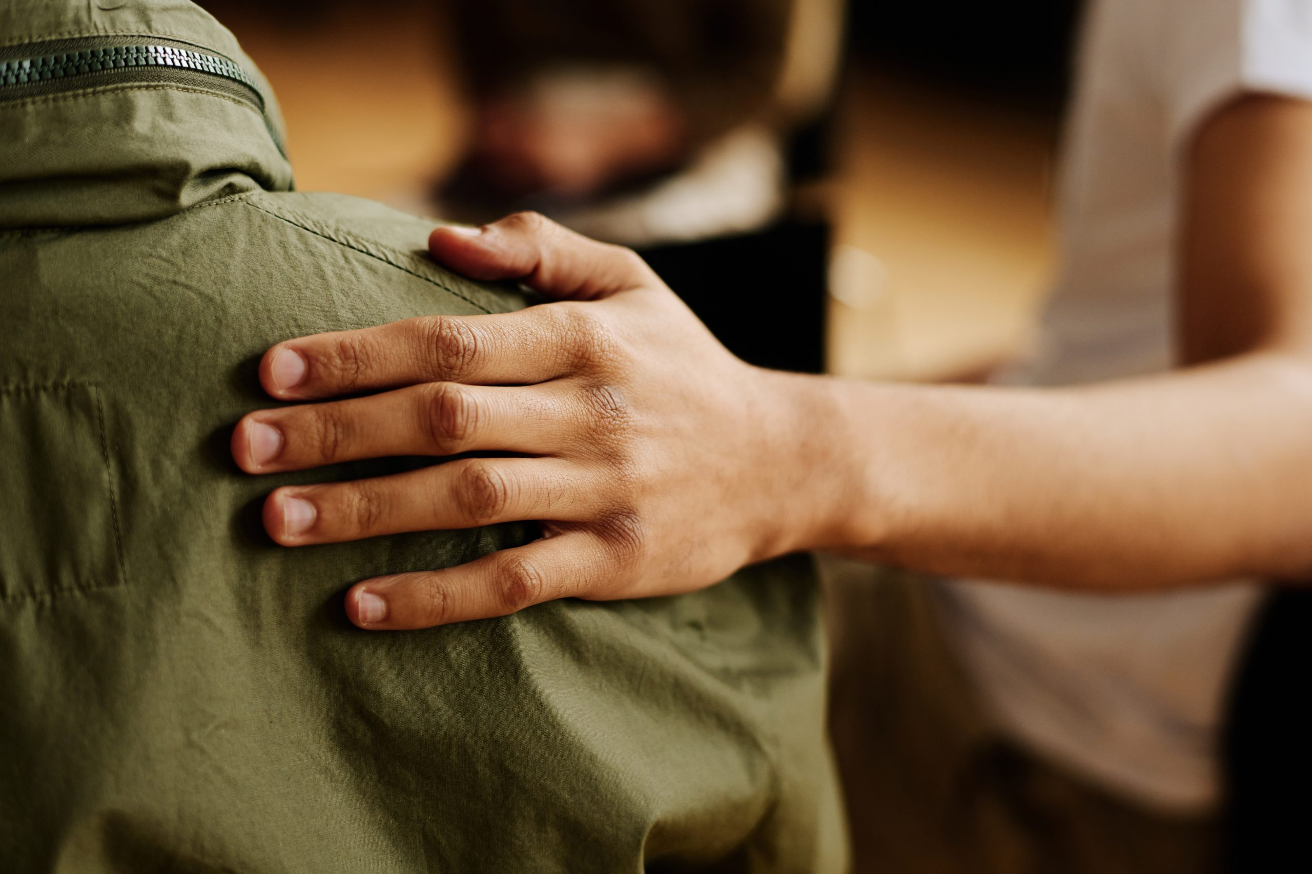 [Alcohol now leading risk factor for disease and injury in young men, new data reveals](https://fare.org.au/alcohol-leading-risk-factor-disease-injury-young-men/)

## [**Alcohol now leading risk factor for disease and injury in young men, new data reveals**](https://fare.org.au/alcohol-leading-risk-factor-disease-injury-young-men/)

[View all media releases](https://fare.org.au/news/media-releases/) [View all blogs](https://fare.org.au/news/blog/) [View all submissions](https://fare.org.au/policy/submissions/)

## Join our community taking action on alcohol