# FARE HOMEPAGE PP

[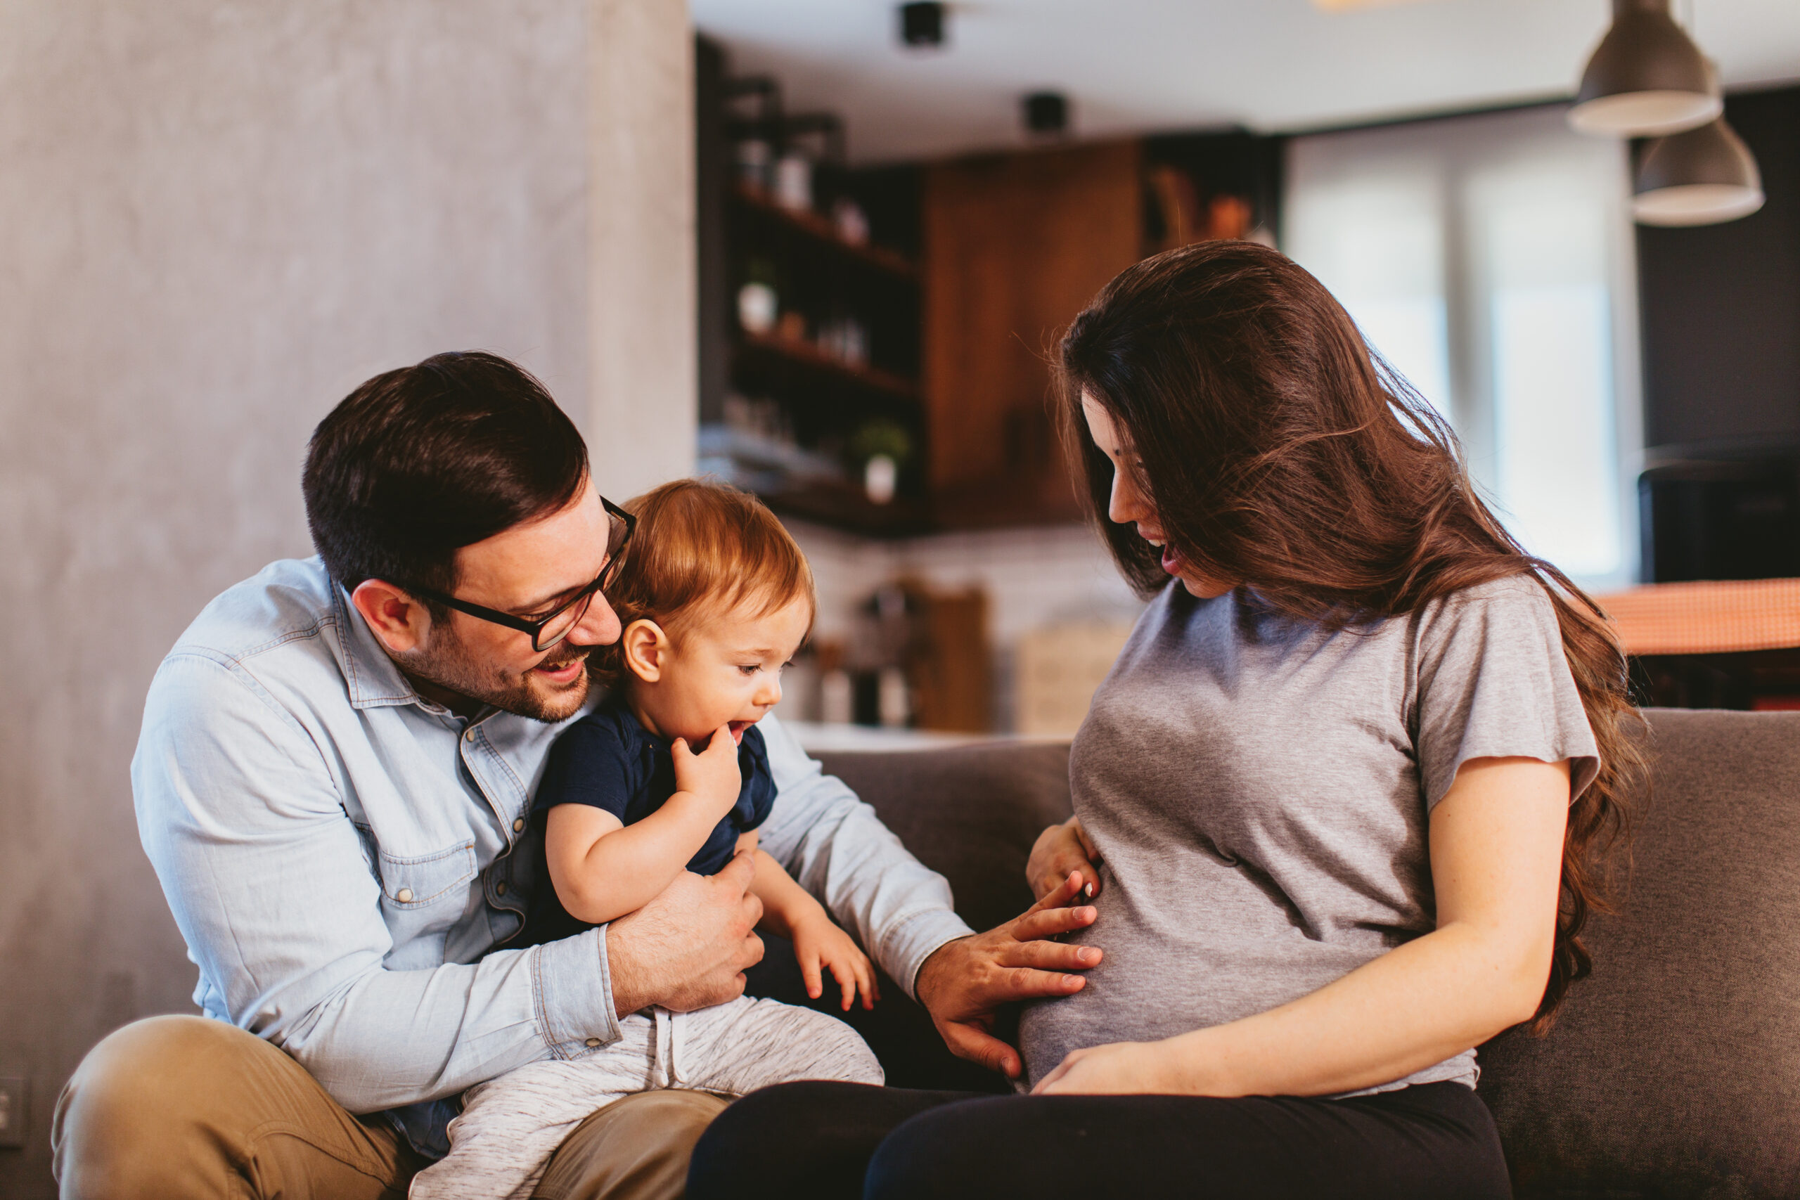](https://www.pregnantpause.com.au/)

##### [Pregnant Pause](https://www.pregnantpause.com.au/)

Pregnant Pause is creating a community of support for mums-to-be to have alcohol-free pregnancies.