# FARE HOMEPAGE DARWIN

[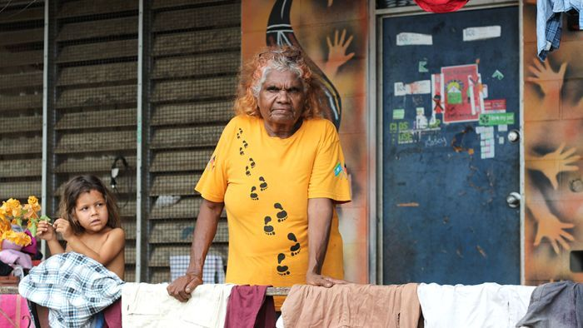](https://fare.org.au/darwin/)

##### [Darwin Dan Murphy's](https://fare.org.au/darwin/)

Darwin’s Bagot community object to Woolworths building a Dan Murphy's megastore on their doorstep.