# Every Moment Matters campaign celebrates two year milestone

Every Moment Matters is a groundbreaking national health campaign about alcohol, pregnancy and breastfeeding.

The campaign has been developed by the Foundation for Alcohol Research and Education (FARE) and is funded by the Australian Government from July 2020 to September 2024.

https://www.youtube.com/watch?v=N2WUwlDPcPo&ab_channel=FAREAustralia

The campaign aims to:

* Increase Australians’ awareness of the risks associated with alcohol consumption during pregnancy and while breastfeeding, including Fetal Alcohol Spectrum Disorder (FASD)
* Increase the proportion of Australians who are aware alcohol should not be consumed during pregnancy and that it is safest not to drink alcohol when breastfeeding
* Increase the proportion of Australian women who intend to not drink any alcohol during pregnancy and when breastfeeding.

Since launching in November 2021, the campaign has effectively increased awareness, changed intentions and influenced behaviours when it comes to alcohol, pregnancy and breastfeeding across Australia.

## Our impact at a glance

[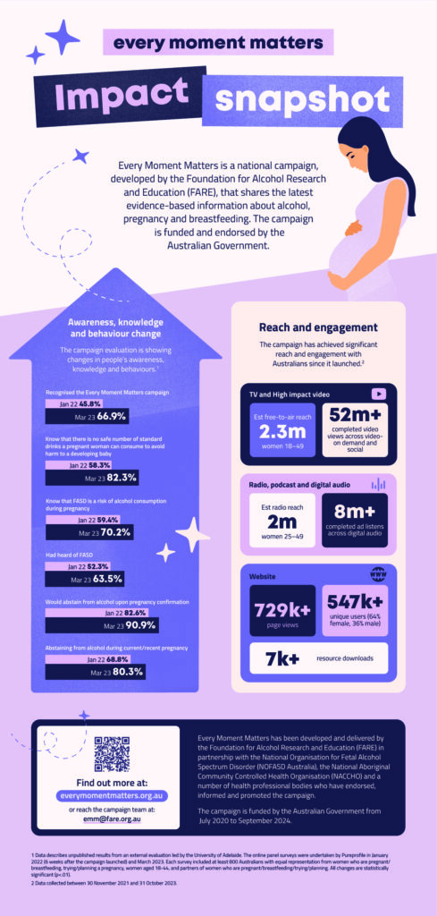](https://fare.org.au/wp-content/uploads/FARE-EMM-Impact.jpg)

Tap image to enlarge

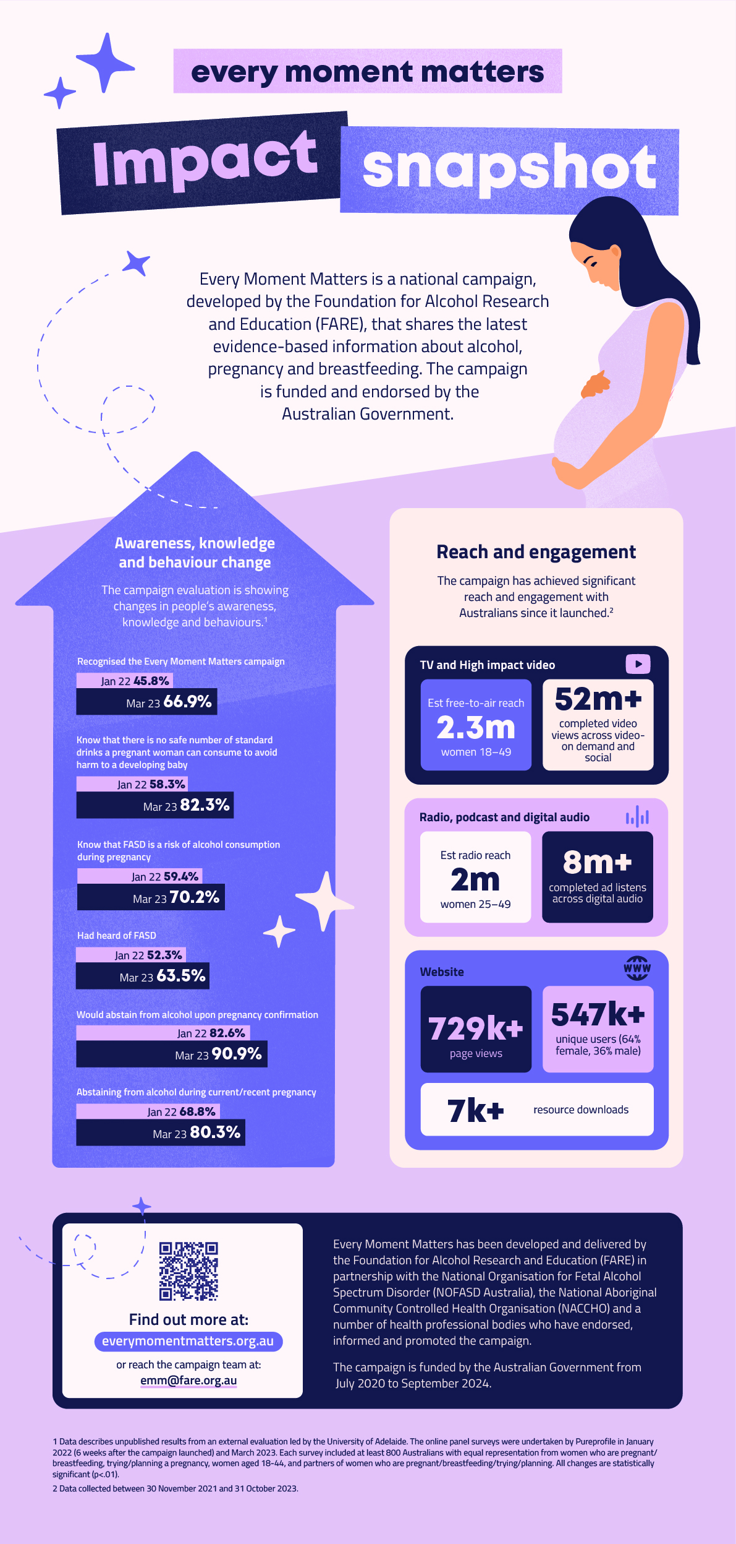

In January 2022 (two months after the campaign launched), our evaluation data¹ showed that 58.3 per cent of women and their partners knew that there is no safe amount of alcohol use during pregnancy. By March 2023, that number had increased to 82.3 per cent.

The number of women who would abstain from alcohol upon pregnancy confirmation has increased from 82.6 per cent in January 2022 to 90.9 per cent in March 2023.

And the number of women who are currently or were recently pregnant who abstain for alcohol has increased from 68.8 per cent in January 2022 to 80.3 per cent in March 2023.

In addition, the number of people who recognized the campaign increased from 45.6 per cent in January 2022 to 66.9 per cent in March 2023.

This shows that the campaign is creating attitudinal and behavioural change, and that more Australians are becoming familiar with the campaign.

## Community stories

An important part of the campaign has been connecting to people’s lived experiences of Fetal Alcohol Spectrum Disorder (FASD) and sharing community stories to raise awareness and provide support and solidarity for women who are pregnant or breastfeeding.

Jen found a range of enjoyable ways to stay healthy and active during her pregnancies with her sons. She also learned more about why it’s important to avoid alcohol during this time and while breastfeeding.

https://www.youtube.com/watch?v=3vIFl6Tx3-k

When Jessica was diagnosed with Fetal Alcohol Spectrum Disorder (FASD) at age 33, it helped her to better understand herself and her experiences of the world. Hear about Jessica’s journey to her diagnosis and how she’s raising awareness of FASD in the community.

https://www.youtube.com/watch?v=KPPLZJcuu2E&t=5s

Angelene’s son lives with FASD. In this video, she talks about alcohol dependence, her son’s FASD diagnosis and her life now as a passionate FASD advocate.

https://www.youtube.com/watch?v=kvwXDsR8SGo

Our Every Moment Matters Ambassador, Dr Jana Pittman shared her story of being both a health professional and a mother of six – read it online [here](https://everymomentmatters.org.au/janas-story/).

If you have a story you’d like to share with us we’d love to hear from you – get in touch at [emm@fare.org.au](mailto:emm@fare.org.au).

## Resources and training for health professionals

Health professionals play a crucial role in providing evidence-based information and advice about alcohol, pregnancy and breastfeeding.

That’s why throughout the campaign we’ve collaborated with a range of health professionals to develop and deliver training and resources on alcohol, pregnancy and breastfeeding.

We’ve reached more than 8,000 health professionals through events online and across Australia, and more than 1,000 health professionals have signed up for our accredited eLearning course.

Hear what Steve Robson, President of the Australian Medical Association has to say about it.

https://www.youtube.com/watch?v=aaRac_x1MD8&ab_channel=FAREAustralia

Of the health professionals who have completed the course, they report an increase in their:

* Confidence in providing advice about alcohol and pregnancy, from 61 per cent prior to undertaking the course to 87 per cent upon completion
* Confidence in providing advice about alcohol and breastfeeding, from 54 per cent prior to undertaking the course to 90 per cent upon completion
* Knowledge about referring for further support, from 44 per cent prior to undertaking the course to 76 per cent upon completion

Find out more about our [resources and training for health professionals.](https://everymomentmatters.org.au/for-health-professionals/)

## Our partners and team

We would like to acknowledge our amazing team at FARE and our partners who have made significant contributions to shaping and delivering Every Moment Matters:

* [NOFASD Australia](https://www.nofasd.org.au/)
* [National Aboriginal Community Controlled Health Organisation](https://www.nofasd.org.au/)
* [Royal Australian and New Zealand College of Obstetricians and Gynaecologists](https://ranzcog.edu.au/)
* [Australian College of Midwives](https://www.midwives.org.au/)
* [Royal Australian College of General Practitioners](https://www.racgp.org.au/)
* [Royal Australasian College of Physicians](https://www.racp.edu.au/)

We would also like to thank our incredible Steering Committee members, who have provided us with support, guidance and advice along the way:

* Professor Elizabeth Elliott
* Dr Hester Wilson
* Dr Vijay Roach
* Ms Louise Gray
* Ms Sophie Harrington
* Dr Dawn Casey
* Mr Steve Ella
* Dr Tanya Hosch
* Professor Simone Pettigrew
* Ms Alison Weatherstone
* Ms Caterina Giorgi

And finally, a shout out to our evaluation and advisory team members:

* Professor Jacqueline Bowden
* Professor Caroline Miller
* A/Professor Scott Wilson
* Dr Shona Crabb
* A/Professor Philippa Middleton
* Joanna Caruso
* Professor Robin Room
* Professor Sarah Robertson
* Paula Medway

## Next steps

The campaign will continue to create change across the country.

In the coming months, we’ll share more community stories and perspectives about alcohol, pregnancy and breastfeeding.

We’ll also bring you more tips and tools on alcohol and breastfeeding.

And we’ll continue to work with health professionals to support alcohol-free pregnancies and safe breastfeeding practices.

If you’d like to get in touch with the campaign team, email [emm@fare.org.au](mailto:emm@fare.org.au) – we’d love to hear from you.

Want to get tips and resources straight to your inbox? Sign up to the [**Every Moment Matters newsletter**](https://everymomentmatters.org.au/every-moment-matters-newsletter/)**.**

1. Data describes unpublished results from an external evaluation led by the University of Adelaide. The online panel surveys were undertaken by Pureprofile in January 2022 (6 weeks after the campaign launched) and March 2023. Each survey included at least 800 Australians with equal representation from women who are pregnant/breastfeeding, trying/planning a pregnancy, women aged 18-44, and partners of women who are pregnant/breastfeeding/trying/planning. All changes are statistically significant (*p*<.01).