# Despite industry objections, alcohol and pregnancy warnings will be mandatory in Australia and New Zealand

The food regulator, Food Standards Australia New Zealand (FSANZ) has finalised the form of the alcohol and pregnancy warning label that will be mandatory on packaged alcohol sold in both countries.

Assuming the States do not request a further review, the new warning will be added as an amendment to [Standard 1.2.7](https://www.legislation.gov.au/Series/F2015L00469) of the [Food Standards Code](https://www.foodstandards.gov.au/code/Pages/default.aspx) and will become mandatory after a two year transition period (see pp 6, 78 [here](https://www.foodstandards.gov.au/code/proposals/Documents/P1050%20Approval%20Report.pdf)).

Here it is.

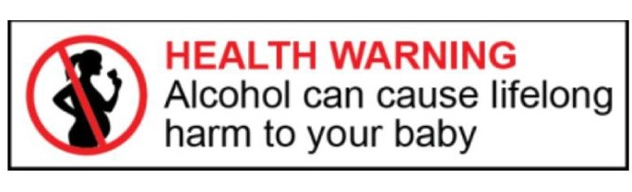

#### It’s been a long time coming

In 2011, the Australian and New Zealand Food Regulation Ministerial Council commissioned a review of food labelling law and policy, chaired by Neil Blewett AC.

The committee’s report, co-authored by Australian public health law pioneer Chris Reynolds, is a terrific document, although increasingly difficult to locate online.

The Committee saw no reason to exempt alcohol from labelling requirements, in view of evidence relating to the risks of binge drinking and longer-term over-consumption.

(In 2015, alcohol use was responsible for more than 6,300 deaths in Australia, or 4% of total deaths – [see AIHW, Australian Burden of Disease Study 2015, Table D2, p 167](https://www.aihw.gov.au/getmedia/c076f42f-61ea-4348-9c0a-d996353e838f/aihw-bod-22.pdf.aspx?inline=true))

Amongst many sensible recommendations, the report recommended that “generic alcohol warning messages should be placed on alcohol labels” as part of a broader, multifaceted, national campaign addressing alcohol-related harm [recommendation 24].

Secondly, it recommended that a mandatory warning about the risks of drinking while pregnant should be included on “containers of alcoholic beverages and at point of sale for unpackaged alcoholic beverages” [recommendation 25].

Thirdly, it recommended that alcoholic beverages should not be exempt from energy labelling requirements that apply to packaged food under [Standard 1.2.8](https://www.legislation.gov.au/Details/F2018C00944) of the [Food Standards Code](https://www.foodstandards.gov.au/code/Pages/default.aspx) [recommendation 26].

The Government’s response to the review is [here](https://foodregulation.gov.au/internet/fr/publishing.nsf/Content/53351997D78AAC31CA258359007E80F5/$File/Forum-Response-to-the-Food-Labelling-Law-and-Policy-Review-9-12-2011.pdf).

Added momentum for a warning label about the risks of drinking while pregnant came from a Parliamentary inquiry in 2012 into the Prevention, Diagnosis and Management of Fetal Alcohol Spectrum Disorders.

The Foreword to this report, from the House of Representatives Standing Committee on Social Policy and Legal Affairs, states:

“FASD [fetal alcohol spectrum disorders] is an entirely preventable but incurable condition caused by a baby’s exposure to alcohol in the womb. The consequences are expressed along a spectrum of disabilities including: physical, cognitive, intellectual, learning, behavioural, social and executive functioning abnormalities and problems with communication, motor skills, attention and memory.”

The lifetime cost of for one person with FASD in the United States is at least UD$2 million (see FASD Strategic Action Plan 2018-2028, p 8).

The Standing Committee recommended that the Commonwealth implement – by 1 October 2013 – a mandatory warning label advising women not to drink when pregnant or planning a baby on packaging of all pregnancy test kits (Recommendation 7).

This recommendation has not been implemented.

The Committee also recommended implementation – by 1 January 2014 – of a warning label for all alcoholic beverages advising women not to drink while pregnant or planning pregnancy (Recommendation 11).

FSANZ has now finalized this warning – for packaged alcohol.  A warning about drinking while breastfeeding was outside the scope of this work.



#### It should have been a non-brainer

The Australian Institute of Health and Welfare reports that in 2016, [around 35% of Australian women drank while pregnant](https://www.aihw.gov.au/reports/children-youth/australias-children/contents/health/smoking-and-drinking-in-pregnancy).  One in four women who were unaware of their pregnancy continued to drink after they found out.

In this age of personal responsibility, alcohol and pregnancy warning labels ought to be a no-brainer, but it has taken until 31 January 2020 for Food Standards Australia New Zealand to approve a mandatory health warning and graphic for alcoholic beverages that contain more than 1.15% alcohol by volume.

For detail of the amendment to Standard 2.7.1, which governs labelling of alcoholic beverages, see [here](https://www.foodstandards.gov.au/code/proposals/Documents/P1050%20Approval%20Report.pdf) (pp 100-104).

The Australian and New Zealand Ministerial Forum on Food Regulation, which is responsible for developing food regulation policy, had earlier, in October 2018, [requested FSANZ to consider options for mandatory alcohol and pregnancy warning labels](https://foodregulation.gov.au/internet/fr/publishing.nsf/Content/forum-communique-2018-October).

Getting FSANZ involved was a good idea – long overdue.  FSANZ is a technical, a-political agency that reviews evidence, considers options and develops the mandatory technical standards that make up the Food Standards Code.

A methodical, evidence-based, bureaucratic process has significant advantages in areas of regulation prone to lobbying and interference from well-resourced industries.

#### The internet remembers

[Draft (updated) National Health and Medical Research Council (NHMRC) Guidelines](https://www.nhmrc.gov.au/health-advice/alcohol) clearly state:

“A To reduce the risk of harm to their unborn child, women who are pregnant or planning a pregnancy should not drink alcohol.

B For women who are breastfeeding, not drinking is safest for their baby.” (p 47)

In 2018, DrinkWise, a responsible drinking campaign largely funded by the alcohol industry, distributed a poster to hospitals and GP clinics around the country that said: [“It’s not known if alcohol is safe to drink when you are pregnant”](https://www.smh.com.au/healthcare/utterly-wrong-what-happens-when-the-alcohol-industry-makes-pregnancy-warning-posters-20180827-p50022.html).

This was widely criticised; [even the *New York Times* ran a story.](https://www.nytimes.com/2018/08/29/world/australia/alcohol-pregnancy-poster-drinkwise.html)

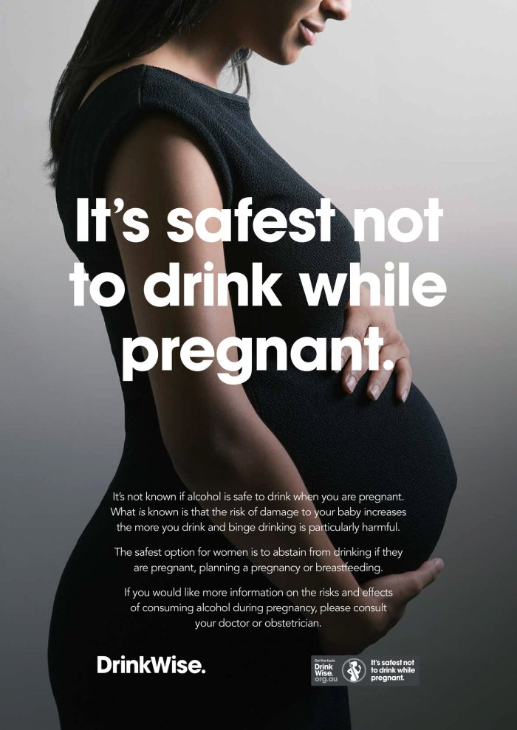

DrinkWise re-phrased its poster (see below).

DrinkWise now has a new campaign called “The internet remembers”.

Indeed.

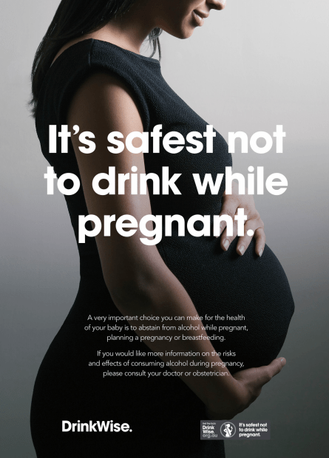

#### Alcohol industry objections

The Approval Report for the new warning label lists the concerns raised by the alcohol industry, together with FSANZ’ response.  The warning FSANZ chose was: “Alcohol can cause lifelong harm to your baby” – which performed better in consumer testing than “Any amount of alcohol can harm your baby”.

For its part, the alcohol industry suggested that the text of the warning should be “It’s safest not to drink while pregnant” as “medical knowledge is not settled whether drinking small amounts [while pregnant] has a bad influence [on the foetus] (see p 44 [here](https://www.foodstandards.gov.au/code/proposals/Documents/P1050%20Approval%20Report.pdf)).

Industry was also concerned that the words “HEALTH WARNING” were “misleading, inflammatory and may alarm consumers” (p 26).  It recommended changing “HEALTH WARNING” to “DRINK RESPONSIBLY” (p 28).

FSANZ noted, unsurprisingly, that such a change would “not meet the intended purpose of the pregnancy warning label to reinforce public health advice and messaging not to drink alcohol while pregnant”.

Industry also objected to the red font required for “HEALTH WARNING”, on the basis that it would inflate costs.  It requested a monochromatic label (p 44).  It wanted the label to be smaller (p 29).  It felt the cost of the label was not proportionate to the benefit (pp 33-34).

Industry sought a longer phase-in period of up to 5 years, rather than the 2 years proposed by FSANZ (p 36).

Overall, while the alcohol industry was “fully supportive of interventions that are proportionate, well evidenced and shown to be effective at changing harmful consumption behaviours”, it was “concerned about the lack of rigour of the proposal in this regard” (p 43).

Its objections even extended to the ponytail in the graphic of the woman (p 24).

Overall, the impression you get is of an industry keen to reduce the consumer impact of the warning, keen to delay its implementation, and far more interested in revenue than the harm its products can cause the next generation.

No surprises there, unfortunately.



**You can help protect future generations with mandatory alcohol pregnancy warning labels.**

[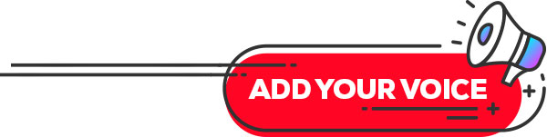](https://fareaustralia.good.do/campaign/pregnancywarninglabel/)