Darwin Dan Murphy's

April 2021: After almost a five-year battle, Woolworths decided not to proceed with the alcohol megastore in Darwin.
This is a huge community victory after years of poor consultation and lack of empathy for community concerns from one of the nation’s biggest corporations.
Thank you for amplifying the voices of the local community, Aboriginal and Torres Strait Islander organisations and health groups, who have been fighting for what is right.
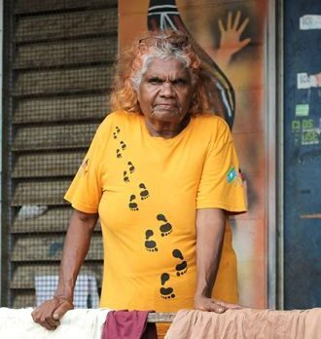
"It just goes to show people that if you can use your mouth like I do, and use it in the right way, you can get to where you want to go."

Helen Fejo-Frith
Bagot Aboriginal Community April 2021

Hear from the community

Will you pitch in?
Who doesn’t want to see passionate communities standing up to large alcohol companies… and winning?
This story shows the true might of people power. It shows that no matter the circumstances, we can win if we come together as a community. We want to use the power of storytelling to move people and inspire similar movements.
If we can inspire at least one community in Australia or the world to fight for what is right, it would have served its purpose.
FARE wants to work with Garuwa, an Aboriginal-owned storytelling agency, to create a documentary trailer to showcase to others why this story needs to be told, and to raise funds to support the production costs.
Can you please donate to help us raise $5,000 to create a trailer with Garuwa?
Click here to donate

How did we get here?
For almost five years, Woolworths relentlessly fought to build what would have been one of Australia’s largest liquor stores, an 1800-square-meter Dan Murphy’s, on the doorstep of Bagot community, a dry Aboriginal community in Darwin.
Woolworths pursued this store in the face of community opposition and concern, in the full knowledge that the Northern Territory (NT) already has the highest levels of alcohol harm in the country, and despite being aware that the proposed development threatened to undermine the successful alcohol policies that the NT Government introduced to reduce community harm.
Woolworths knew there was strong community objection to its proposed Dan Murphy’s development.
The development was opposed by the Bagot Community, members of the public, and organisations including the Northern Territory Council of Social Service (NTCOSS), Danila Dilba Health Service, Aboriginal Medical Services Alliance NT (AMSANT), and Aboriginal Peak Organisations Northern Territory (APONT).
The NT Liquor Commission rejected Woolworths’ application for this store. In making its decision, the Commission found that “approving the application would lead to a significant increase in the level of alcohol related harms which already exist in this community.”
"It is most unfortunate that the Applicant did not engage in consulting the local community prior to committing to this site because it would, in our view, have come to the realisation that this was not an appropriate position for any liquor store, let alone one the size of Dan Murphy’s."

NT Liquor Commission
Decision Notice 20 September 2019
Yet Woolworths continued to ignore community concern in its pursuit of its giant Dan Murphy’s store, refusing to accept the clear decision of the independent Liquor Commission. They appealed to the NT Civil and Administrative Tribunal (NTCAT) and then the Supreme Court. In the end, Woolworths did not win any cases in favour of building this store.
Enter the NT Government. Introduced by the Minister for Small Business in November 2020, the Government passed legislation to allow yet another re-consideration of the proposed development. This time, Woolworths could have their liquor license decided by just one person — the Director of Liquor Licensing — rather than the independent Liquor Commission.
Since the rules of natural justice did not apply under this new legislation, the Director of Liquor Licensing was not required to consult with the impacted community — and decided to approve Woolworths’ application to build their alcohol megastore in Darwin.
But this legislation and change in process also drew further attention to the problems of this store and how community views had unfairly been ignored.
In response to growing community pressure from around the country, just before receiving their liquor license approval, Woolworths announced they would fund an independent review of their proposed store led by Danny Gilbert. The review would also look at whether Woolworths had behaved appropriately in their engagement with community.
The community told their story to the review panel and made sure their voice would be heard.
In April 2021, Mr Gilbert and his panel submitted the report clearly stating that the development should not go ahead because local Aboriginal and Torres Strait Islander communities were not adequately consulted during this process.
Woolworths conceded. After almost a five-year battle, Woolworths decided not to proceed with the alcohol megastore in Darwin.
During this long period of campaigning, people from all over the country helped amplify the campaign efforts at various stages. More than 155,000 of people signed petitions and shared content on social media. They actively engaged in this campaign and made sure that Woolworths and Dan Murphy’s felt the public pressure and listened to what the communities had to say.
Woolworths’ decision to halt the development of the store is an acknowledgement to people power and how we can bring about real-world change.

Timeline
9 June 2021Landmark report highlights failures by Woolworths and shows need for reform
The full report by the Woolworths-appointed panel, into the company’s now abandoned plan to build an alcohol megastore in Darwin, has been released.
Read the report
24 May 2021Woolworths surrenders the liquor licence to the government
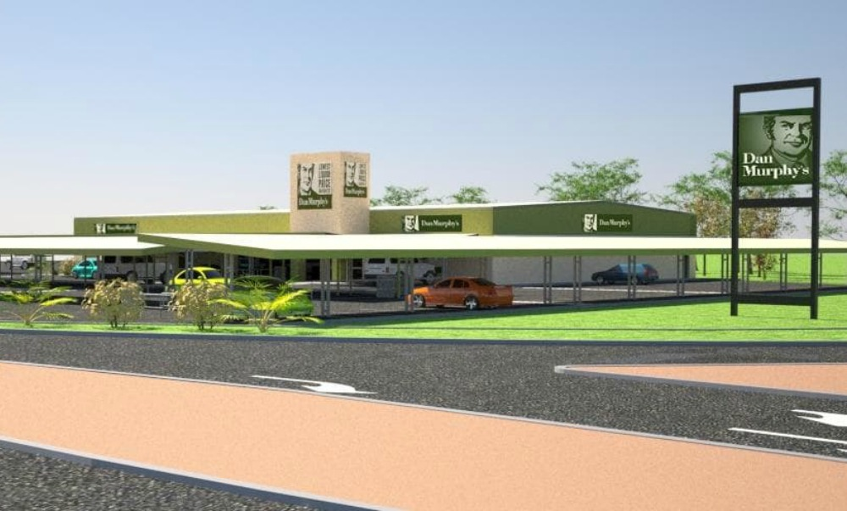Following Woolworths’ decision to abandon its plans to build the alcohol megastore in Darwin, the company has now formally surrendered its liquor licence back to the NT Government, which was granted to them by the Director of Liquor Licensing in December 2020. This means that, for now, there is no back door open for Woolworths or any of its subsidiaries to build a liquor store in the area.
30 April 2021Woolworths has abandoned its plan for a Dan Murphy’s in Darwin. But is that the end of the story?
After a five-year saga involving court challenges and political twists, the company has abandoned its plan to set up its first Dan Murphy’s store in Darwin.
Read more
26 April 2021Community leaders say new Dan Murphy’s store will add fuel to fire of town’s drinking problem
“We don’t want another [liquor store] outlet,” Helen Fejo-Frith says. “Especially one that big. There’s already enough outlets around here and look at the violence, kids roaming the streets here, kids fighting.”
Watch the 7.30 report story
5 March 2021Danila Dilba launches legal action against Woolworths, NT Liquor Licensing director over Darwin Dan Murphy’s
“I think we have to use every available means to try and stop the development of this particular takeaway outlet.” – Danila Dilba chief executive Olga Havnen
Read more
18 February 2021Call for Reconciliation Australia to pull Woolworths support over Darwin Dan Murphy’s
Aboriginal and Torres Strait Islander community and health leaders want Reconciliation Australia to revoke its support for Woolworths over the retail giant’s plans to build one of Australia’s largest alcohol stores in Darwin, near three dry Aboriginal communities.
Read more
4 February 2021Community groups criticise Woolworths for divisive tactics during push to build Darwin liquor store
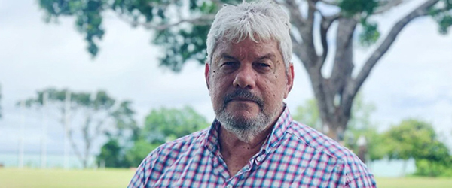“It’s wedging Aboriginal groups against each other. This is the game that they’re good at, big corporates, they love it, and we’re calling on them to cease it. Take a social conscience in all of this and listen to the Aboriginal leadership here in the Northern Territory and withdraw your application now.” – John Paterson, CEO AMSANT
Read more
4 February 2021Woolworths’ social responsibility called out over Darwin liquor store
Indigenous community groups in Darwin have hit out against the Woolworths Group for what they say is the company’s failure to have genuine community consultation over the construction of a Dan Murphy’s liquor store.
Listen to the interview
4 February 2021Danny Gilbert names panel for Darwin Dan Murphy’s review
Mr Gilbert subsequently appointed four panel members – Heather D’Antoine, an honorary fellow with Menzies School of Health Research, Neil Westbury, chairman of the MJD Foundation and a former director of the Indigenous Land Corporation, Nigel Browne, former crown prosecutor and chief executive of the Larrakia Development Corporation, and Roland Houareau, general manager of INPEX in the Northern Territory.
Read more
18 December 2020Director of Liquor Licensing officially approves Woolworths application despite strong community objection
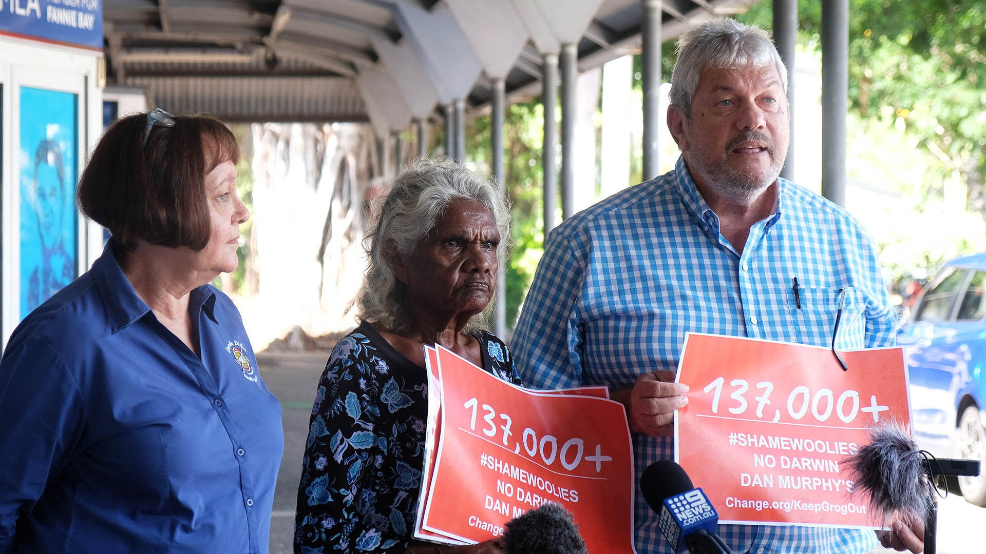
Community groups disappointed in decision but vow to keep fighting alcohol megastore
Read more
12 December 2020Australian Financial Review: Woolworths Dan Murphy’s under fire over first Darwin store
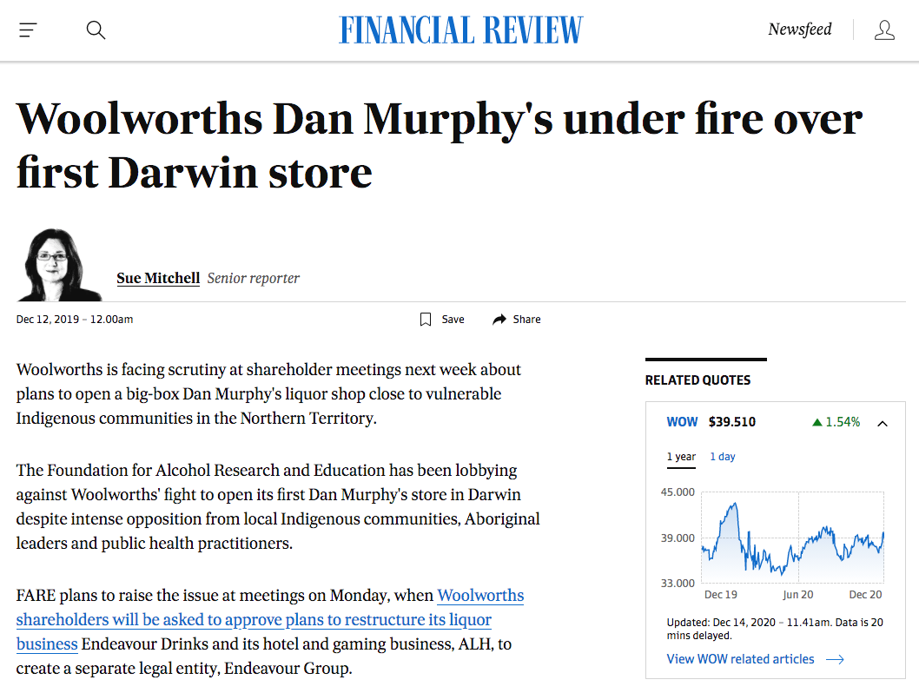
“The Darwin Dan Murphy’s saga now threatens to become Woolworths’ version of Rio Tinto’s Juukan Gorge scandal.”
“Woolworths is facing scrutiny at shareholder meetings next week about plans to open a big-box Dan Murphy’s liquor shop close to vulnerable Indigenous communities in the Northern Territory.”
Read the article
9 December 2020Open Letter to Woolworths Chairperson Gordon Cairns
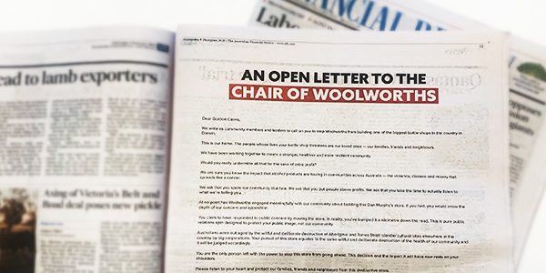
45 organisations and community leaders signed an impassioned open letter to Woolworths Chairperson Gordon Cairns. This letter was published as a full-page advertisement in the Australian Financial Review (AFR).
The Bagot Community, members of the public, and organisations including the Northern Territory Council of Social Service (NTCOSS), Danila Dilba Health Service, and Aboriginal Medical Services Alliance NT (AMSANT) have all been loud and clear in their demand:
“Abandon your plans to build a Dan Murphy’s in Darwin.”
View the open letter
3 December 2020NT Community continues to speak out, refuting Gordon Cairns (Woolworths Chairperson) claims of community consultation during Woolworths AGM.
“Woolies we don’t want your megastore here in Darwin” – Samuel Bush-Blanasi (Chairman, Northern Land Council)
“You haven’t consulted with the community” – John Paterson (CEO, Aboriginal Medical Services Alliance Northern Territory)
24 November 2020Change.org petition hits more than 130,000 signatures
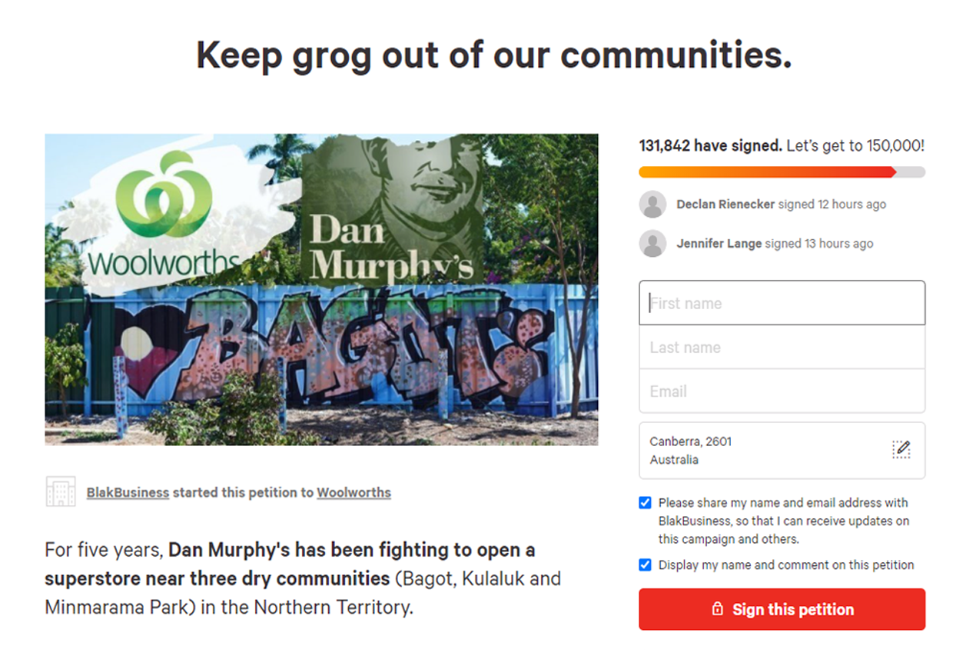
Sign the petition
13 November 2020New location for proposed liquor megastore still not welcome, say Aboriginal health advocates
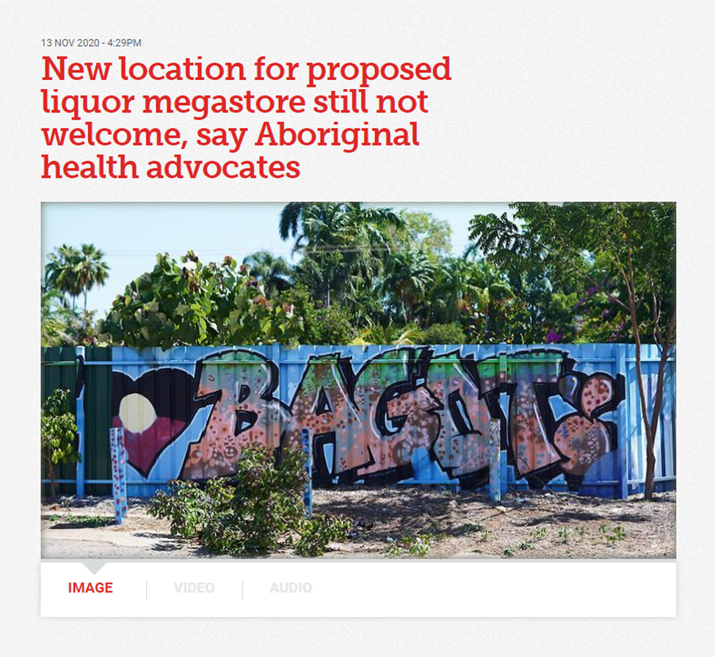
The announcement that a Dan Murphy’s outlet would relocate to an alternate site fails to alleviate the concerns of Aboriginal community health advocates.
12 November 2020‘Absolute hypocrisy’: Woolies faces backlash over Dan Murphy’s Darwin megastore
Supermarket giant Woolworths faced increasing pressure from Darwin-based health and Indigenous community groups to reconsider a controversial plan to open one of its biggest Dan Murphy’s liquor outlets in the city.
Read more
11 November 2020Aboriginal groups warn on health and social costs if Northern Territory opens door to Dan Murphy’s
Moves by the NT Government to weaken its alcohol policy reforms were condemned by leading NT Aboriginal, health and social groups and community members, including Aboriginal Medical Services Alliance Northern Territory (AMSANT), the NT Council of Social Service, FARE, and Association of Alcohol and other Drug Agencies Northern Territory (AADANT).
Read more
10 November 2020NT Government introduces legislation to bypass independent Liquor Commission process
The NT Government introduced the Liquor Further Amendment Bill 2020, giving power to the Director of Liquor Licensing to decide on the Woolworths’ Dan Murphy’s application within 30 days.
Under the legislation, the Director of Liquor Licensing has discretion to make the decision without following the laws of natural justice or considering the previous decisions by the Liquor Commission or NTCAT.
Woolworths can propose an alternative location without submitting a new application [s334 (4) (a)] and without seeking the views of the community at the new location. The current NTCAT proceedings would be terminated and the Director’s decision would not be reviewable by NTCAT.
The legislation was considered urgently by the NT Legislative Assembly and passed on 12 November.
Read more
22 October 2020Woolworths seeks adjournment of NTCAT public hearing to early 2021
Having sought a number of delays to the NTCAT proceedings, Woolworths was granted a further delay and the full hearing was adjourned to early 2021.
18 May 2020An Elder’s plea to Woolworths
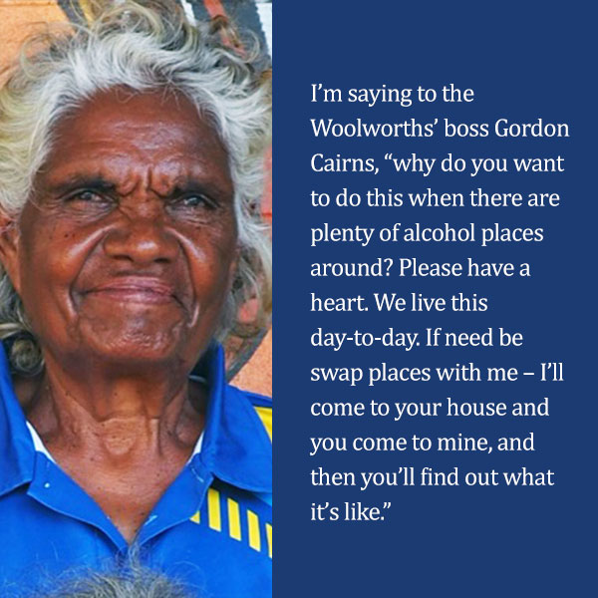
15 May 2020NTCAT Directions Hearing for Woolworths’ application, setting out the timeframe for the case
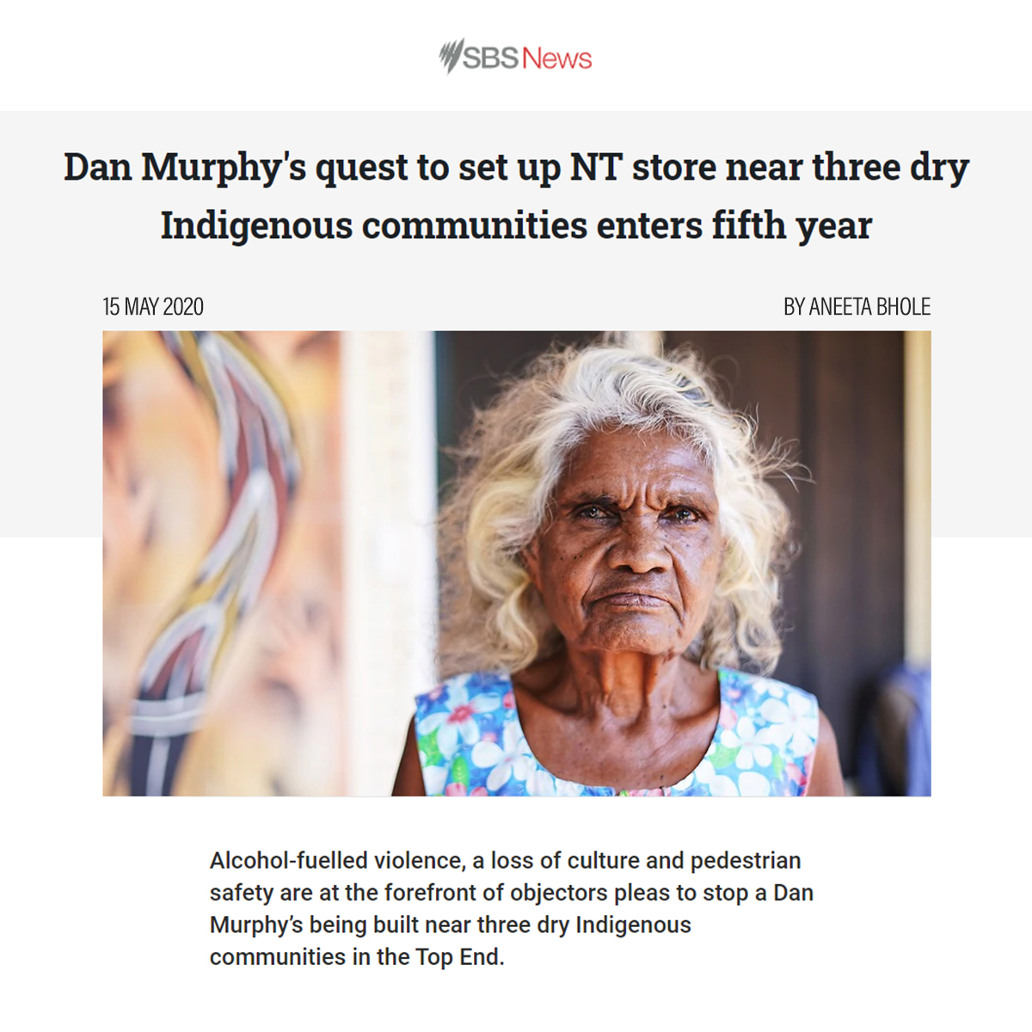
29 April 2020Research: Independent evaluation finds alcohol reforms aimed at cutting alcohol related crime and antisocial behaviour and harm across the Northern Territory are working

Minimum Unit Price results in:
- 23 per cent reduction in alcohol related assaults across the Territory in 2018/19 compared to the same period in 2017/18
- 17.3 per cent reduction in alcohol related ED presentations in the NT in 2018/19 compared to the same period in 2017/18.
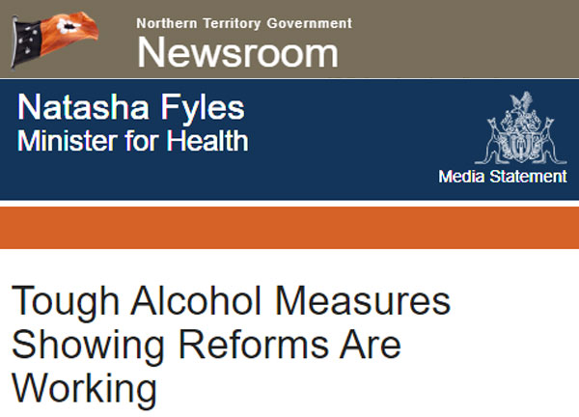
23 April 2020Woolworths lodged an application to have the case reconsidered at NCAT.
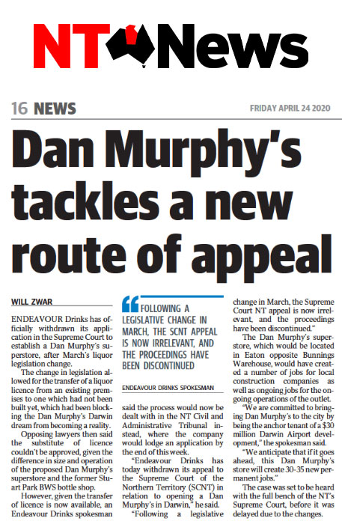
20 April 2020News: Should Woolworths’ board stop a morally dubious liquor barn?
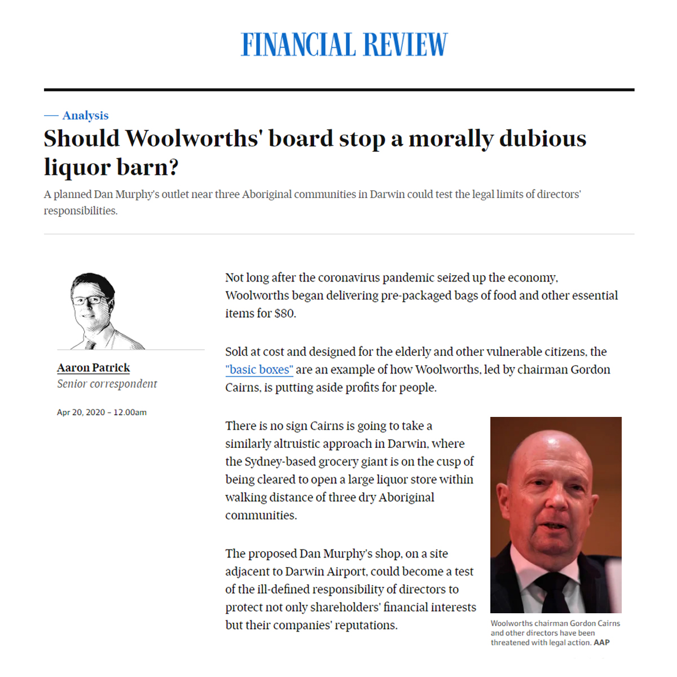
A planned Dan Murphy’s outlet near three Aboriginal communities in Darwin could test the legal limits of directors’ responsibilities.
Read more
27 March 2020FARE took the unprecedented step of formally writing to the Board of Woolworths asking them to properly consider and reassess their Director responsibilities under the Corporations Act 2001.
“In light of the LC Decision, FARE’s position is that it is reasonably foreseeable that to continue to pursue the proposed development will carry with it significant reputational risk to Woolworths.”
Read more
24 March 2020The Scrutiny Committee report was tabled in Parliament, The Liquor Amendment Bill was introduced and passed before Parliament was suspended due to COVID-19.13 February 2020Legislative Assembly introduced the Liquor Amendment Bill 2020 and referred it to the Legislation Scrutiny Committee for inquiry.
The legislation was passed by the Assembly on 27 March 2020. As a result, Woolworths withdrew from the Supreme Court action since the legislation changed the Liquor Act 2019 to remove the barriers to the application identified by NTCAT.
19 January 2020News: Dan Murphy’s bid to set up NT store enters fifth year as appeal heads to Supreme Court.
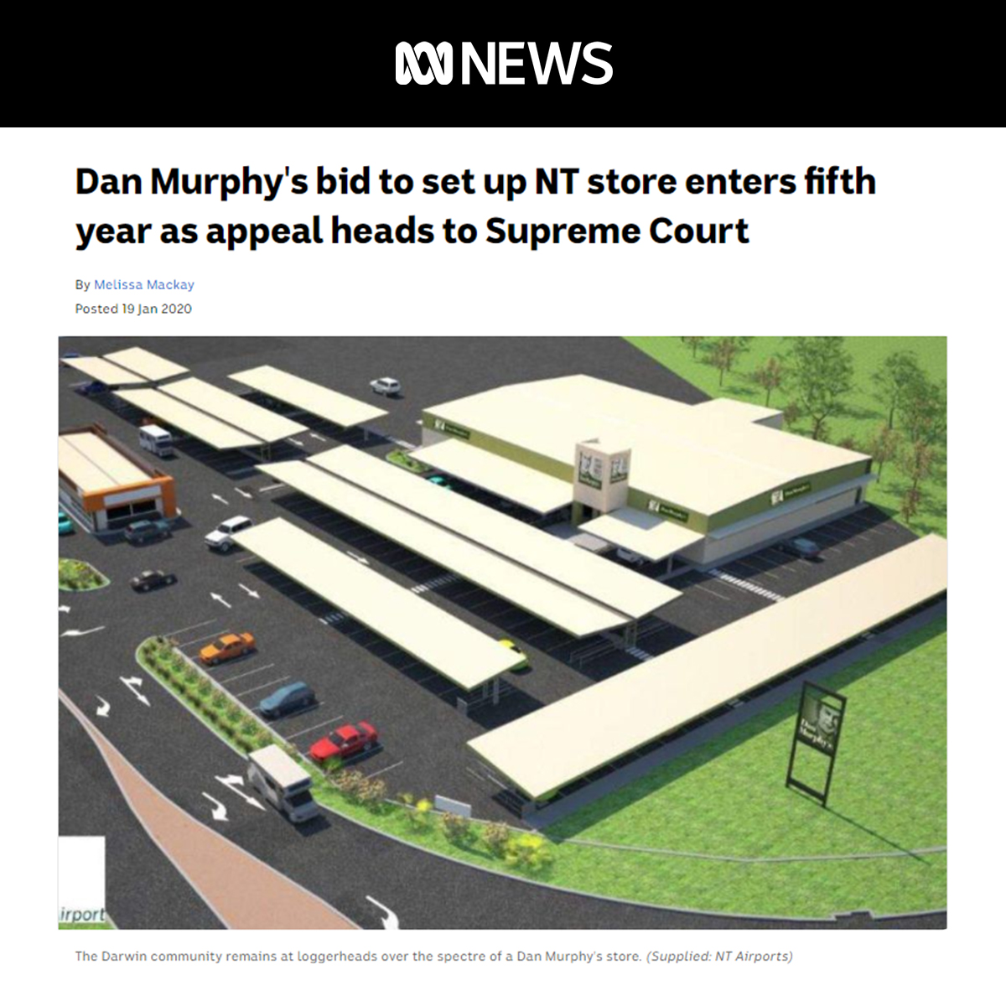
6 January 2020Woolworths applied to the Supreme Court of the Northern Territory for leave to appeal the Tribunal decision.23 December 2019NTCAT dismisses Woolworths’ application on the grounds that it wasn’t open to Woolworths to make the application
“an application to the Commission pursuant to s 46A of the 1978 Act for the substitution of other premises, could only be made in relation to premises that existed”.
Read more
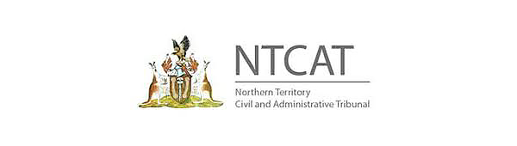
12 December 2019News: Woolworths Dan Murphy’s under fire over first Darwin store
Woolworths is facing scrutiny at shareholder meetings next week about plans to open a big-box Dan Murphy’s liquor shop close to vulnerable Indigenous communities in the Northern Territory.
Read more
18 October 2019Report: NT alcohol harm-reduction report
FARE & PAAC Report examines data following the introduction of the NT’s most comprehensive alcohol reforms, including the Riley Review recommendations. The data indicates that the measures progressively executed since the election of the Gunner Government in 2016 have had a significant effect in reducing alcohol-related violence.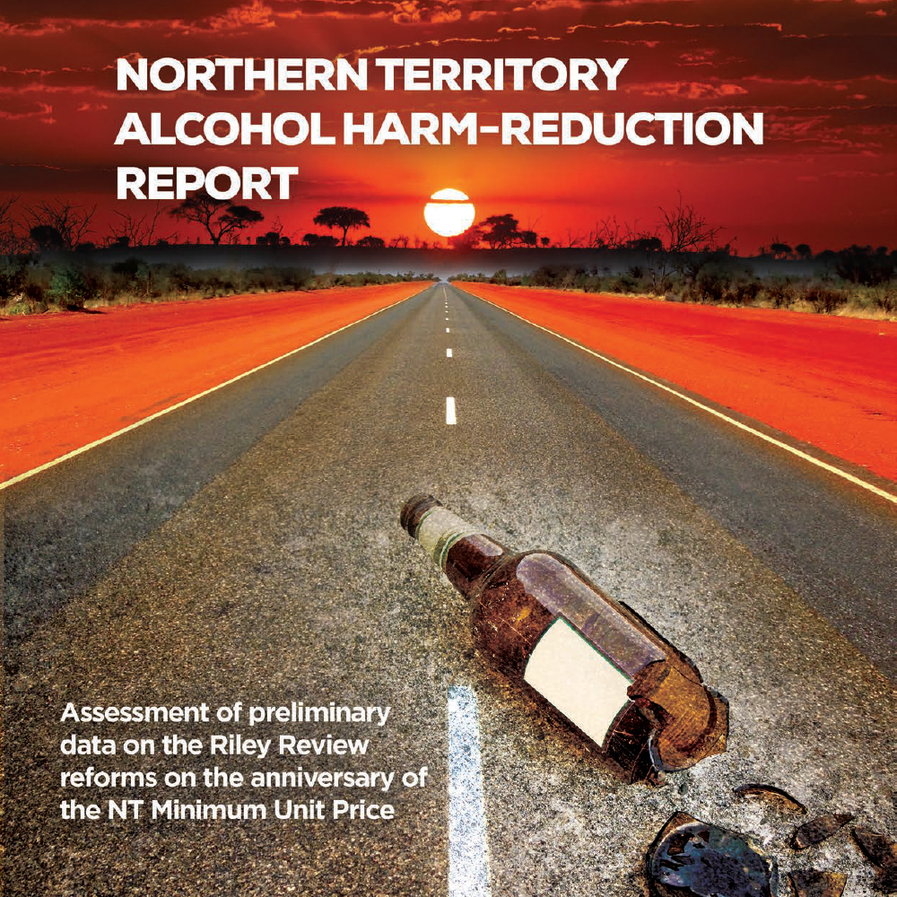
18 October 2019Woolworths appealed the NT Liquor Commission decision to the NT Civil and Administrative Tribunal (NTCAT)1 October 2019NT Liquor Act 2019 came into effect.
The Northern Territory Government overhauls the Liquor Act 1978 in response to the 2017 Alcohol Policies and Legislation Review Final Report (the Riley Review).
20 September 2019News: Dan Murphy’s Darwin store plans rejected by NT Liquor Commission
Woolworths’ bid to set up a Dan Murphy’s liquor store in Darwin has been rejected by the Northern Territory Liquor Commission because it would increase the risk of alcohol-related harm in nearby Aboriginal communities.
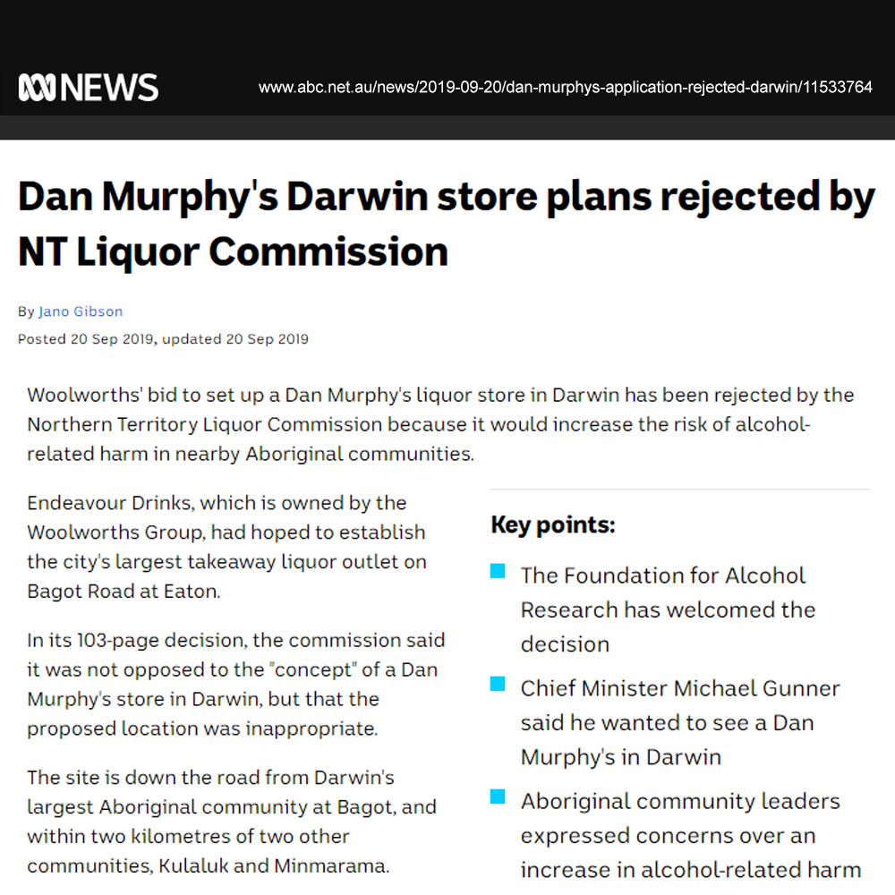
20 September 2019The NT Liquor Commission denied the application for substitution on 20 September 2019, noting the “potential for a significant increase in harm due to the use of liquor, over and above that already occurring within the community areas”.
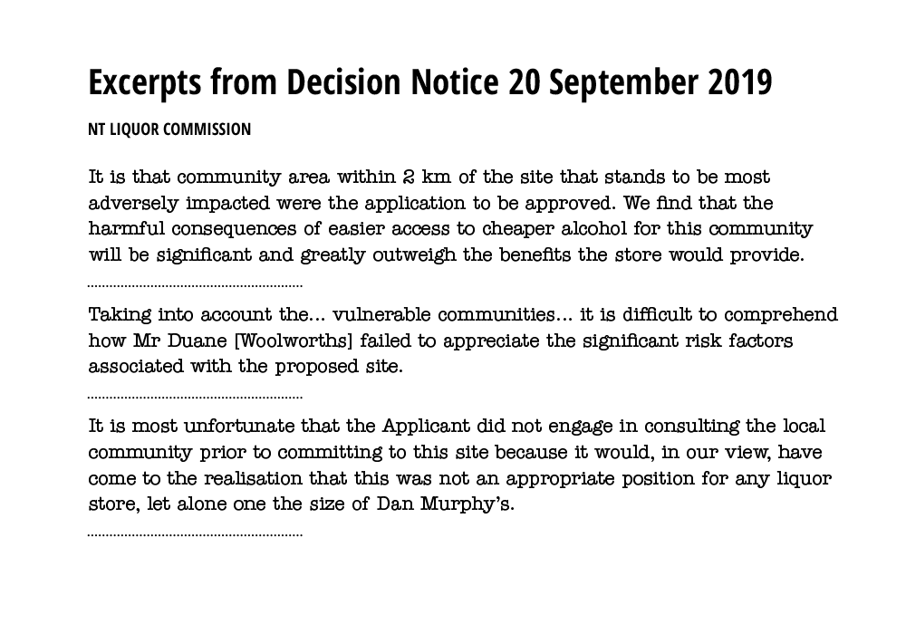Read more
4 June 2019Take a closer look: Woolworths’ proposed high-risk location for alcohol superstore.
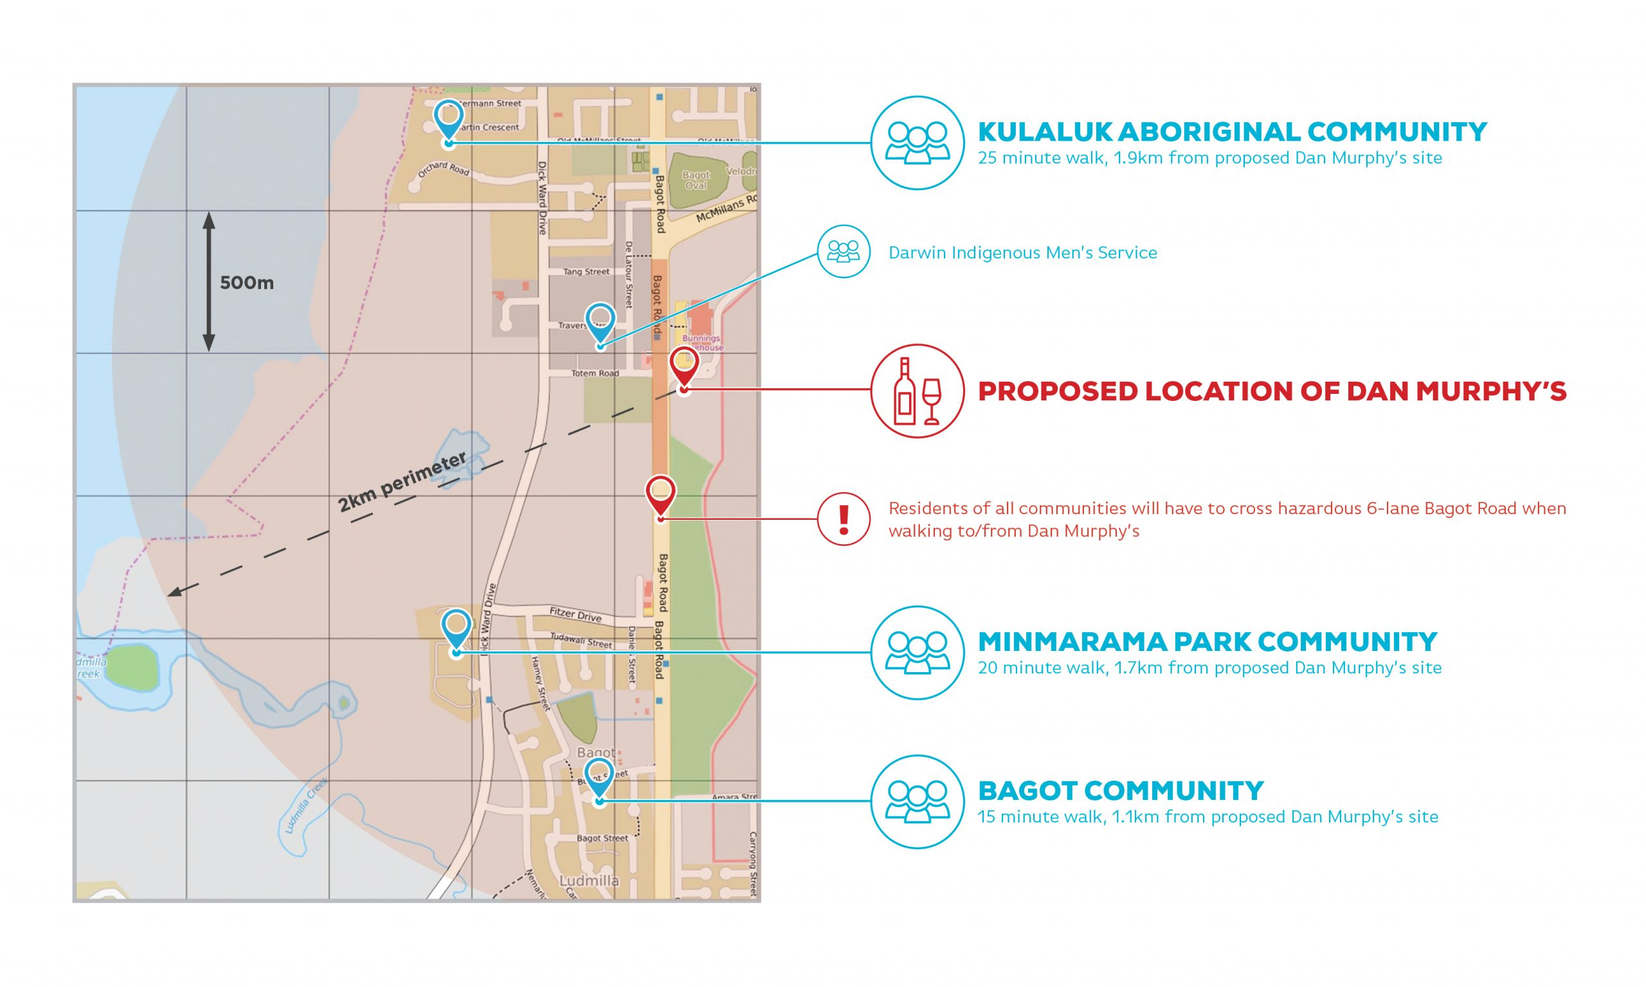
4 June 2019Bagot Community spokesperson, Ms Helen Fejo-Frith has lived at Bagot for 21 years. She represents her community in opposing the development.
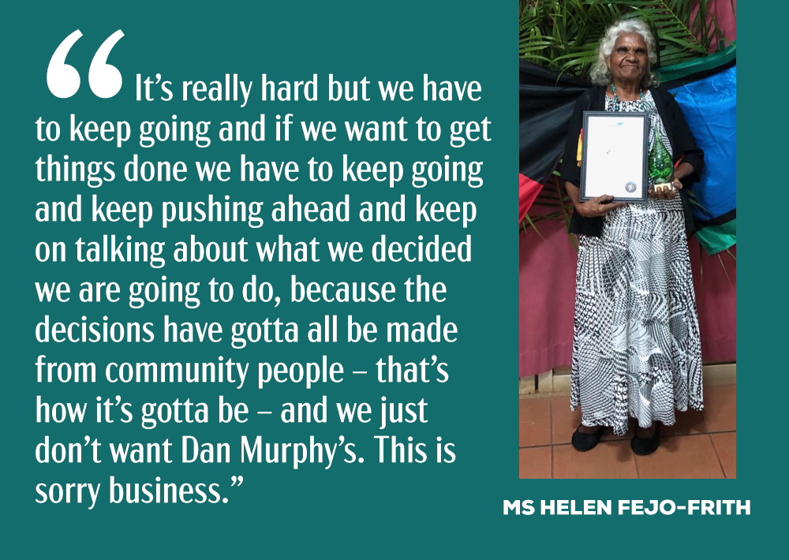
4 June 2019Woolworths applies to NT Liquor Commission for licence: Since December 2016, the largest packaged liquor retailer in Australia has been attempting to build what will be one of Australia’s largest liquor stores.
In June 2019 Woolworths commenced its next legal action, applying to the NT Liquor Commission to open the first Dan Murphy’s store in Darwin.
The application was opposed by local Aboriginal communities, members of the public, and organisations including FARE, NTCOSS, Danila Dilba health service, Aboriginal Medical Services Alliance NT, Public Health Association NT, and Amity Community Services.
19 July 2018Woolworths lodged an application to build a Dan Murphy’s liquor outlet on the corner of Osgood Drive and Bagot Road, Eaton.5 February 2018The NT Government announces legislation to reestablish an NT Liquor Commission.
Read more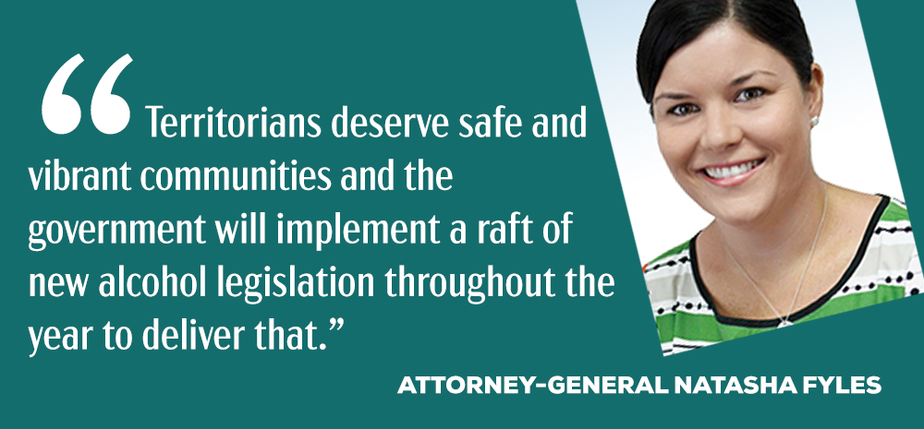
27 October 2017The NT Government’s five-year moratorium on new take-away liquor licences came into effect on this day.
This completes recommendations 1.1.4 – 1.1.6 of the Riley Review, and is an initiative under the NT Alcohol Harm Minimisation Action Plan 2018-2019.
19 October 2017The Alcohol Policies and Legislation Review Final Report made a range of recommendations to reduce alcohol harm in the NT. The NT Government has implemented almost all of these recommendations.
FARE welcomed the review saying “the exhaustive review and its recommendations set a new benchmark for effective alcohol harm reduction measures…and will transform the lives of most Territorians”.
View the report | View the media release
1 August 2017Woolworths withdraws case from Federal Court action against the NT Government.27 April 2017In 2017, an independent review into alcohol in the NT — the Alcohol Policies and Legislation Review (Riley Review) was established to tackle the high level of alcohol harm in the NT.
The Independent Expert Advisory Panel, Chaired by Justice Trevor Riley, undertook wide public consultation on all aspects of the current alcohol policies and legislation together with the Liquor Act.
The overarching objective of the review was to provide recommendations to the NT Government on evidence based best practice alcohol harm prevention and management initiatives.
Read more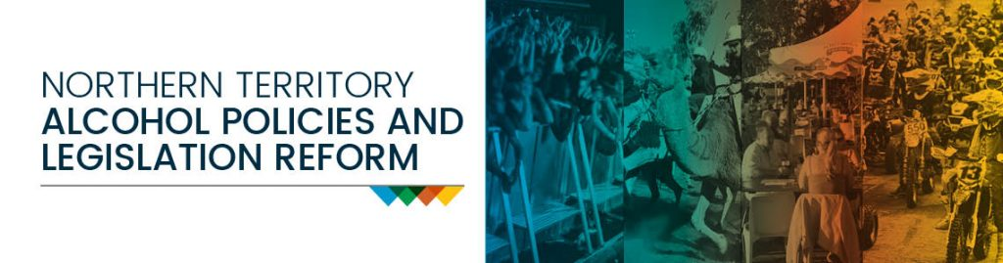
9 March 2017Woolworths applied to the Federal Court of Australia to have the amendments made under the The Liquor Amendment Regulations 2016 declared invalid on the basis that they were not within the regulation making powers of the Government.22 December 2016Woolworths applied to substitute an existing licence for a Dan Murphy’s store and threatened to take the NT Government to court.19 December 2016The NT Government amended the Liquor Regulations to make it a condition of a store licence that the retail floor space was limited to a maximum of 400 square metres.

