# City2Surf 2024

|  |  |
| --- | --- |
|  |  |

[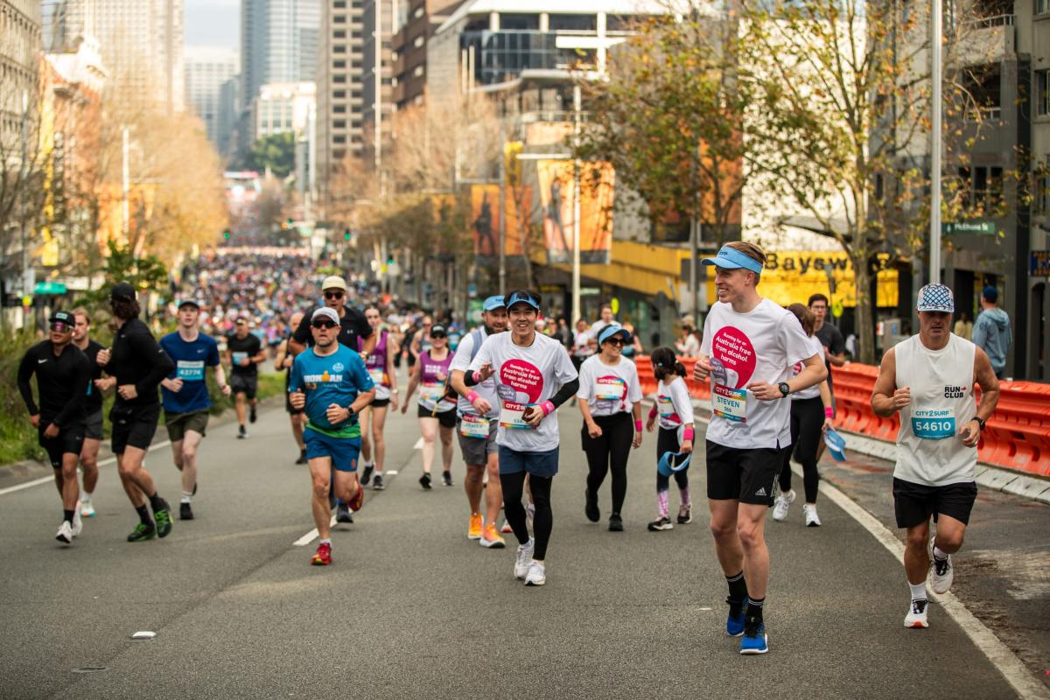](https://fare.org.au/wp-content/uploads/photo-gallery/imported_from_media_libray/RBB11321-scaled.jpg?bwg=1723526803)