# Children with disabilities shouldn't be in prison

Children with disabilities shouldn’t be in prison. Children shouldn’t be in prison at all.

Sam is a 14-year-old living with Fetal Alcohol Spectrum Disorder (FASD), who deserves to be living a happy and healthy life, with the support services she needs.

Sam's story, [shared by the Guardian and SBS The Feed](https://www.theguardian.com/australia-news/article/2024/jul/18/at-14-sam-has-the-mental-capacity-of-a-five-year-old-so-what-is-she-doing-in-a-queensland-police-cell-ntwnfb), exposes how our health and justice systems are failing children like her who live with FASD, a brain-based disability, placing her at greater risk of harm by locking her up again and again.

[FASD is a life-long neurological disorder](https://everymomentmatters.org.au/alcohol-and-pregnancy/fetal-alcohol-spectrum-disorder-fasd/) caused by prenatal exposure to alcohol, and it affects an estimated two per cent of the Australian population.

People living with FASD will have unique strengths and challenges.

Some common challenges include:

* Memory impairment
* Physical and emotional developmental delay,
* Impaired speech and language development,
* Impulse control deficits
* Difficulty regulating emotions and understanding cause and effect and consequences,
* Finding communication and social interactions challenging and
* Difficulty managing response to external sensory stimuli

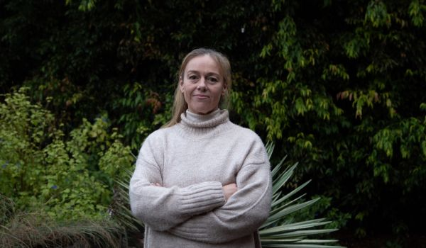

Angelene Bruce is the biological mum to a thriving child with FASD, and a FASD advocate.

Children affected by FASD are also born with more naturally occurring cortisol in their brains. This causes a fight, flight, freeze response to high anxiety-provoking situations. If there is added environmental trauma, children can live in this response 24/7.

Young people living with FASD are more likely to admit to crimes they didn’t commit, not understand some behaviours are wrong, or panic during encounters with police and run away or resist arrest.

This is further evidence of their brain domain deficits and flight, fight, freeze response.

Given these challenges, children with FASD can be disproportionately caught in a spiral of offending and detention.

We need to ensure we’re doing all we can to prevent FASD through education and awareness and, for people living with FASD we need to ensure informed support is readily available.

My biological son, now 15, was diagnosed with FASD by age four.

I know first-hand how challenging it is for women to disclose prenatal alcohol exposure, and this disclosure makes up half of the diagnosis.

Prenatal alcohol exposure is never malicious and disclosing it is the most selfless thing a woman could do for her baby to obtain a correct diagnosis.

My son is thriving thanks to early diagnosis, access to an NDIS plan, FASD informed interventions from his speech and occupational therapists and psychologist, alongside appropriate accommodations at school.

Despite this, he does still suffer from high anxiety.

Thankfully he hasn’t experienced any of the secondary disabilities of undiagnosed, misdiagnosed and unaccommodated FASD.

These include a disrupted school experience through punishment, expulsion or suspension, early and ongoing contact with criminal justice systems, substance misuse disorders, homelessness and extreme sexual vulnerability.

https://youtu.be/kvwXDsR8SGo

Every child with diagnosed or suspected FASD should have access to the same informed services my son does, regardless of where they live or their socioeconomic situation.

Wherever alcohol goes, FASD will follow.

The introduction of FASD, trauma and culturally informed occupational therapists, speech therapists and psychologists, working side by side with staff in the justice system would undoubtably improve the outcomes for all involved.

Importantly, the rates of reoffending would also be significantly less.

We need to screen everyone who interacts with the criminal justice system for developmental disabilities including FASD and train people working in the system to better understand that the challenging behaviours these children present, are primary symptoms of FASD hiding in plain sight.

It’s also crucial to remember that FASD will be invisible from the outside in the vast majority of people, however the brain and central nervous system is profoundly affected.

Children with FASD, and their families should be offered care and compassion and given the support they need in the community to remove barriers and allow strengths to shine.

***For confidential information or support for families living with FASD, call the*** [***NOFASD Australia***](https://www.facebook.com/NOFASD.Australia?__cft__%5b0%5d=AZWIGt02HrsvqBVlCedNNCvQg_oLq-t35DlNPoOxuCG8vOaGK16_pXRL3e9yN7r-n5qU82AJRQUnMIHT44IhHQHFVhIWNfF1AqxLPgKsDSI9WRikIAb3EFvyNP6S0ASutJ4HLOrjyaWKP9_yNHE_8uQLEszfuWwaLL4blfPIIxTE5wVAUT_WvNT2re8QY0DIhWeJq1rjylRXodTFoH0-7l2b&__tn__=-%5dK-R) ***national helpline on 1800 860 613.***