# Beyond education, what can school communities do to address harm from alcohol?

Schools are central parts of our community that reflect and can impact on broader community values, including around alcohol. They have significant potential as settings where well-planned alcohol education programs can be delivered to large populations of young people at key times in their development, for example before young people have their first drink. Schools are also in a great position to influence social norms on alcohol through their policies and practices. While it’s clear they have significant potential, we know that schools cannot do everything and that the curriculum is already crowded. In an effort to help inform and guide activities of schools and those working with schools, the Alcohol Programs Team at PHAIWA, in consultation with a range of organisations and individuals, developed a [list of priorities for action on alcohol through the school setting in WA](https://alcohol.phaiwa.org.au/assets/publications/reports/Priorities-for-action-to-prevent-alcohol-related-harm-through-school-communities_January-2020.pdf). The priorities are evidence-informed and consensus based. They were developed based on a review of the best available evidence and key guiding strategies and refined through consultations with public health organisations, parent associations, child advocates, educational associations, peak bodies, government departments, researchers, and school staff. Promoting the use of mandatory, well-supported, evidence-based alcohol and other drug education across the school curriculum is a clear priority. Alcohol education in WA schools is not compulsory or comprehensively recorded. While health education is required as part of the curriculum, schools may make the choice to include alcohol education programs. There is no doubt that many schools provide high quality alcohol education, but no one knows exactly what is taught, how much, how well and with how much teacher training. School alcohol and other drug education programs should be evidence-based and undergo regular evaluation. School staff should also be well supported to be able to deliver comprehensive alcohol and other drug education with appropriate training, professional development and access to high quality resources.   Other opportunities to address alcohol-related harm include encouraging schools to become truly alcohol-free environments. In WA, it is not uncommon for occasional liquor licences to be issued for events held at primary and secondary schools. We requested information from the Department of Local Government, Sport and Cultural Industries on the number of occasional liquor licences issued to WA primary and secondary schools. It showed that in 2018/19, 195 liquor licences were issued for events held at 107 schools, such as school concerts and performances, fetes, quiz nights, family picnics and milestone celebrations. That’s an average of almost 16 liquor licences being issued each month to WA schools. Therefore, another priority identified is to encourage schools to prevent the use and promotion of alcohol in association with school activities, particularly at events that children attend.

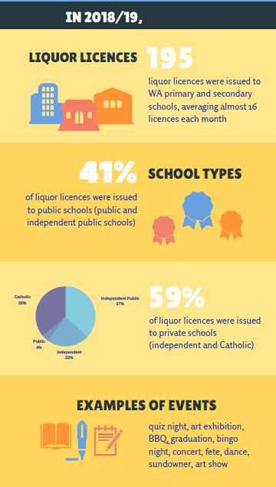

Summary of liquor licences issued to WA primary and secondary schools in 2018/19 Schools can also work towards being alcohol-free environments by using healthier alternatives to alcohol as prizes for school raffles or at fundraisers, and discouraging parents and guardians to give alcohol as gifts to teachers. Given the increasingly independent nature of schools, we can also continue to encourage individual schools to develop clear guidelines and policies preventing the use and promotion of alcohol where children would be exposed.   Schools have a critical role and a great opportunity to equip young Australians with the necessary knowledge, attitudes and skills to lead healthy lives. We hope that these priorities will be handy in helping to guide their advocacy and education activities as we all continue to work towards preventing alcohol-related harm among young people.