# Australians talk about alcohol harm

|  |  |
| --- | --- |
| **Author** | Editorial |
| **Date** | 2019-10-29 13:56:03 |
| **Categories** | Community stories |

### ABC’s national survey reveals Australians believe alcohol is one of the biggest issues we face as a nation.

::

The national broadcaster has [revealed](https://www.abc.net.au/news/2019-10-26/australia-talks-alcohol-use-older-younger-generations/11611078) that 90 per cent of Australians believe the drug alcohol is one of the biggest issues we face as a nation.

The ABC’s national survey, [*Australia Talks*](https://australiatalks.abc.net.au/)*,* polled more than 54,000 people across the country and revealed that alcohol (and other drugs) was one of the top three issues identified by respondents, alongside household debt and cost of living.

[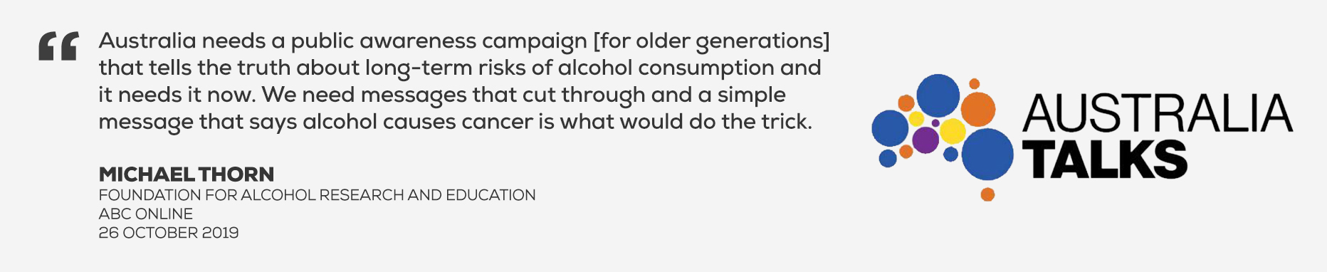](https://drinktank.org.au/wp-content/uploads/2019/10/Michael-quote-1.jpg" \t "_blank)

As the leading national public health organisation focussed on reducing alcohol harm in Australia, the [Foundation for Alcohol Research and Education](https://www.abc.net.au/news/2019-10-26/australia-talks-alcohol-use-older-younger-generations/11611078) (FARE), along with the Centre for Policy Research (CAPR), were asked to provide insights to the ABC on the social and health issues around alcohol use and alcohol harm.

The ABC’s national survey results tell a similar story to FARE’s Annual Alcohol Poll, which this year celebrated ten years of surveying Australians about their attitudes and opinions about alcohol, their knowledge of the risks of drinking alcohol and associated harm.

[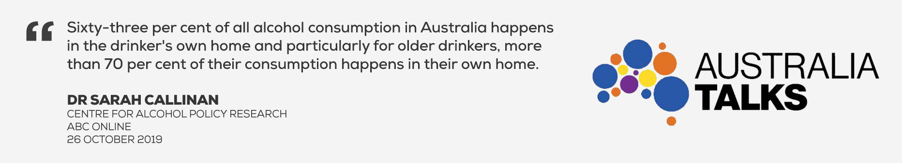](https://drinktank.org.au/wp-content/uploads/2019/10/Sarah-quote.jpg" \t "_blank)

In FARE’s 2019 poll released in May, a majority of Australians voiced concern about alcohol, with 66 per cent indicating they believe Australia has a problem with excess drinking, 53 per cent believing that alcohol-related problems in Australia will worsen or remain the same over the next five to ten years, and 75 per cent believing that more needs to be done to reduce the harm caused by alcohol.

The perception that more needs to be done to reduce alcohol harm has remained relatively consistent over the past ten years. There have been variations in responses to some of these core questions over the years. After all, Australians’ attitudes towards alcohol are influenced by a range of factors, including media reporting and government policy decisions, which have changed the emphasis over time.

[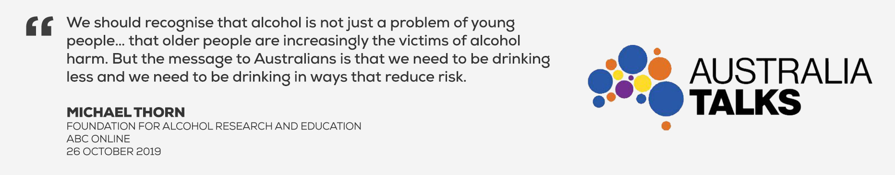](https://drinktank.org.au/wp-content/uploads/2019/10/Michael-quote-2.jpg" \t "_blank)

A prime example of the latter is the change in the community’s perception of the drug that causes the most harm in Australia. While data continues to demonstrate that alcohol causes more harm in society than any illegal drug, the 2016 Poll saw a shift in perception away from alcohol to illegal drugs. This shift corresponded with a rapid increase in media reporting on the drug ice, as the Australian Government’s focus turned to the so-called ‘ice epidemic’, with the establishment of the National Ice Taskforce in 2015 and development of the National Ice Action Strategy soon after. The perception that illegal drugs are the drugs that cause the most harm in society has continued to be observed in subsequent polls, despite consumption data showing a significant decline in methamphetamine use.

[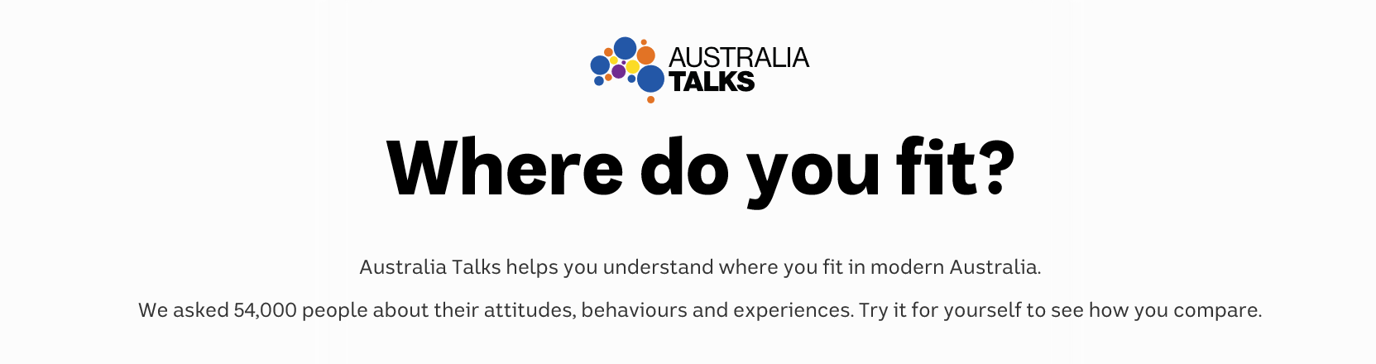](https://australiatalks.abc.net.au/" \t "_blank) [More information on FARE's Annual Alcohol Poll](https://fare.org.au/annual-alcohol-poll-2019-attitudes-and-behaviours/) [Take the ABC Australia Talks online survey](https://australiatalks.abc.net.au/)

### Metadata

|  |  |
| --- | --- |
| **Views** | 154 |