# Apps and websites to help you cut back

# Apps and websites to help you drink less

## Online tools can be part of your support network

# Apps and websites to help you drink less

## Online tools can be part of your support network

## Apps and communities that can help you

[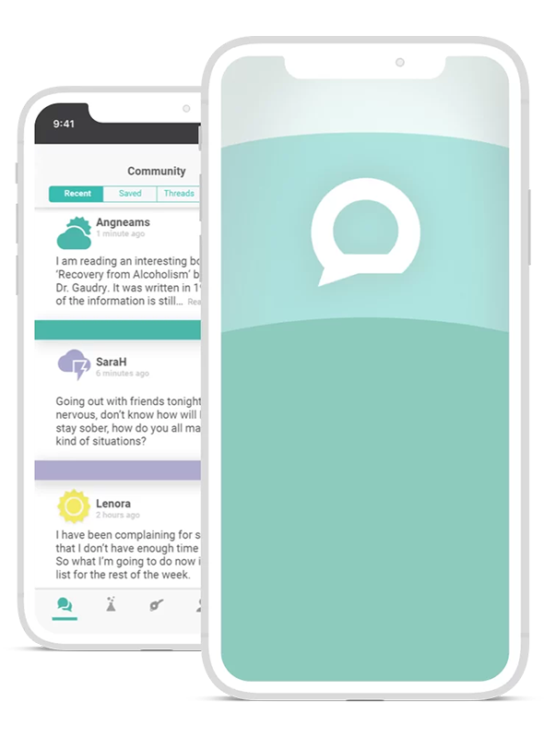](https://hellosundaymorning.org/daybreak/" \t "_blank)

### Daybreak

A free app from Hello Sunday Morning, Daybreak offers self-directed activities to help you change your drinking habits, whether you want to cut back or quit drinking completely. ‘Daybreakers’ receive support from like-minded community members who can help each other achieve their alcohol change goals. One-on-one coaching is also available. Daybreak is free for Australian residents and is confidential, anonymous and secure.

[Download Daybreak](https://hellosundaymorning.org/daybreak/" \t "_blank) [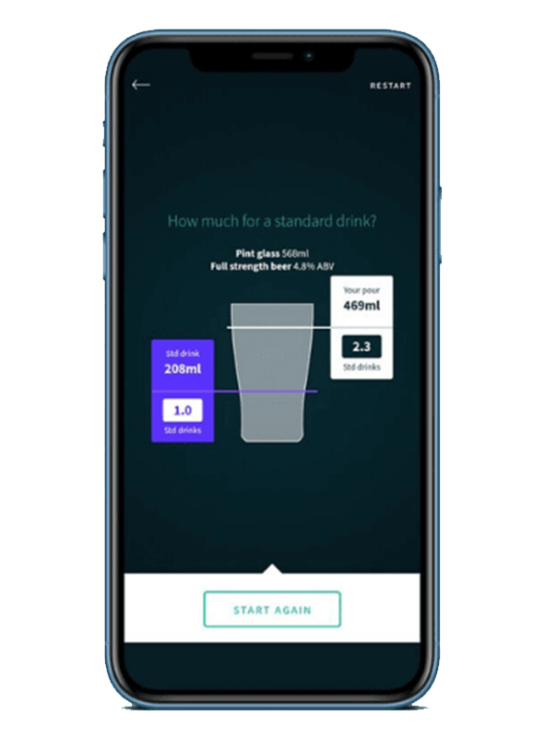](https://yourroom.health.nsw.gov.au/whats-new/Pages/Drinks-Meter-social-isolation.aspx)

### Drinksmeter

Drinksmeter is a free app containing tools like goal-setting and a drinking diary to help you cut down your drinking, including an interactive drink pouring tool helping you make sense of standard drinks. Confidential, personalised feedback is provided about your alcohol use, based on risk factors in your family and medical history. The app can also record and monitor how much you spend on alcohol and how many kilojoules or calories the alcohol you drink contains. It compares your drinking with other users of the app, and with Australia’s national alcohol guidelines.

[Download Drinksmeter](https://yourroom.health.nsw.gov.au/whats-new/Pages/Drinks-Meter-social-isolation.aspx" \t "_blank) [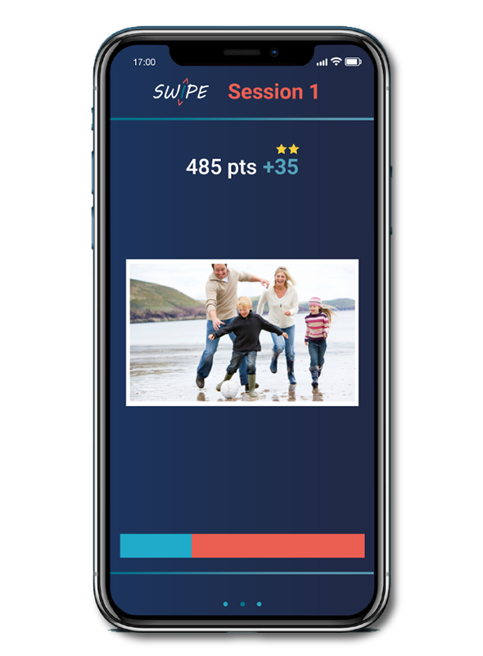](https://www.swipebraintraining.com.au/)

### SWIPE

SWIPE is a novel 'brain-training' app that uses a form of cognitive training known as Approach Bias Modification (ABM) to help users reduce their alcohol consumption. ABM works by semi-subconsciously training your brain to avoid alcohol cues, and approach positive cues. Simply upload images of the drinks you want to avoid and the activities you want to start doing more of, and you’re ready to go! A peer-reviewed study by Monash showed that after 4 weeks SWIPE app users reported significant reductions in alcohol craving, drinking days and weekly consumption of standard drinks.

[Download SWIPE](https://www.swipebraintraining.com.au/" \t "_blank) [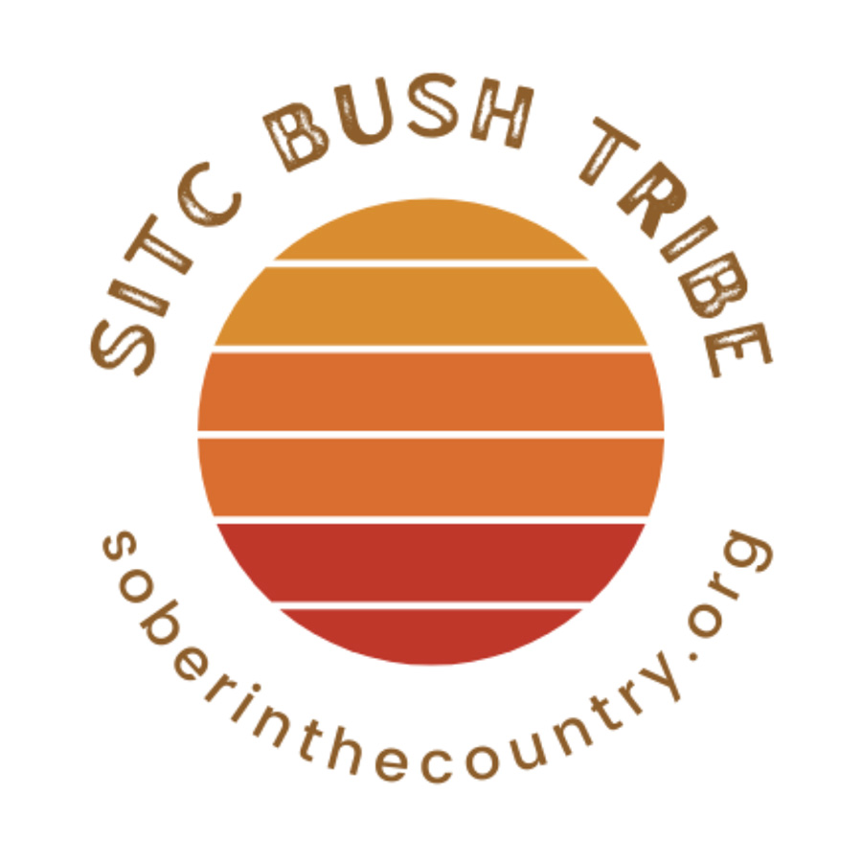](https://www.soberinthecountry.org/bush-tribe/)

### Sober in the Country Bush Tribe

Sober in the Country is a rural grassroots charity who work to deliver national alcohol awareness via real talk. Bush Tribe is their peer-to-peer online community that connects rural and remote Australians who have a shared wish to cut back on or quit alcohol. It is a closed, carefully curated Facebook community where people from the bush can find an open, accepting place to chat with like-minded people.

[Visit Sober in the Country](https://www.soberinthecountry.org/bush-tribe/" \t "_blank)

## Reaching out

We all need help and support from time to time. If you need support in making a change around alcohol, have a look at the services in the link below for further advice and assistance.

[Services that can help](https://fare.org.au/resources/alcohol-support-services/)

If you have been drinking heavily for a long time, it could be dangerous to reduce or quit alcohol on your own without medical advice or additional support. Your doctor can help by advising on withdrawal planning, prescribing medication, or referring you to withdrawal and counselling services.

More information

## Related information

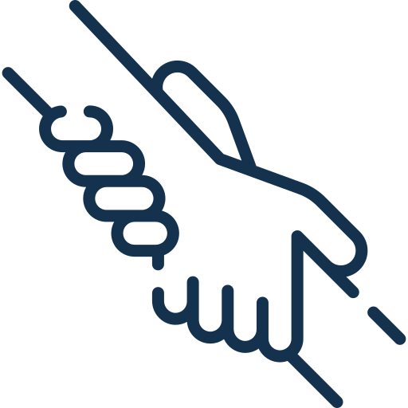

## Need advice or support?

To find a local GP, you can call 1800 022 222 or visit [healthdirect.gov.au](http://healthdirect.gov.au). To find a local psychologist, visit [psychology.org.au/find-a-psychologist](http://psychology.org.au/find-a-psychologist). If you need other support to reduce your drinking, you can contact the National Alcohol and Other Drug Hotline on 1800 250 015.

## Join our community

Will you join the community taking action on alcohol?