# Annual alcohol poll 2019: Attitudes and behaviours

 

# Poll confirms ‘decade of deception’ as Australia’s ‘get drunk’ club climbs to six million

The number of people who drink alcohol to get drunk has edged close to half the drinking population, to around six million people, despite little change in overall alcohol consumption.

Now in its tenth year, the *2019 Annual Alcohol Poll: Attitudes and Behaviours* (the Poll) shows a steady climb over the past decade of people drinking to get drunk, and has found Australians remain confused about what constitutes low-risk to high-risk alcohol consumption.

Since 2011 there’s been an overall increase in the proportion of Australian drinkers who drink to get drunk from 35 to 47 per cent, with a quarter admitting to drinking to get drunk once or more a month. And alcohol harm has continued to increase despite the fact that overall consumption has remained relatively constant over the past ten years, with no significant fluctuations.

The Poll also highlights the dangerous lack of clarity about the long-term risks of drinking alcohol, including mouth, pharynx, larynx, oesophagus, liver and breast cancer, finding that fewer than half of Australians are aware of the link between alcohol use and mouth and throat cancer (29%) and breast cancer (16%).

It is not surprising, however, that Australians are confused about cancer and other health risks when nebulous terms such as ‘drink responsibly’ and ‘drink in moderation’ are commonplace in alcohol marketing.

The Poll results clearly demonstrate how ambiguous and subjective the concept of ‘responsible drinking’ actually is, when 68 per cent of drinkers who consume 11 or more standard drinks on a typical occasion, consider themselves responsible drinkers.

 

# Australians share their views on alcohol

We hit the streets to talk to everyday Australians. Does Australia have a problem with Alcohol? Why are so many Australians drinking at risky levels? And why aren’t they better informed about the long-term health harms? Join FARE as we unpack the 2019 Poll findings and examine how governments should respond to ensure a healthier and safer Australia.

[Play](https://fare.org.au/wp-content/uploads/video1.jpg) [Play](https://fare.org.au/wp-content/uploads/video2.jpg) [Play](https://fare.org.au/wp-content/uploads/video3.jpg) Previous Next

# At a glance

[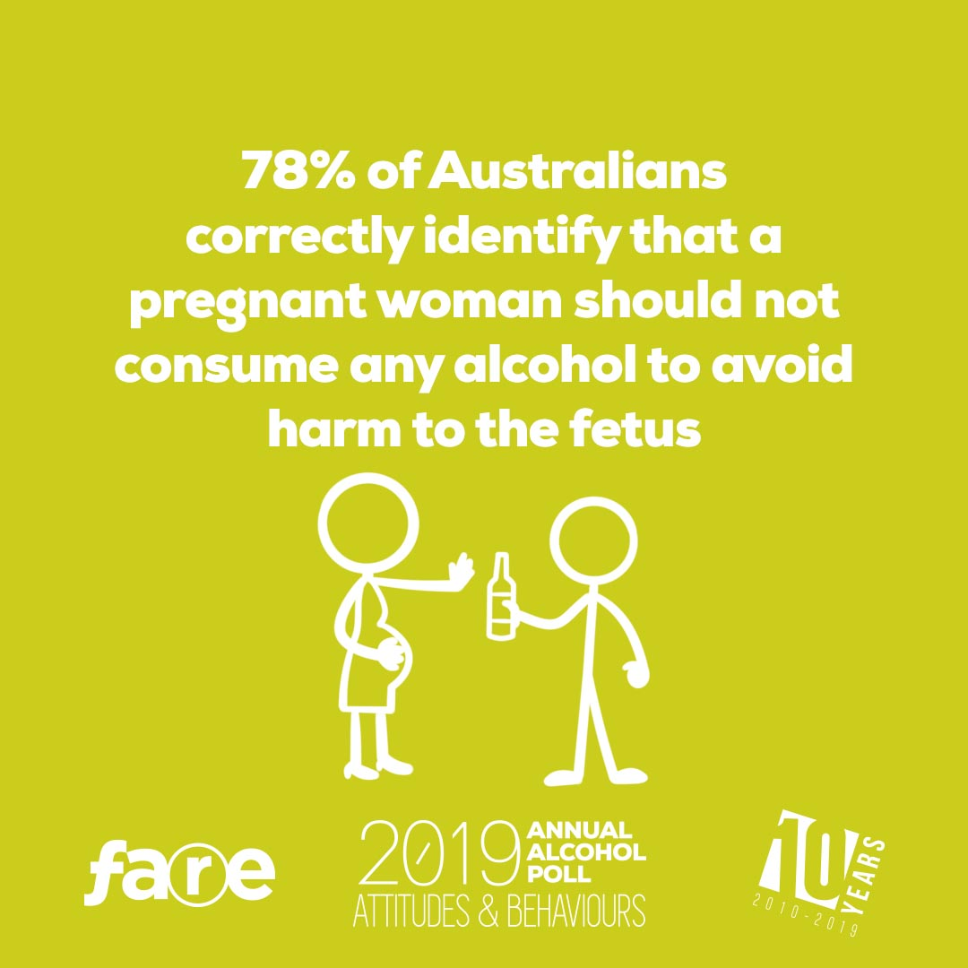](https://fare.org.au/wp-content/uploads/ALCPOLL2019-SOCIALAP19-8.jpg)

[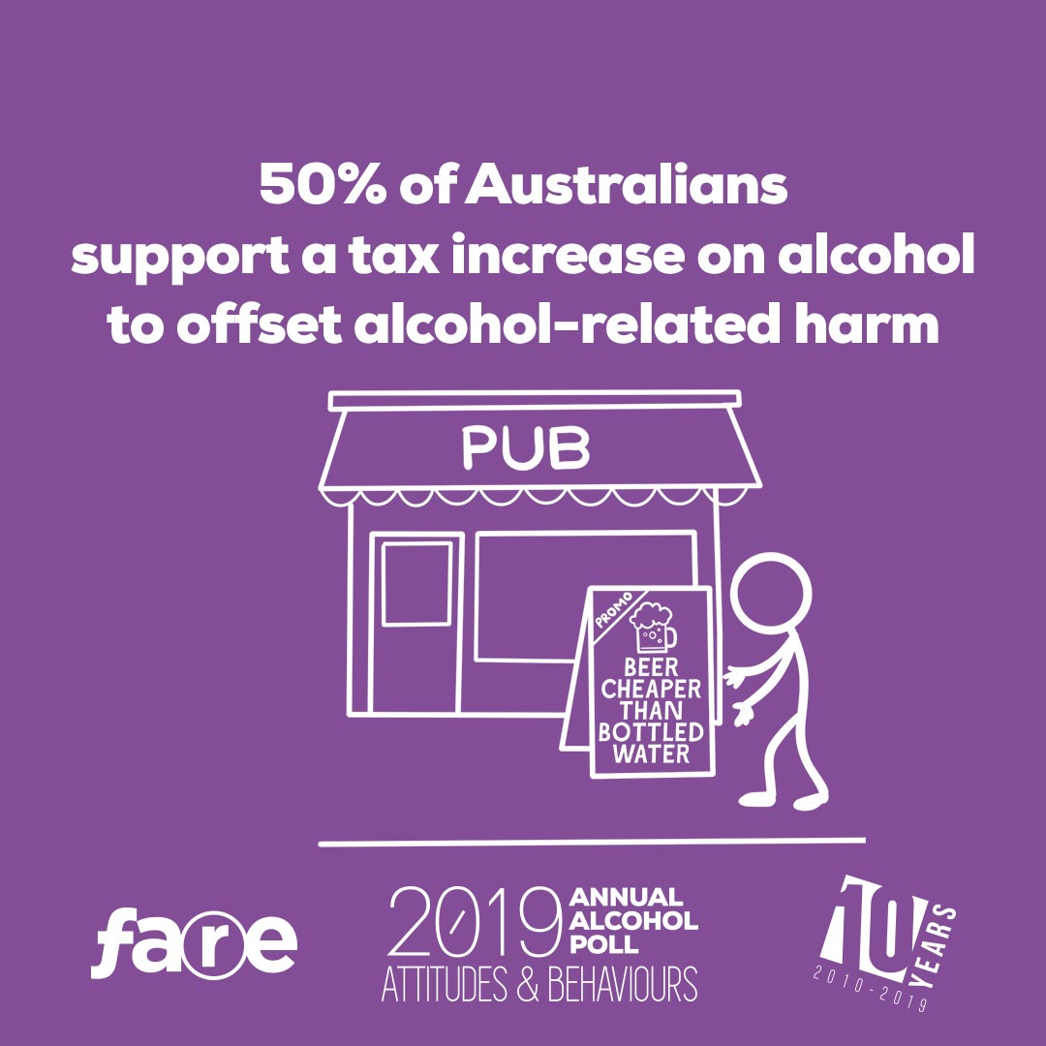](https://fare.org.au/wp-content/uploads/ALCPOLL2019-SOCIALAP19-13.jpg)

[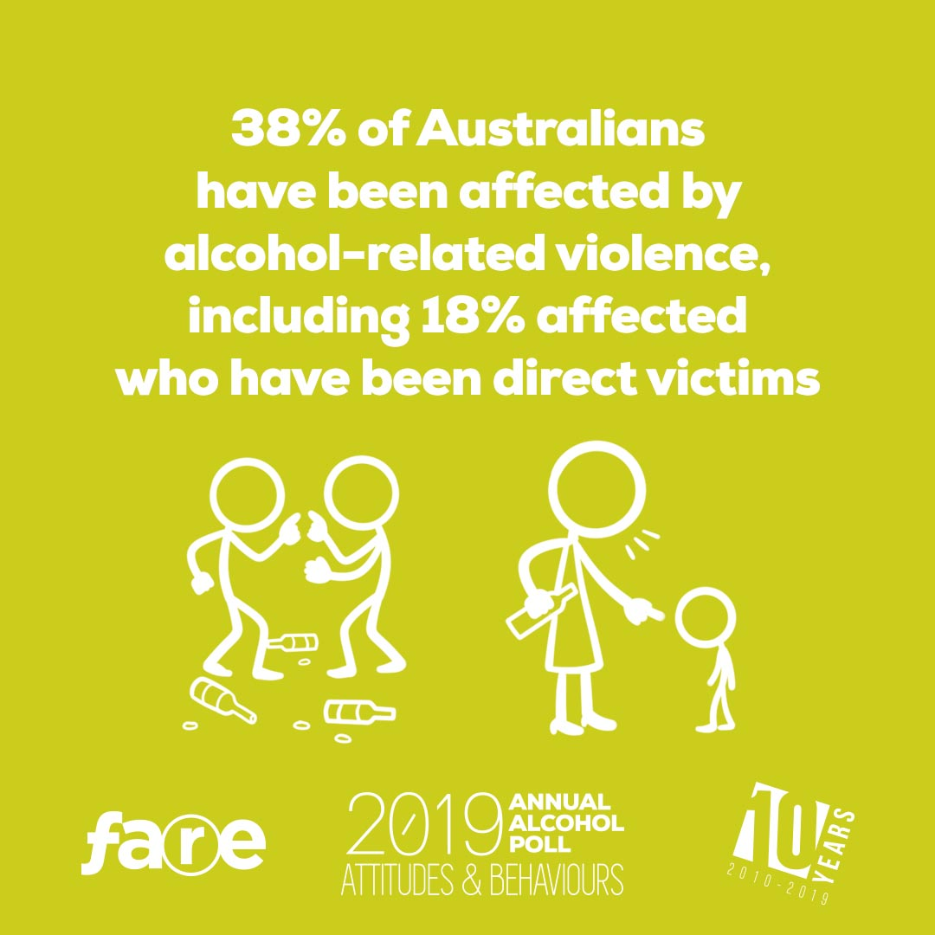](https://fare.org.au/wp-content/uploads/ALCPOLL2019-SOCIALAP19-9.jpg)

[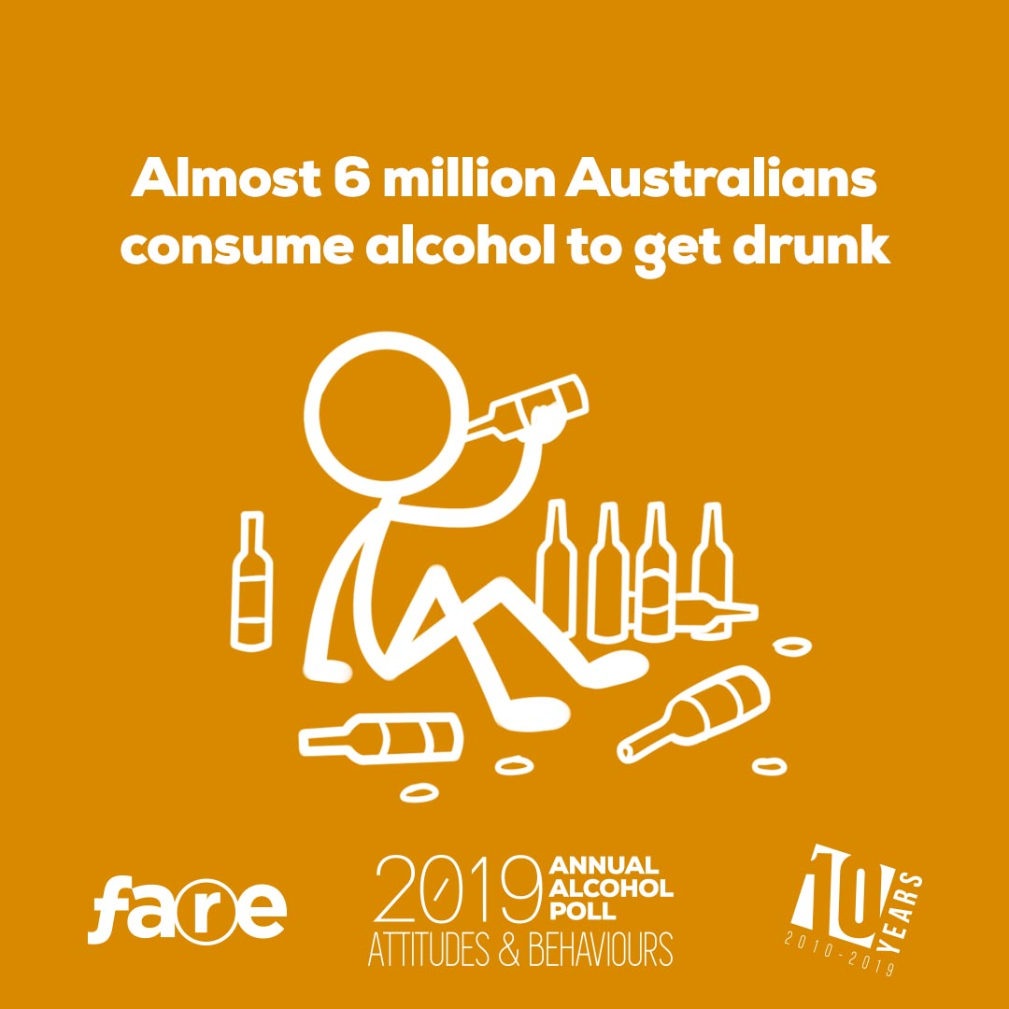](https://fare.org.au/wp-content/uploads/ALCPOLL2019-SOCIALAP19-3.jpg)

[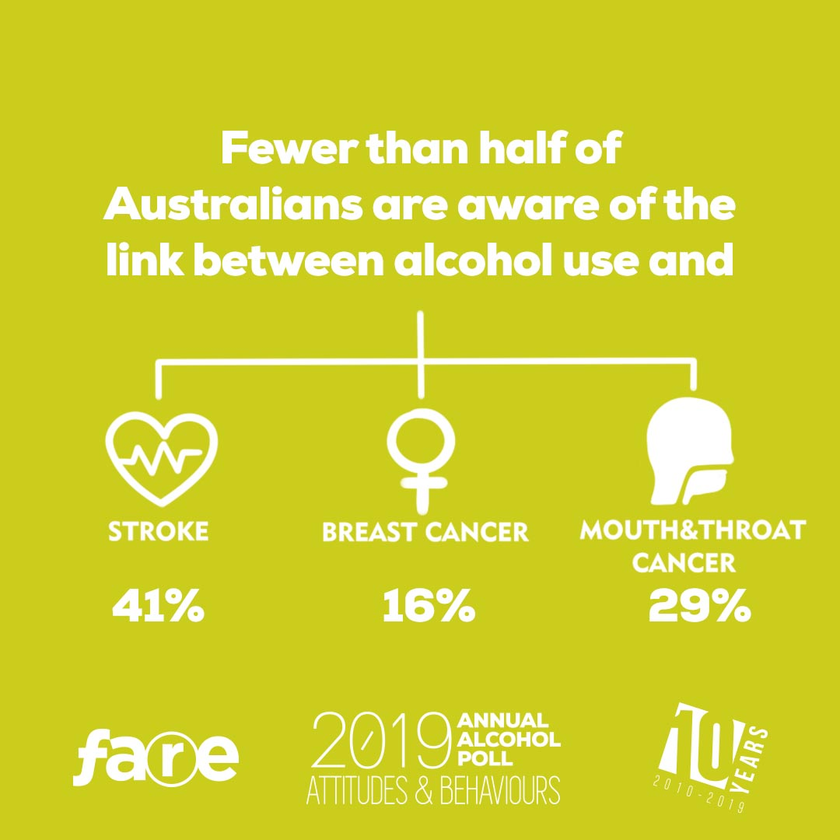](https://fare.org.au/wp-content/uploads/ALCPOLL2019-SOCIALAP19-5.jpg)

[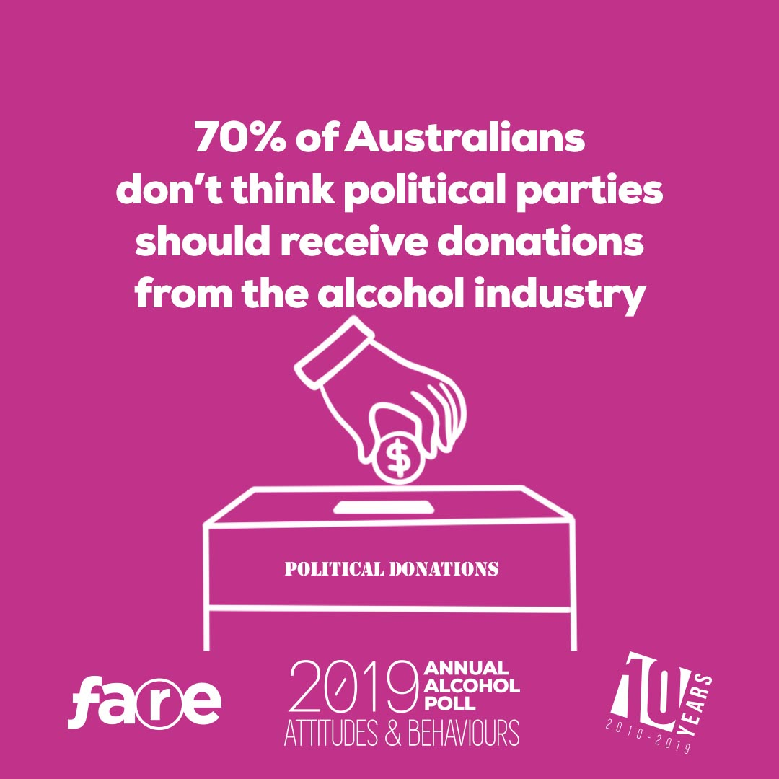](https://fare.org.au/wp-content/uploads/ALCPOLL2019-SOCIALAP19-2.jpg)

[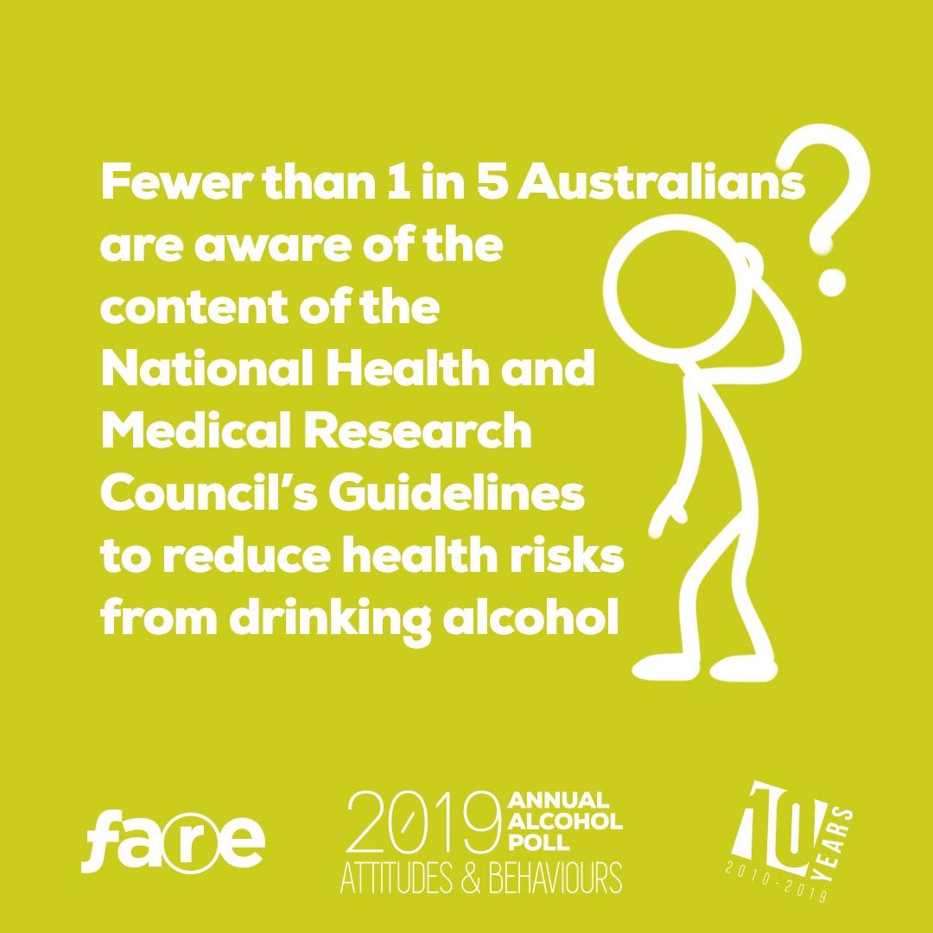](https://fare.org.au/wp-content/uploads/ALCPOLL2019-SOCIALAP19-6.jpg)

[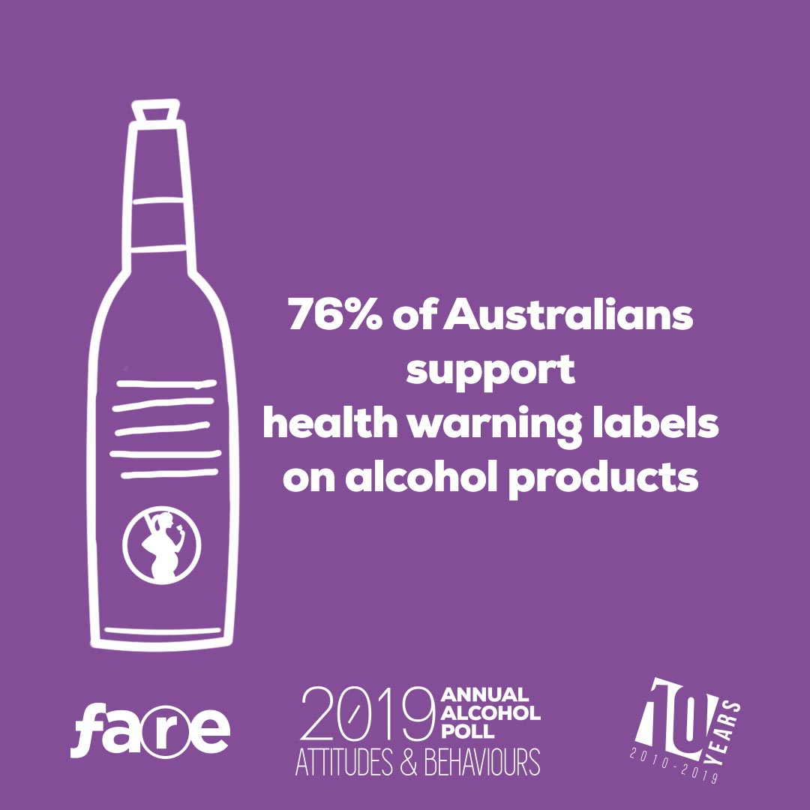](https://fare.org.au/wp-content/uploads/ALCPOLL2019-SOCIALAP19-10.jpg)

[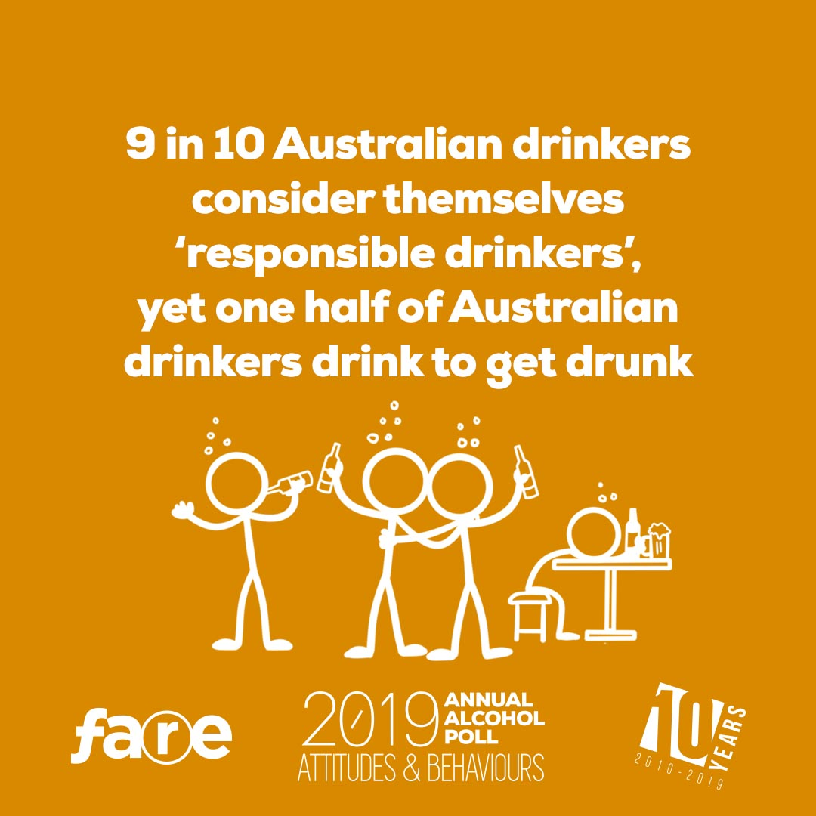](https://fare.org.au/wp-content/uploads/ALCPOLL2019-SOCIALAP19-4.jpg)

[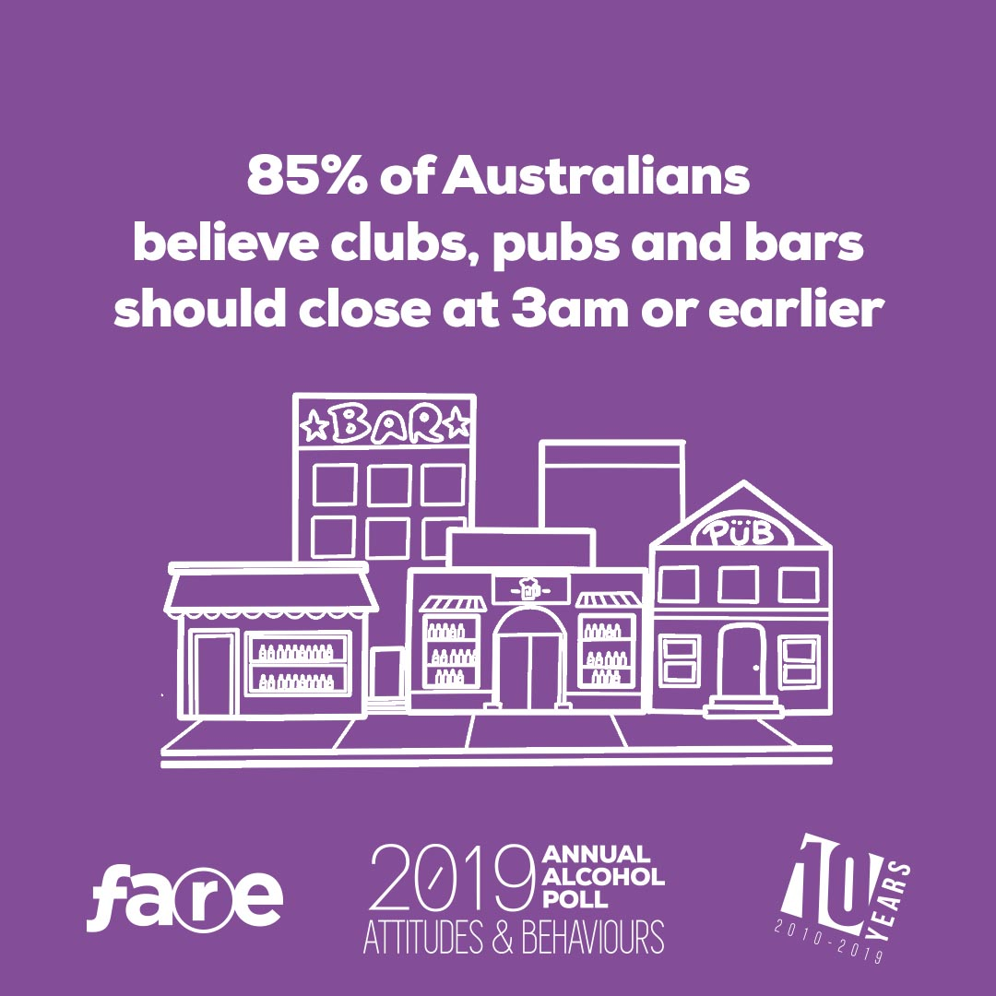](https://fare.org.au/wp-content/uploads/ALCPOLL2019-SOCIALAP19-12.jpg)

[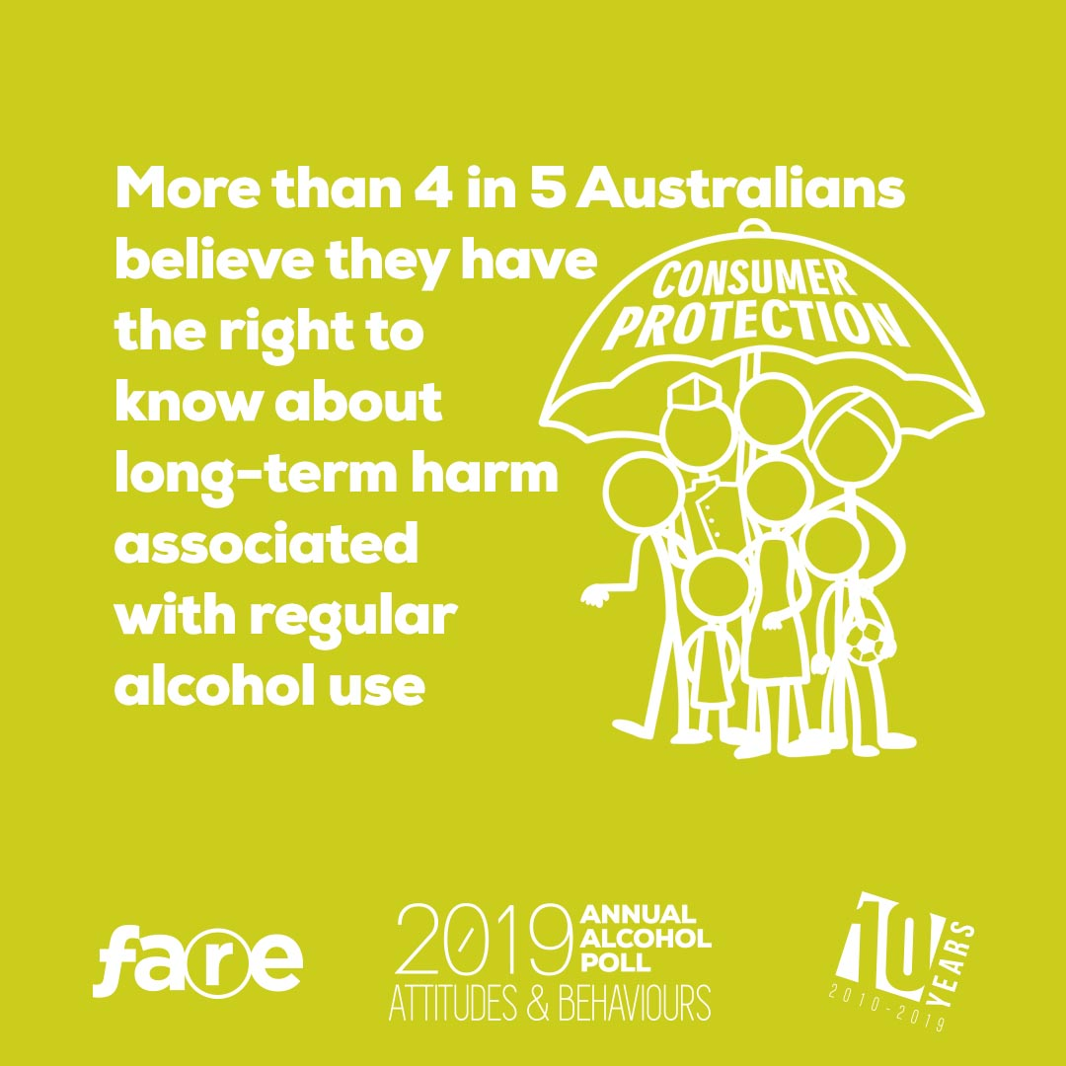](https://fare.org.au/wp-content/uploads/ALCPOLL2019-SOCIALAP19-7.jpg)

[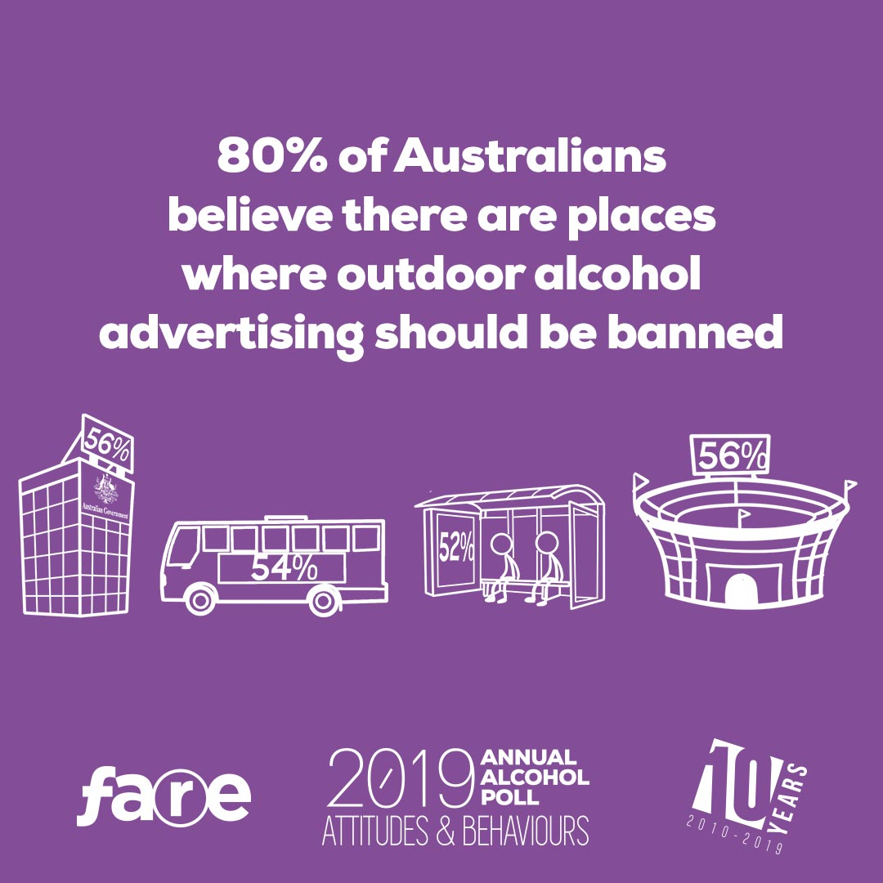](https://fare.org.au/wp-content/uploads/ALCPOLL2019-SOCIALAP19-11.jpg)

# The findings

Download the full report and our comprehensive editorial coverage.

[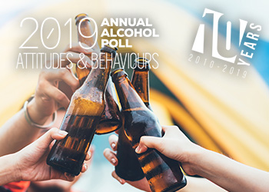](https://fare.org.au/wp-content/uploads/FARE-Annual-Alcohol-Poll-2019-FINAL.pdf)

### [Full Report](https://fare.org.au/wp-content/uploads/FARE-Annual-Alcohol-Poll-2019-FINAL.pdf)

FARE’s Annual Alcohol Poll provides a comprehensive snapshot of Australia’s relationship with alcohol.

[](https://fare.org.au/2019-annual-alcohol-poll-confirms-decade-of-deception-as-australias-get-drunk-club-climbs-to-six-million/)

### [Media release](https://fare.org.au/2019-annual-alcohol-poll-confirms-decade-of-deception-as-australias-get-drunk-club-climbs-to-six-million/)

New polling has found the number of people who drink alcohol to get drunk has edged close to half the drinking population.

[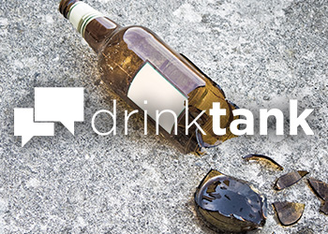](https://drinktank.org.au/2019/05/10th-annual-alcohol-poll-australians-concerns-on-alcohol-continue-to-go-unheard/)

### [Poll unpacked](https://drinktank.org.au/2019/05/10th-annual-alcohol-poll-australians-concerns-on-alcohol-continue-to-go-unheard/)

Australian’s concerns on alcohol continue to go unheard. Unpacking the 2019 Annual Alcohol Poll findings.

 

©2019 Foundation for Alcohol Research & Education. All rights reserved.