# Alcohol marketing in the time of COVID-19

|  |  |
| --- | --- |
| **Author** | Julia Stafford |
| **Date** | 2020-04-23 11:08:00 |
| **Categories** | Health |

### Is the alcohol industry exploiting this vulnerable time in our lives as yet another opportunity to maximise their profits?

It doesn’t take long for the well-resourced alcohol industry to adapt their marketing to tie-in with current events. We see it with [major sporting events](https://www.carltondraught.com.au/pages/collingwood-cans), the [holiday season](https://www.jacobscreek.com/en-au/christmas-jacobs-creek), and even the devastating [Australian bushfires](https://cub.com.au/raise-a-vb-to-help-bushfire-victims-this-rounds-for-them/).

A global pandemic is no different. In a very short period of time, alcohol companies have pivoted their marketing to reflect our new lives of social distancing and self-isolation.

For some of the big players, the COVID-19 pandemic is an opportunity to present themselves as responsible corporate citizens. Lion, the second largest [beer company by market share](https://www.ibisworld.com.au/industry-trends/market-research-reports/manufacturing/beverage-tobacco-product/beer-manufacturing.html) in Australia, took out [full page ads in major newspapers](https://mumbrella.com.au/six-of-lions-beers-encourage-australians-to-stay-home-and-enjoy-a-drink-with-friends-in-the-future-623139) across the country recently espousing the need for social distancing.

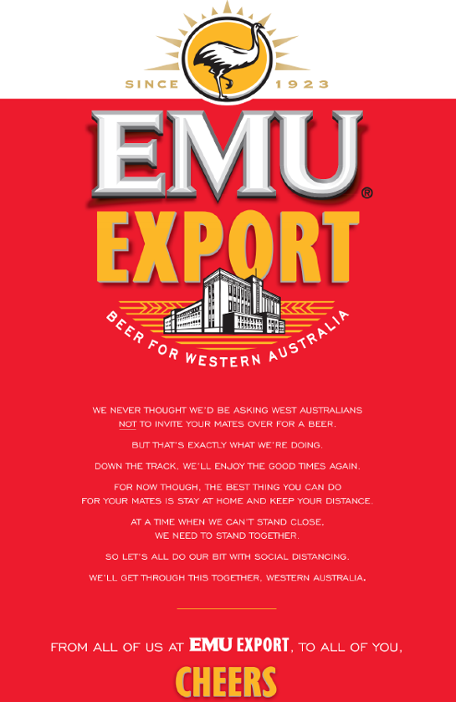

The brand logos dominated most of the page, followed by just one or two lines regarding the advice on social distancing. Ads like these are more likely to build brand awareness and generate free PR for the alcohol brand than make any real contribution to responding to the pandemic.

Other beer brands, like [VB](https://www.facebook.com/VB/photos/a.207768037133/10156633833367134/?type=3&theater), were quick to jump on Facebook to tell you to enjoy their products at home.

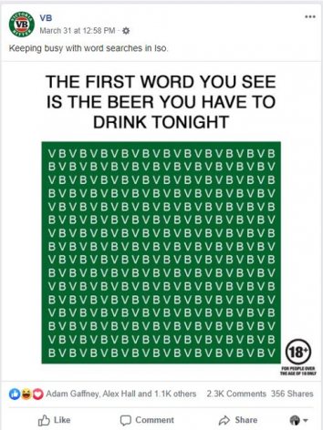

Some companies are getting inventive. [Jacob’s Creek](https://www.facebook.com/JacobsCreekAustralia/posts/2614657908645475?__xts__%5b0%5d=68.ARDuC_bwoyA81twB4vz45KMVL1egOPpncoiZDu_IbZ6iSir_400m-MQaG5GbXpJDWPpZUhu4C7B-RylsVaA6oacojxOQONM--X7EY4wCGqQucgfKL68vuPFyzXxKr9uOI702ZadK-Fd2tpMe8enSN7LzKTX3k0tOiRg5hWUOOBuJ9Hsrj7WnK-GVQjFQ5jyYwG5vXwEEWYqvDd9f7HBv6fvbISuFi6xhzcUjSdJOcSbStnPI3c-fyQh8OcMymm4nH9KABNe5-u9L0MzE4zGWLa0aQXTxtMl2Nn66vuf0mrCP1TyVylplMXAcHFDpeBoOI99eCROcUCWRLSjo1Hay7FwgBM7EsAP-SgW9eq2Uz2muuTNOwQ&__tn__=-R) says with social distancing, there’s never been a better time to become a wine connoisseur.

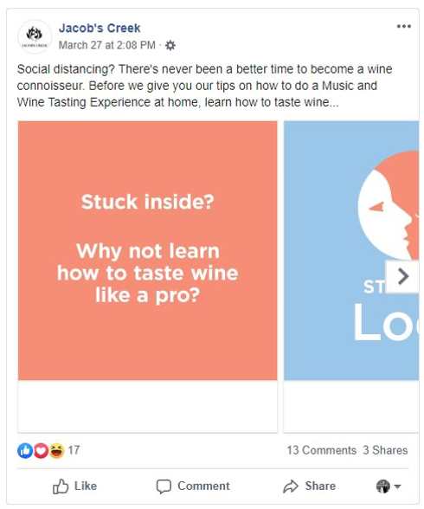

[Busch Beer](https://twitter.com/BuschBeer/status/1242828151505510408) in the US is giving 3 months’ worth of Busch Light to anyone who fosters or adopts a dog from a rescue service. What could go wrong?

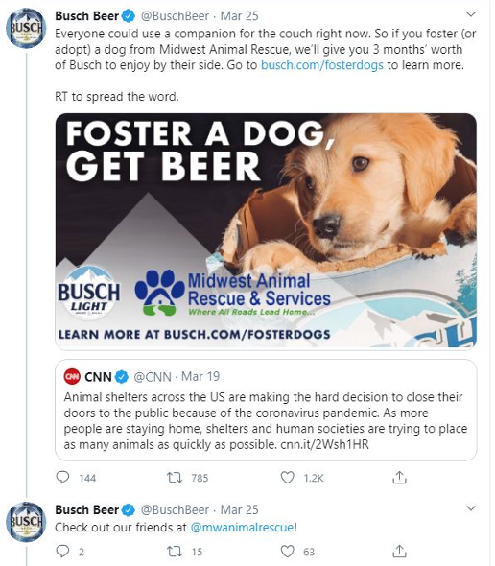

For liquor retailers, COVID-19 is an opportunity to capitalise on people staying at home by heavily promoting ‘contactless’ home delivery services and emphasising that drinkers need never run out of their chosen alcohol products. Pre-pandemic, health groups were [already concerned](https://alcohol.phaiwa.org.au/assets/publications/factsheets/Policy-position---Online-sales-and-home-delivery-of-alcohol_FARE,-PHAA-and-PHAIWA.pdf) about the expansion of online sales and delivery of alcohol, given there were virtually no restrictions on how late, how rapidly or how much alcohol can be delivered to a home. There are also no effective mechanisms in place to stop underage and intoxicated people purchasing and receiving alcohol through these services. In the current COVID-19 world, ‘contactless’ delivery means [some online retailers](https://www.boozebud.com/account/delivery#contact-free-delivery) are recommending customers select ‘Authority to Leave’ for alcohol deliveries, raising concerning questions about whether ID checks will occur.

We’ve also seen some liquor retailers promoting stockpiling of alcohol and heavy drinking while in quarantine at home. The Alcohol Programs Team at Cancer Council WA [submitted a complaint](https://www.abac.org.au/adjudication/thirsty-camel-wa-facebook-posts/) to the Alcohol Beverages Advertising Code (ABAC) Scheme, the self-regulatory alcohol advertising system in Australia, about two particularly concerning Thirsty Camel WA Bottleshop Facebook posts.

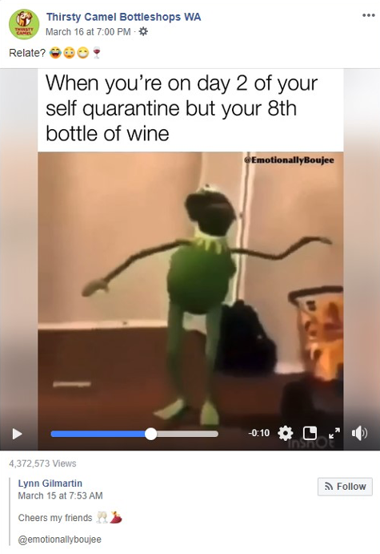

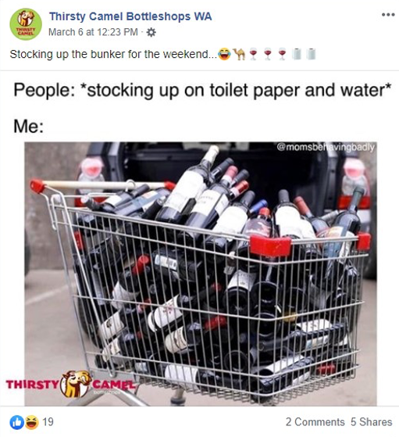

The Facebook posts encouraged drinking at levels that were clearly inconsistent with the NHMRC Australian Alcohol Guidelines. However, in its [response to the complaint](https://www.abac.org.au/adjudication/thirsty-camel-wa-facebook-posts/), Thirsty Camel WA said the ads were an appropriate way to market alcohol as the Facebook page provides “social commentary” and “entertainment” to their audience of 28,000.

Wanting to be humorous is not a valid reason for promoting heavy drinking, particularly at a time when people may be looking for ways to relieve stress and our health systems are already under a lot of pressure. While our complaint was upheld by the ABAC Panel and the posts removed, the determination shows that even in these challenging times, some alcohol companies continue to flout their own rules. Of concern to health groups, there is no monitoring system in place to ensure alcohol companies are abiding by the relevant self-regulatory marketing codes. It’s highly likely that some other marketers are using similar techniques to Thirsty Camel WA and getting away with it.

Given these are just a few of the opportunistic marketing tactics currently being used by the alcohol industry, we really shouldn’t be surprised at the reports of increased spending on alcohol during the COVID-19 pandemic. While government restrictions have seen bars, pubs, and clubs across Australia close, Commbank [reported](https://www.commbank.com.au/guidance/business/an-early-look-at-how-coronavirus-is-affecting-household-spending-202004.html) the last week of March saw an 86% increase in spending on alcohol in bottle shops compared with the same time last year. [Data available](https://www.commbank.com.au/guidance/newsroom/aussies-spend-on-home-improvements--202004.html) since then has continued to show higher spending at bottle shops compared to the same time a year earlier. A number of news articles have already been published with comments from people who are [stockpiling alcohol](https://www.theguardian.com/lifeandstyle/2020/apr/07/drinking-in-coronavirus-isolation-experts-warn-australians-to-monitor-their-intake), and [already drinking more](https://www.smh.com.au/national/the-booze-epidemic-with-no-boss-in-sight-workers-can-drink-from-home-20200326-p54e74.html) than they usually would.

This is a difficult time for everyone, and people will be looking for ways to reduce their stress. But instead of being bombarded with ads encouraging us to drink, the Australian community should be hearing that alcohol can make us feel [more stressed and anxious](https://alcoholthinkagain.com.au/Alcohol-Your-Health/Alcohol-and-Mental-Health). It can affect our [sleep](https://alcoholthinkagain.com.au/Alcohol-Your-Health/Alcohol-and-Mental-Health), as well as our ability to [fight disease](https://www.nhmrc.gov.au/health-advice/alcohol#download). Drinking habits that are created now may be difficult to shake when we come out of the pandemic. Reducing your drinking will not only help to keep you healthy and safe now, you’ll [reduce your risk](https://alcoholthinkagain.com.au/Alcohol-Your-Health/Alcohol-and-Your-Long-Term-Health) of cancers and other health problems later. It will also help to prevent extra burdens on already-stretched health services.

On 25 March, the WA Government recognised the impact alcohol can have and [introduced reasonable limits](https://www.mediastatements.wa.gov.au/Pages/McGowan/2020/03/COVID-19-response-Temporary-changes-to-takeaway-alcohol.aspx) on takeaway alcohol to prevent alcohol-related problems placing additional burdens on our health system and police service. This was an excellent move, and we encouraged the WA Government to keep these restrictions in place at least until the pandemic is over.

Unfortunately, less than a month later, the limits on takeaway alcohol [were lifted](https://www.mediastatements.wa.gov.au/Pages/McGowan/2020/04/COVID-19-takeaway-alcohol-restrictions-lifted.aspx). We know the WA Government was [under pressure](https://lsawa.org.au/2020/04/08/liquor-industry-unites-over-wa-alcohol-restrictions/) from the alcohol industry to remove the restrictions and instead rely on the industry’s [voluntary initiative](https://www.retaildrinks.org.au/news/retail-drinks-announces-voluntary-national-initiative) that ‘limits’ purchases to around 150 standard drinks in one transaction. It’s possible this is yet another example of the power the alcohol industry can have, even during a global public health crisis.

Our team will continue to monitor how alcohol is being marketed during the COVID-19 pandemic. If you see examples of alcohol brands and liquor retailers promoting their products in connection with COVID-19, let us know by sending a photo to [AlcoholPrograms@cancerwa.asn.au](mailto:AlcoholPrograms@cancerwa.asn.au).

For those wanting to reduce their drinking in the home, visit [Alcohol.Think Again](https://alcoholthinkagain.com.au/Alcohol-Your-Health/Tips-for-reducing-your-drinking-in-the-home) for some great tips.

***This article was first published on***[***Croakey***](https://croakey.org/alcohol-marketing-in-the-time-of-covid-19/)***on 15 April 2020.***

### Metadata