# Alcohol industry exposed undermining health policymaking

|  |  |
| --- | --- |
| **Author** | Editorial |
| **Date** | 2019-08-01 14:57:52 |
| **Categories** | Policy |

### Pro-alcohol modifications to the draft National Alcohol Strategy suggest the process has been hijacked by the powerful alcohol industry.

As one of the medical and health groups involved in campaigning for a rigorous national strategy to reduce harm from alcohol use, the Foundation for Alcohol Research and Education (FARE) is extremely concerned by revelations of alcohol industry interference in the development of the National Alcohol Strategy (NAS).

[An ABC investigation,](https://www.abc.net.au/radionational/programs/backgroundbriefing/the-pub-test/11346964) aired on Friday 26 July, says pro-alcohol modifications to a ‘consultation draft’ of the NAS suggest the policymaking process has been infiltrated by the powerful alcohol industry.

The ABC report also questions Health Minister Greg Hunt’s decision to yield to pressure and involve the alcohol industry in finalising the strategy.

Medical and public health bodies and researchers say significant wording changes, deletions and the insertion of pro-alcohol industry language into the latest draft seriously risk making the process of developing the NAS a pointless exercise.

Adding weight to these claims, the ABC says five of the State and Territory governments have not yet backed the strategy, with the ACT and WA publically criticising the Health Minister for allowing the strategy to be watered down.

WA’s Minister for Mental Health Roger Cook says he is bitterly disappointed and Minister Hunt now needs to go back to the evidence about what works to reduce levels of alcohol-related harm and revisit the objectives of the strategy.

He told the ABC:

“I think that everyone should be consulted, but the harsh reality is that we are talking about alcohol, not talking to alcohol, and as a result of that we need to do what we think is necessary to reduce the negative impact of alcohol in our community. Now if that creates some discomfort for the industry well that’s simply a fact of life”.

[](https://fare.org.au/wp-content/uploads/Roger-Cook-quote.jpg)

Throughout the day on Friday, the ABC’s 45-minute exposé was repackaged into radio news and online stories spread across the ABC’s platforms.

https://eus-streaming-video-msn-com.akamaized.net/41fc132a-6984-4173-8124-df2bd3bce3b8/e8e581ed-8661-4adf-8846-8fc2d337_2250.mp4

FARE Chief Executive Michael Thorn was also invited to respond to the story on News 24. In the same live discussion with the ABC host, the Chief Executive of Australian Grape and Wine Incorporated (AGWI), Tony Battaglene, was put forward by the alcohol industry to answer questions about inappropriate industry influence.

In what sceptics might call a tactical move by the industry, the head of the winemaking sector was able to deny having seen the leaked NAS draft, as the AGWI is not the representative body for the entire alcohol industry.

https://vimeo.com/351335527

The peak body is Australian Beverages Australia, whose Chairman Brian Fry was interviewed in the [original Background Briefing story](https://www.abc.net.au/news/2019-07-26/national-alcohol-strategy-leaked-draft-lobbying-involvement/11346054), boldly stating that the revised draft NAS (which was a confidential document), was a much stronger strategy document following industry consultation – so not so confidential.

The issue also generated considerable TV panel debate in primetime viewing, with discussion on Channel 10’s The Project and ABC’s [The Drum](https://www.abc.net.au/news/2019-07-26/the-drum-friday-july-7/11366236) [starts at 41:54].

The framing of the ABC’s story – that the State/Territory Ministers are holding out on approving the strategy because of alcohol industry interference – was picked up in the Australian Capital Territory by WIN TV news, who interviewed the ACT Health Minister Rachel Stephen-Smith.

“Changing the emphasis to normalise the drinking of alcohol and to downplay the harm that alcohol causes in our community is a real problem. Policy should be set by the experts based on the research,” she told WIN News.”

[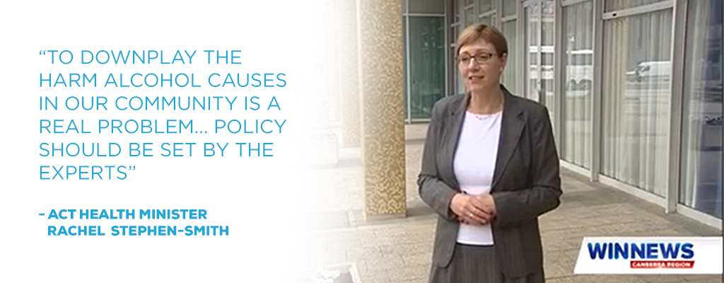](https://fare.org.au/wp-content/uploads/Rachel-Stephen-Smith-quote.jpg)

FARE’s position is that this situation is neither surprising nor an isolated example of industry influence that borders on regulatory capture. Governments have historically and repeatedly shown sympathy for the alcohol industry's position in health policymaking.

That doesn’t diminish how disappointing it is that the industry appears to have had significant influence on government at such a critical stage of finalising the NAS.

We’ve been without an alcohol strategy since 2011, and the current version has now been completely sullied.

FARE believes Health Minister Hunt must reverse this deplorable situation and reinstate the voice of the public interest in this vital national framework.

To reduce the harm done to alcohol users and those around them, as well as the multitude of impacts on the community, the NAS must be a health strategy not an alcohol industry development strategy.

### Metadata

|  |  |
| --- | --- |
| **Views** | 479 |
| **enclosure** | https://eus-streaming-video-msn-com.akamaized.net/41fc132a-6984-4173-8124-df2bd3bce3b8/e8e581ed-8661-4adf-8846-8fc2d337_2250.mp4 38475250 video/mp4 |