# Alcohol causes cancer

# Alcohol causes cancer

# Alcohol causes cancer

## Alcohol is a cancer-causing substance

Every drink increases your risk of developing cancer in the mouth, throat, breast, liver, and bowel.

The link between alcohol and cancer is incredibly strong. Alcohol is responsible for more than 5,000 new cases of cancer in Australia each year. It is classified as a Group 1 carcinogen. That’s the same classification held by tobacco smoke and asbestos.

Reducing your alcohol use reduces your risk of cancer.

Reducing your alcohol use reduces your risk of cancer.

### Alcohol is linked to cancer in at least seven sites in the body:

* Mouth
* Pharynx (throat)
* Larynx (voice box)
* Oesophagus
* Liver
* Bowel
* Breast

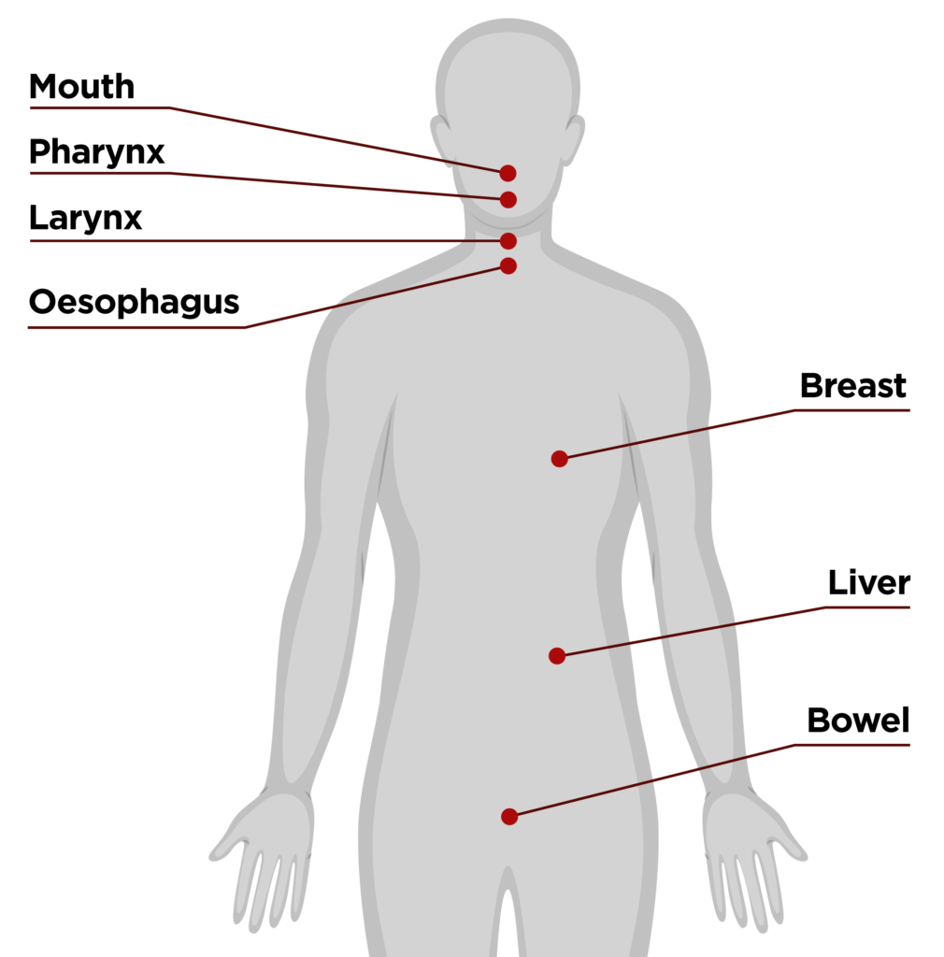

## How alcohol causes cancer

Here are five ways alcohol increases your risk of cancer:

* **Alcohol influences hormone levels** – Alcohol can impair the body’s hormone system. This can increase the risk of breast cancer.
* **Alcohol damages your body** – When alcohol breaks down it forms acetaldehyde, a known carcinogen that damages your cells. It also causes direct tissue damage, affecting areas like your mouth, pharynx, oesophagus, colon and liver
* **Alcohol reduces folate absorption** – Long-term risky alcohol use reduces the amount of folate your body can absorb. This impacts cell structures and increases the likelihood of alcohol-related cancers.
* **Alcohol mixes with other cancer-causing substances** – Alcohol can mix with other known carcinogens in your body like tobacco, forming compounds that damage cells.
* **Alcohol contributes to weight gain** – Alcohol is high in calories. The same goes for drinks that are usually mixed with it. Being above healthy weight increases your risk of many cancers.

### Kathryn shares her breast cancer story

Throughout her early adulthood, Kathryn was a binge drinker – so much so, she says, that it felt like part of her identity. Later, as a mum of three sons, a ‘morning after’ moment on a family holiday led her to decide to take a break from alcohol.

It was soon after this that Kathryn received the shocking news that she had breast cancer.

Kathryn started researching information on her diagnosis. Only then did she learn about the direct links between alcohol consumption and breast cancer.

Watch Kathryn’s powerful and heartfelt story on how she gave up alcohol for her health.

[Watch Kathryn's story](https://fare.org.au/kathryns-story/)

## Reducing your risk of cancer

There is no safe level of alcohol when it comes to cancer – even drinking at low levels increases your risk. But the more alcohol you drink over time, the higher your risk of cancer.

This means you can reduce your risk of cancer by reducing the amount of alcohol you drink.

The Australian Alcohol Guidelines recommend having no more than 10 standard alcoholic drinks in a week to reduce your risk of cancer and other diseases, and no more than 4 standard drinks on any one day to reduce your risk of injuries or accidents.

The less you drink, the lower your risk of cancer, other diseases and injury.

Learn more about the Australian Alcohol Guidelines and the evidence behind them.

Australian Alcohol Guidelines

Explore ways to reduce your risk by reducing the amount of alcohol you drink.

Reduce your risk Menu

* [Resources & support](https://fare.org.au/resources/)
* [Alcohol & health](https://fare.org.au/resources/alcohol-effects/)
* [Supporting others](https://fare.org.au/resources/supporting-others/)
* [Tips & tools](https://fare.org.au/resources/tips-and-tools/)
* [Support services](https://fare.org.au/resources/support/)

Related information

Download the Alcohol and Cancer fact sheet

## Facts at a glance: Alcohol and Cancer

Alcohol can cause at least **seven types of cancer** in the body. Alcohol is responsible for more than **5,000 new cases of cancer** in Australia each year. When the body breaks down the pure alcohol (ethanol) in alcoholic drinks, it becomes a toxic chemical called acetaldehyde. **Acetaldehyde can damage your DNA** and cause abnormal cell growth. Drinking alcohol can interfere with the ability of the body to **repair DNA and prevent cancer.** Alcohol can allow cells to absorb **higher levels of other carcinogenic (cancer-causing) substances,** such as tobacco. Drinking at high levels can lead to **not having enough essential nutrients,** such as folate, which may make tissues in your body more vulnerable to developing cancer. Alcohol can influence levels of oestrogen and other hormones in the body, **increasing the risk of breast cancer for women.** Previous Next 

## Need advice or support?

To find a local GP, you can call 1800 022 222 or visit [healthdirect.gov.au](http://healthdirect.gov.au). To find a local psychologist, visit [psychology.org.au/find-a-psychologist](http://psychology.org.au/find-a-psychologist). If you need other support to reduce your drinking, you can contact the National Alcohol and Other Drug Hotline on 1800 250 015.

## Join our community

Will you join the community taking action on alcohol?