# 2021: The year in review

|  |  |
| --- | --- |
| **Author** | Editorial |
| **Date** | 2021-12-21 11:59:00 |
| **Categories** | Community stories |

### We are almost at the end of 2021 – and what a year this has been. Together, we elevated the voices of people and communities around Australia who are taking action on alcohol harms. And we made a real difference.

We are almost at the end of 2021 – and what a year this has been.

Together, we elevated the voices of people and communities around Australia who are taking action on alcohol harms. And we made a real difference.

Here are just some of the things we have achieved together this year:

##### We stood shoulder-to-shoulder with communities in the Northern Territory to stop the development of a Darwin Dan Murphy’s alcohol megastore

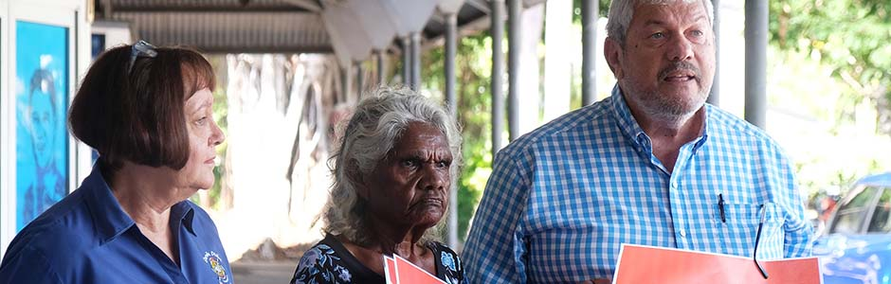

In April, after almost a five-year battle, Woolworths abandoned its plans to build what would have been one of Australia’s largest liquor stores, an 1800 square-meter Dan Murphy’s, on the doorstep of Bagot Community, a dry Aboriginal community in Darwin.

Together with community organisations in the NT, we stood with Aunty Helen Fejo-Firth and other community leaders, shared their stories, published a full-page open letter in the *Australian Financial Review*, spoke to media across the country, and challenged Woolworths in the NT Supreme Court.

More than 155,000 of you signed petitions and shared content on social media. You actively engaged in this campaign and made sure that Woolworths and Dan Murphy’s felt public pressure to listen to what the community had to say. Thank you!

While there were moments this victory didn’t seem possible, we didn’t lose heart and promised to fight until the end.

##### We delivered an award-winning awareness campaign highlighting the link between alcohol and cancer to people across the Australian Capital Territory

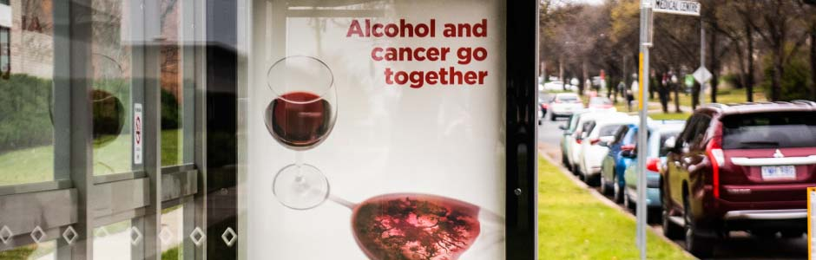

With the support of the community and ACT Health, we delivered *Reduce your Risk*to the Canberra community, raising awareness about the NHMRC’s updated Alcohol Guidelines, and the link between alcohol and cancer.

Appearing across television, radio, bus shelters, doctors’ surgeries and social media, the message was received loud and clear with an increase in awareness of the Guidelines, and the link between alcohol and cancer across adults in the ACT.

The campaign also picked up Silver for Regional Communications Campaign category at the Public Relations Institute of Australia’s 2021 Golden Target Awards!

##### We worked closely with family violence organisations, community advocates and health groups to call for strong amendments in the Victorian Liquor Control Reform Act to reduce alcohol harm across the State



We have been working closely with community and family violence advocates, including Kym Valentine and organisations like Berry St, to paint a real picture of how alcohol has been affecting Victorian communities and why stronger laws around online sales and delivery of alcohol are needed.

“We must ask ourselves, are elevated levels of domestic abuse an acceptable tradeoff for allowing alcohol companies to aggressively promote rapid booze delivery into homes late at night?”

*- Kym Valentine, SMH, 13 June 2021*

Together we secured some much-needed changes to online alcohol sale and delivery when the Victorian Parliament passed legislation that included requirements to check identification on alcohol home deliveries and no unattended same-day deliveries.

Although these amendments fell a little short of meeting community expectations, our joint advocacy with communities and organisations on this issue has proven that people power works – our voices can shift the public narrative, which can lead to greater changes and protect against alcohol harm. And so we keep campaigning!

The Parliamentary debate and media attention on this issue has demonstrated a significant shift in the conversation about alcohol harm in the community. Parliament did not argue about businesses, economy, or profits – instead, members talked about how these amendments would impact our children and our families.

Our advocacy does not stop there. We will continue to hold decision-makers to account, so that checks and balances expected by our communities are in place.

##### We witnessed the roll-out of measures we secured across New South Wales that close loopholes on online delivery, holding alcohol companies to account and better protecting young people and families from alcohol harm



Last year, we stood with the people of NSW and family violence organisations like Women’s Safety NSW, calling for common-sense measures to help protect the community and hold alcohol companies to account.

And this year, we saw these laws come to fruition. The reforms will stop alcohol being delivered to people who are intoxicated or underage, better-protecting children and families from alcohol harm.

The NSW Government also committed to undertaking a two-year review to consider issues raised by FARE and others in the community. The review is an important part of examining how alcohol companies use direct and social media marketing, as well as personal data to target people who are most vulnerable.

##### We unveiled a fresh new look and website that we think captures our collaborative, community-driven approach

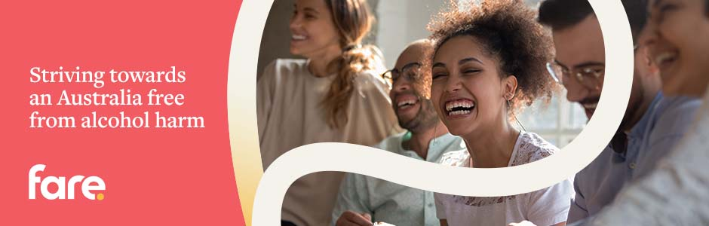

Over the past two decades, we have continued to evolve and strengthen our partnerships with communities across the country working towards an Australia free from alcohol harm.

Our new look seeks to capture this community driven approach, representing our core values, what we do and how we operate.

As part of our rebrand, we also launched a new website – a one-stop-shop to learn, connect and find support.

While we have a fresh new look and feel, our commitment to elevating community voices, developing evidence-informed policy, delivering health education, and holding alcohol companies to account is stronger than ever.

##### We launched *Every Moment Matters –* Australia’s first national awareness campaign on alcohol and pregnancy and FASD awareness, to support all Australian families to be healthy and well

We were incredibly proud to launch *Every Moment Matters*– an Australian-first, nation-wide campaign raising awareness of the importance of supporting alcohol-free pregnancies and breastfeeding, that is funded and endorsed by the Australian Government Department of Health.

This campaign is the culmination of many years of work, and was only made possible through ongoing consultation and support from the Fetal Alcohol Spectrum Disorder (FASD) community and organisations such as NOFASD Australia, National Aboriginal Community Controlled Health Organisation (NACCHO), Royal Australian and New Zealand College of Obstetricians and Gynaecologists (RANZCOG), Royal Australian College of General Practitioners (RACGP) and the Australian College of Midwives (ACM).

The campaign will continue until 2024 and spreads the word that the moment you start trying is the moment to stop drinking alcohol, providing Australians with the best information about alcohol, pregnancy and breastfeeding, and FASD.

https://www.youtube.com/watch?v=N2WUwlDPcPo&ab_channel=FAREAustralia

[visit the website](https://everymomentmatters.org.au/)

##### We celebrated 20 years of FARE, reflecting on the many amazing people and around the globe who have helped us work towards an Australia free from alcohol harm

Friday, 3 December marked 20 years of operations at FARE.

https://www.youtube.com/watch?v=-wyblA2i_hk&ab_channel=FAREAustralia

It was a pleasure to celebrate with so many incredible members of our community as we took the time to reflect on 20 incredible years and all the times that FARE has stood together with communities and organisations to develop evidence-informed policy, enable people-powered advocacy, and deliver important health awareness programs.

From providing early support to Hello Sunday Morning, funding the first Alcohol and Drug Healing Service for young Aboriginal people, contributing to the first Australian FASD diagnostic centre, to calling for healthier community sport, we have a lot to be proud of about what we’ve achieved together over the last two decades.

Across December and into 2022 – FARE’s 20th year – we will take you on a trip down memory lane, highlighting some of our most significant achievements, releasing our 20-year Impact Report, and sharing the stories and faces connected to our history.

It’s been a truly momentous year at FARE. We are so proud of what we have achieved together and can’t wait to celebrate more community wins with you next year.

To all of our supporters, thank you for believing in this work and our vision of an Australia free from alcohol harm.

### Metadata

|  |  |
| --- | --- |
| **ao_post_optimize** | Array |