# 2020_PRICING&TAX

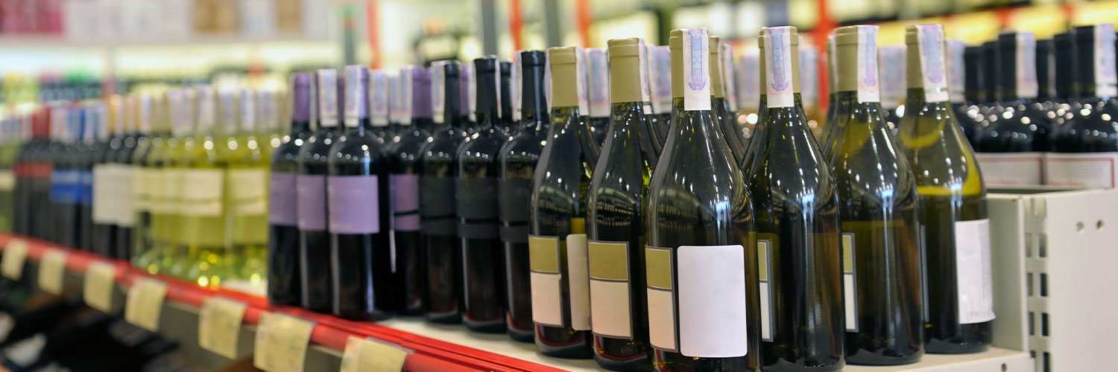

Reports commissioned by FARE from The Australia Institute, ACIL Alen Consulting, and Marsden Jacob Associates make a strong case for alcohol tax reform.

Modelling in The Australia Institute report, [*The goon show: How the tax system works to subsidise cheap wine and alcohol consumption*](https://fare.org.au/the-goon-show-taxpayers-pick-up-1-4-billion-dollar-wine-tab/), exposed Australia’s wine tax system as corporate welfare, with Australians paying a billion dollars a year to subsidise the wine industry. Economic modelling by ACIL Allen Consulting in the report, [*Alcohol tax reform: Economic modelling*](https://fare.org.au/consign-wine-equalisation-tax-to-history/) assesses the impact of replacing the Wine Equalisation Tax (WET) with three different scenarios, highlighting the monetary and health benefits of a fairer alcohol tax regime. And a cost-benefit analysis by economists Marsden Jacob Associates, [*Optimal rates of alcohol taxation*](https://fare.org.au/optimal-rates-of-alcohol-taxation/), found Australians would be better off if the government taxed alcohol rationally at substantially higher excise rates.

## Background

The current alcohol taxation system is illogical, incoherent and does not adequately recognise the extent of harms that result from the consumption of alcohol in Australia. The most illogical part of the alcohol taxation system is the Wine Equalisation Tax (WET). Under the WET, wine and other fruit-based alcohol products are taxed based on their wholesale price, rather than alcohol content. All other alcohol products like beer and spirits are taxed on a volumetric basis, albeit at different rates, with the amount of tax paid determined by the volume of alcohol within the product and the category of alcohol (for instance, full-strength packaged beer is taxed differently to spirits).

The WET has contributed to wine being the cheapest form of alcohol available for sale, with some wine in Australia being sold for as little as 24 cents per standard drink and the majority of bottled wine (65 per cent) being sold for under $8.00.

## The evidence

Alcohol is more affordable than it has been in the past three decades. There is strong evidence to demonstrate that [the lower the price of alcohol, the higher the levels of consumption](https://www.ncbi.nlm.nih.gov/pubmed/19149811).

In 2009, a [meta-analysis](https://www.ncbi.nlm.nih.gov/pubmed/19149811) was conducted of 112 peer reviewed studies on the effects of alcohol price and taxation levels on alcohol consumption and found that there was “overwhelming evidence of the effects of alcohol pricing on drinking”. Young people and heavy drinkers are particularly sensitive to alcohol price, with the [heaviest drinkers more likely to seek out cheaper drinks](https://www.wpro.who.int/publications/docs/Addressingtheharmfuluseofalcoholforupload.pdf) than moderate drinkers.

Alcohol taxation is the most cost-effective measure to reduce alcohol harms. An analysis of alcohol harm prevention policies found that [alcohol taxation was the most effective policy, had the most breadth of research and has been implemented across a range of countries](https://onlinelibrary.wiley.com/doi/10.1111/j.1360-0443.2010.02945.x/full). The analysis found that alcohol taxation is effective, as it has the ability to reduce consumption and related harms but also provides a source of revenue. A key element of alcohol taxation polices is its [ability to target heavy drinkers](https://onlinelibrary.wiley.com/doi/10.1111/j.1360-0443.2010.02945.x/full).

Policies that increase the price of alcohol lead to a [reduction in the proportion of young people who are heavy drinkers, a reduction in underage drinking, and a reduction in per occasion ‘binge drinking’](https://www.who.int/substance_abuse/expert_committee_alcohol_trs944.pdf). Research in the USA found that a [one per cent increase in price due to taxation resulted in a 1.4 per cent reduction](https://www.ncbi.nlm.nih.gov/pubmed/25428795) in binge drinking (defined as drinking at or above levels associated with intoxication) by adults.

## The solutions

A staged approach to alcohol taxation reform is needed in Australia and this should include immediate action to move the WET to a differentiated or category based volumetric tax rate, with the intention being to tax wine and other WET products at a rate that considers the alcohol content of the products.

This staged approach should also include a longer term plan, based on clearly established public policy objectives that benefits the Australian community.

The Australian Government can no longer delay reform and ignore the negative impacts the current alcohol tax system is having on the community.

### Policy submissions